Chapter 6 Fuel consumption calculations and final results

This chapter explains the processing of the data produced by AVL Boost that will lead to a final fuel consumption result for the European test cycle.

6.1 Fuel consumption calculation programs
When engine maps are obtained from any engine simulator program, such as AVL Boost, it is necessary to include these maps in a program to calculate the fuel consumption in the European test cycle or in any other equivalent test cycle. In these programs it will be necessary to introduce data of the car in which the engine will be fitted. These data are the one assumed in chapter3 and summarised in table 3.4 to calculate the torque required to pass the European test cycle.
Although a free program called ADVISOR from the U.S. Deptartment of Energy's Office of Transportation Technologies is available for this purpose in http://www.ctts.nrel.gov/analysis/download.html, it was decided that the author would write his own code. The main reasons for this were that it will allow to process the data as it comes from AVL Boost and it will provide high flexibility to analyse data for this thesis and for future work.

6.2 Description of the programs
The author wrote three programs in MATLAB to calculate the fuel consumption in the European test cycle: eropeancycleprogram, ecesubprogram and eudcsubprogram.
These programs provide a flexible tool where any of the car parameters can be changed easily. They will identify any point of the European test cycle where the engine is not capable of producing enough torque in any of the gears, displaying an error message identifying the problematic points.
As the European test cycle is a velocity defined cycle, the programs will calculate the best gear shift to achieve optimum fuel consumption.
Another important feature of the programs is that they use external data input files such as those with the bsfc map, torque map or gear ratios, allowing changes to be made by new simulations or changes made in Microsoft Excel or any text editor and therefore, allowing a quick study of the input parameters to be performed. Also in this way, it allows changes without the need to use Matlab, allowing those people that do not know Matlab programming to use the program.

6.2.1. Europeancycleprogram
This is the main program and it will call the other two. It will produce a plot of the bsfc and torque maps of the engine and it will give the fuel consumption of the ECE cycle, the EUDC cycle and the combined (European test cycle).
It contains the vehicle data and it loads into MATLAB the cycles definition, the bsfc, bmep, torque and idle maps that should be previously created by the user. The cycle definition data was obtained from the matlab file that ADVISOR uses to calculate the fuel consumption in the European cycle and it has defined the car velocity in the cycles in points with a separation between them of 1 second. The bsfc, bmep, torque and idle maps are constructed in AVL Boost as a function of engine speed and flow restriction coefficient of the butterfly valve.
In order to plot the bsfc and the torque vs engine speed and load, the load is calculated as
(maximum bmep at a given throttle position) / (maximum bmep at WOT) (6.1)
In this definition, the load will take value of 1 at WOT and 0 at idle, because there is no net torque output and therefore bmep = 0.
This program will also check that all the maps have the same dimensions and will display an error message if they do not have the same dimensions and will display which was the problem found.
The program will be used to validate if the desired swept volume is big enough to pass the European test cycle, because it will display an error massage if it is not possible to obtain the torque required by the cycle with the mounted engine. More over, it will give the points at which these errors occurred and it will overcome them in order to produce in this case an idea of the possible fuel consumption.

6.2.2. Ecesubprogram and eudcsubprogram
Both programs are similar. The ecesubprogram will calculate the fuel consumption to perform the urban cycle (ECE cycle) of the European test cycle while the eudcprogram will calculate the fuel consumption for the extra urban cycle (EUDC cycle).
They also will calculate the gear shift for optimum fuel consumption. Care should be taken at this point because it can give more than two changes in a very short period of time. If this condition occurs by examination of the gears shift against the cycle test, it can be easily determined a realistic gear change strategy. With the gear shift strategy determined, it would be easy to fix in the program.
Further information of the programs can be obtained in Appendix B where the code is presented and explained.

6.3 Final model description and its performance
In chapter 4 and chapter 5 some of the most important parameters relating to the engine performance were studied. As a result of these studies ian AVL Boost engine model was obtained with which it was produced bsfc, torque and bmep maps that were processed by the europancycleprogram in order to find out the fuel consumption of that engine fitted in a car with the data assumed in chapter 3 and summarised in table 3.4. In this section the main features of the model are summarised along with its maps and its fuel consumption.

6.3.1 Main features of the model

The final model obtained is the result of a structured approach to the target of the 3 litre per 100 km car. In this structured study, many different parameters where studied and a decision was made in each of those studies. In order to clarify the main features of the model, the following picture and table are presented.
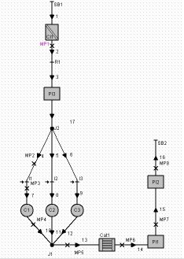
Figure 6.1 Schematic representation of the final model
Bore | 62 mm
Stroke | 65 mm
Connecting rod | 113 mm
AFR | 14.5
Compression ratio | 10.5

Valves
Intake valves |  | Exhaust valves
Valve diametre | 23 mm | Valve diametre | 19mm
Opening time | 350 ºcrank | Opening time | 170 ºcrank
Duration | 220 ºcrank | Duration | 220 ºcrank
Lift | 10 mm | Lift | 10 mm

Runners length
Intake runners | 300+60mm | Exhaust runners | 100 mm

Table 6.1. Main model features
Please note that not all the parameters are include, for more detailed values, please refer to appendix A and D.

6.3.2 Engine maps
AVL Boost was used to simulate the bsfc, torque and power of the model. The final results at WOT can be seen in the following graphs.
Power
Torque

Figure 6.2 WOT torque and power of the final model

Figure 6.3 WOT bsfc of the final mode.

Also with AVL Boost the part load conditions were simulated producing torque, bsfc and bmep maps that were processed in MATLAB to generate following pictures.
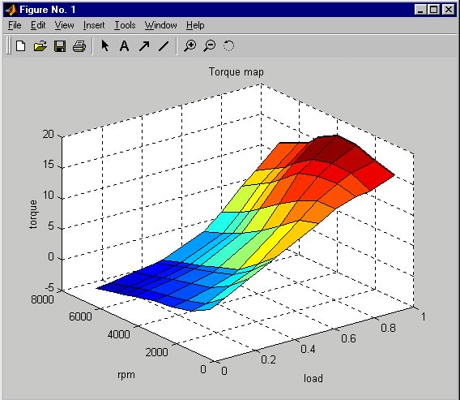
Figure 6.4 Torque versus engine speed and engine load.
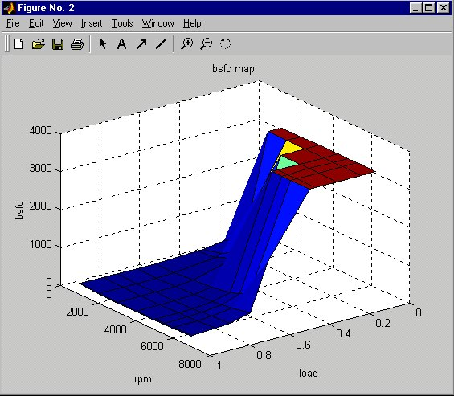
figure 6.5. Bsfc versus engine speed and load

Note that the bsfc against engine speed shape at each load is similar to that at WOT . It is important to highlight that at low loads, as the power output approaches zero, the bsfc tends to infinity and also at very low loads and high engine speeds the engine is not powered, it becomes motored and therefore the bsfc becomes negative. To avoid this infinity value and negative values, the AVL Boost bsfc map was processed by the europeancycle program and this program gave at these points an arbitrary value of 3333 g/kwh that explains the flat part of the bsfc shape at low loads. Note that giving a value of zero when the engine is motored, seems to be more logic, but due to the way the program was made, it will cause wrong fuel consumption values. Also note that a special condition was made to treat the motored condition and avoid using the unreal value 3333 g/kwh.
Also, note that there is a rapid increase in bsfc below 0.6 load. This abrupt increase is produced at relative high load (0.6), but it is just due to the definition of load made in the program. It does not imply that is produced at relative opened throttle (nearly half opened) as can be seen in the following table which relates load with throttle flow restriction coefficient (related with throttle geometric opening point).

Flow coefficient | 1 | 0.5 | 0.07 | 0.05 | 0.03 | 0.02 | 0.01 | 0.009 | 0.007 | 0.005 | 0.004
Calculated load | 1.00 | 0.99 | 0.88 | 0.81 | 0.70 | 0.62 | 0.41 | 0.38 | 0.27 | 0.15 | 0.07

Table 6.2. Relation between flow coefficient and load.
In order to present a graph without any data manipulation and without any infinity value, the following graph was made in Microsoft Excel. It was made with the simulations with values of flow coefficient between 1 and 0.02.

Figure 6.6 Bsfc for flow coefficients between 1 and 0.02

With the europeancyleprogram it was checked that with an engine of 0.6 litres it is possible to perform the European test cycle. Although the first calculations made to decide the engine swept volume where made just at WOT and at few points (figure 5.18 ), this program has shown that it is enough to make these kind of decisions. This is because the maximum torque given by the engine is produce at WOT and as the points chosen where the ones where the maximum torque required is more likely to be demanded. The author wants to highlight with this dissertation the importance of early hand calculations for the engine design and how they can give some orientations about the work to be performed.

6.3 Fuel consumption results
The previous maps where used by the europeantcycleprogram to calculate the fuel consumption of the modelled engine fitted in the assumed car when is performing the urban cycle (ECE cycle), the extraurban cycle (EUDC) and the combined (European test cycle). In the following table are compiled the final results.

 | Modelled vehicle. Idle=1000 rpm | Modelled vehicle. Idle=800 rpm BASELINE | With idle engine deactivation
ECE | 5.28 | 4.99 | 3.48
EUDC | 3.59 | 3.57 | 3.43
Combined | 4.21 | 4.09 | 3.45

Table 6.3. Fuel consumption results. Litres per 100 km

From the above table two important things can be derived. First, that the idle speed is a very important fuel consumption parameter in the ECE cycle and as a consequence in the European test cycle.
The second and more important result is that to achieve a 3 litre per 100 km fuel consumption gasoline car with regular point injection, it is necessary to have engine deactivation at idle. The reason for this is that when idle, the engine is consuming fuel while is not producing any power output, in other words, it is wasting the fuel.
Although the engine deactivation at idle is a current technology used by hybrid cars, it presents the following problems:
- Care must be taken to not have additional fuel consumption when restarting the engine. This was an insolvable problem of carburetted engines, but nowadays is possible to overcome it by delaying the injection until the engine has reach about 800 rpm.
- The catalyst cools down. When deactivating the engine, the catalyst cools down and therefore, the other non CO₂ emissions will increase considerably. This could be solved in two ways, first, by doing a careful study of how long the cylinders could be deactivated or may be by maintaining just one cylinder operating (this last solution will lead in a fuel consumption in the combined cycle of 3.66 litres /100 km). The second solution could be use an alternative fuel where emissions do not depends on a catalyst.

6.4 Fuel consumption sensitivity analysis
In chapter 3 the effects of the mass and drag coefficient on the bmep or torque were studied. Now the effect that they have on the fuel consumption will be considered. The complete results are compiled in the tables of appendix C, were first the absolute values are included and then the comparison with the baseline. The following graph in terms of % of parameter change is presented to allow easy analysis of the results.
Please note that the 0% change is produced in the condition of idle at 800 rpm and without engine deactivation, called the baseline in the previous.

Figure 6.7. Fuel consumption against % of mass, Cd and frontal area change.
European test cycle

From the above graph it can be concluded that the mass reduction is the alternative which will produce bigger fuel consumption improvement for a given % variation. Moreover, the change in mass also is the easiest alternative to achieve because it has many features that can be improved as mentioned in chapter 2. Further more, changes in drag coefficient are really difficult to achieve and even more when low values such as 0.27 are already achieved. Also changes in frontal area can not be made because will change the habitability of the car and will change its comfort.
From the above graph it can be also concluded that reducing mass, Cd and frontal area, does not produce great changes in fuel consumption and therefore just using this strategy the 3 litre car will not be achieved. This shows the importance of improving the engine performance and the possibility of deactivating the engine at idle.

With the sensitivity analysis the possibility of changing the car parameters was also studied. It was found that the car will pass the European test cycle, even if the mass is increased up to 1000 kg or the drag coefficient is increased up to 0.3. With these values the engine just is not able to produce the demanded torque for 3 seconds, at the end of the last acceleration of the EUDC. Just by redesigning the gearbox or tuning a the engine at that engine speed, the engine will pass the cycle without any problem with 1000Kg or 0.3 drag coefficient.

6.5 Validation of the results. Comparison with the Smart
This point will show that the values obtained of torque, power and bsfc are normal for an engine of a swept volume of 0.6 litres. Some other checks are performed in appendix A.
As can be seen in figure 6.2 the peak power has a value of 25000W at 6000 rpm. This implies a 25/0.6 = 41.7 KW per litre. This value is very close to the 45 kW per litre suggested by Harrison (2000) as normal.
The peak torque of the engine is 51.9 Nm at 4000 rpm, which leads in a 51.9/0.6 = 86.5 Nm per litre, again very close to 90Nm per litre suggested by Harrison (2000) as normal.
The bsfc curve has two main advantages, first that it is quite flat between 2000 and 5000 rpm, and second, that if has a low value of 243 g/kWh, lower to the common 260 g/kWh (Harrison 2000).
The final configuration adopted, can be compared with the second best fuel consumption car in the market: the Smart. Its engine specifications from http://www.thesmart.co.uk/index.html?dir=see&main=see_overview.asp are:

Smart engine
Cylinders/configuration 3/in-line, rear-mounted
Cubic capacity in cc 599
Bore x stroke (mm) 63.5 x 63.0
Valves per cylinder 2
Spark plugs per cylinder 2
Aspiration Turbocharged
Boost control Mechanical
Max. boost pressure (bar) 0.4
Fuel Injection Multipoint, electronically controlled
Compression ratio 9.5 : 1
Emission control 3-way catalylic converter
Max. power (bhp) @ rpm 44 @ 5250
Max. torque (overboost) (Nm) @ rpm 70 @ 2250-4500
Transmission 6 gears
Combined fuel consumption = 4.9 l/100 km

Table 6.4. Smart engine specifications
http://www.thesmart.co.uk/index.html?dir=see&main=see_overview.asp

As can be seen, the smart has the same engine swept volume as the designed engine for this thesis, but the engine is turbocharged. The Smart obtains a 31% more power and a 34.8% more torque by having a reduction in fuel economy of 19.8%. Its designers have apparently decided to sacrifice fuel consumption in order to obtain better driveability.
It is also to important to highlight that the Smart has 6 gears, which will allow improved performance and fuel consumption as explained in chapter 2 The advantage of this option could be simply studied by adding its values to the europencycle input file called gear map.
The last point needing comment is that the Smart has two valves per cylinder and two spark plugs. Both configurations were adopted to improve combustion stability. Although as said in chapter 4. , this configuration is worst than the 4 valves because it would imply less volumetric efficiency and worst fuel consumption, when turbocharging the volumetric efficiency problem is overcome and then the 2 valves configuration is preferred.

