Chapter 5 The AVL BOOST model. Sensitivity analysis

5.1 Introduction to AVL BOOST
AVL Boost is a one dimensional code that takes into account wall friction, heat transfer, energy losses in restrictions, volumes, and pressures pulses. There are several different models for in cylinder combustion and heat transfer. There are also models for catalytic converters, injectors and measuring sensors.
AVL Boost consist of three modules: the pre-processor, the main program and the post-processor.
- Pre-processor. In the pre-processor, the calculation model of the engine is designed with a graphical user interface by selecting the required elements from a displayed menu. By applying thermodynamic parameters to each component of the model, a 1 dimensional structure along the gas flow is then build up and will be solved by the main program.
- Main calculation program. The main program provides well optimised simulation algorithms for all available elements. The flow in the pipe is treated as one dimensional. Pressures, temperatures and flow velocities obtained from the solution of the gas dynamic equation represent mean values over the cross section of the pipes.
The elements available for designing an engine are: pipe, system boundary, internal boundary, cylinder with a quasidimensional combustion model, plenum, variable volume plenum/crankcase, flow restrictions, check valve, rotary valve, junction, air cleaner, fuel injector or carburettor, catalyst, turbocharger, turbocompressor air cooler, Fire link (3D flow simulator), waste gates, engine control unit, wire and dynamic link library.
- Post processor. The analysis of the results is supported by an interactive post-processor. It provides the following modes for the analysis of the calculated results: message analysis, transient analysis, traces analysis, series analysis and acoustic analysis.
For further information about each program or the thermodynamic bases in which BOOST is based, please refer to the Boost manual (2000).

5.2 Model representation explanation
In the this chapter different models are analysed, some of which have included a Boost preprocesor image, included to aid to explain the different configurations. These images are schematic representations of an engine model. Therefore in order to allow the reader to understand these models and future explanations, the following diagram is included, explaining the representation of each element. This is the final configuration used to generate the final results.
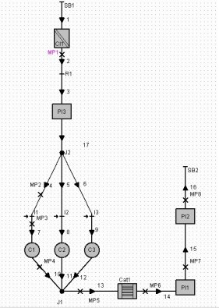
Air -cleaner
Throttle
Restriction
Junction
Injector
Plenum
Catalyst
System
Boundary
Measuring point

Figure 5.1. Final model diagram explaned

5.3 Decisions made
In this section some of the decisions made regarding the engine are discussed.

5.3.1 Bore/stroke decision
Nowadays most cars have the ratio bore/stroke equal to one. This ratio value affects the engine in different ways which produce opposite results but as Bishop (1964) said, it has low influence on economy.
It was decide to use a Bore/Stroke value of 0.95 because this will increase the compression ratio, increasing the thermal efficiency and also because the engine will run slower, producing less friction. The drawback of low value of bore/stroke is that implies smaller bore and therefore smaller valves, reducing volumetric efficiency. In contrast with what the author thought when taking this decision, Bishop (1964) shows that it would be advantageous to have the Bore/stroke slightly above one.

5.3.2 Combustion model and combustion start
It was decided to use the Vibe (also written as Wiebe) model of combustion because it is the simplest. It express the rate mass fraction burn per degree of crank angle as an exponential function of the crank angle and some coefficients (Vibe parameters). Then the rate of heat released is related with the mass fraction burn. For further information about the Vibe model please refer to Boost manual (2000) or to Harrison (2000).
In this model the combustion start and combustion duration are needed as input data. For the combustion start, it was decided 5º of crank angle before TDC and, as suggested in the Boost manual (2000) , a duration of 50º of crank angle.
As the engine speed changes and the load changes the combustion start changes in order to achieve the best torque (MBT) or to avoid knock (Harrison 2000). As AVL Boost has no knock model, no changes were made in the combustion start or combustion duration. This simplification will not make great differences, but the performance of the engine could be improved by using a spark timing map in the ECU and using the combustion model Hires/Tabacsinsky or by using a Vibe parameter map (Boost 2000).

5.3.3 Compression ratio decision
Nowadays gasoline cars have compression ratios around 10. Increasing the compression ratio will increase the thermal efficiency but the friction and heat losses will increase as well. As a result of this opposite effects, when increasing the compression ratio, the power output will increase and therefore the bsfc will diminish, but as Heisler (1995) writes, that will occur up to a compression ratio of 16:1. This improvements in bsfc and power can be seen in the following graph from Heisler (1995).

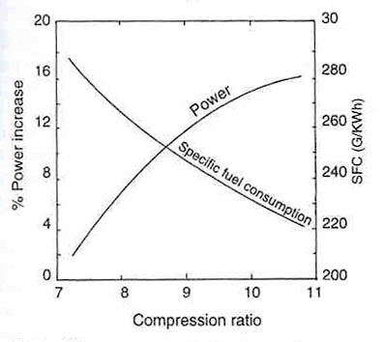

Figure 5.2 Power and bsfc against compression ratio
Heisler (1995)

Note the great advantage of increasing the compression ratio on the fuel economy. But there is a limitation for increasing the compression ratio and it is that it will produce higher pressures and temperatures during the compression stroke, promoting knock. Note that the knock problem, will make the search for alternative fuels interesting and also note the importance of anti-knock additives in gasolines.
As Boost does not have a knock model a 10.5 compression ratio was used.

5.4 Modelling process
In this section some of the modelling decisions adopted are described. The most important decisions when starting the modelling were how to represent the throttle and how to represent four valves per cylinder.
The throttle was represented by a restriction, and in order to simulate the part load, its flow coefficient will be changed. It is necessary to highlight that the throttle is not a linear device and therefore a linear increase in the butterfly flow coefficient will not produce a linear increase in imep or in torque. This is because although air mass is a direct function of the flow restriction coefficient (equations (4.1) and (4.2)), it also depends on the pressure drop in the restriction, equation (4.2), that does not have a linear dependency due to gas dynamics. This non linearity is the cause of the complex relationship between the flow coefficient and the load. The AVL Boost output data is processed by europeancycleprogram, (program made by the author) in order to determine the relationship between load and flow restriction. More will be discussed about this in next chapter.
There are two ways to model a four valve per cylinder engine: having two intake pipes and two exhaust pipes per cylinder or having just one of each. The first model will be compulsory to use if a turbulence model would be included in Boost, but as it is not, the second model was used because it is more simple. When using the simple model of one inlet pipe and one exhaust pipe , care must be taken when introducing the valves input, introducing instead the real valve diameter an equivalent valve diameter. This equivalent diameter would be the diameter of a single valve which has the same area as the two real ones. A formula for the equivalent diameter is $D_{\text{eq}}=\sqrt{2}⋅D$.
Another key point in the modelling process is to decide which are going to be the initial conditions. In industry, the initial conditions will be obtained from a test bed, moreover, it could be defined internally boundary conditions that will force the model to acquire the defined values at the boundary points. As this was not the case, it was decided to do some simulation with reasonable input data and with measurement points in the pipes. Then the Boost global outputs in this measuring points were used as the initial values. It should be noted that there were no convergence problems due to the initial conditions when enough cycles (around 15) were calculated at each rpm. But when one configuration is unstable in the program, such as substituting the manifold junctions by plenums, the model becomes very sensitive to initial conditions. Moreover, in this case, the use of measurement point output values, does not solve the instability. In this case sometimes arbitrary values helped to overcome the instability problem.
Another key point on the modelling, was the representation of the restrictions of the intake systems. When an engine is being modelled, this restrictions will come from bends, expansions and junctions. The values for the flow coefficients in can be obtained in flow books such as Miller (as loss coefficient) or obtained via testing. The problem in this thesis is that the geometry was completely undefined. Therefore, as can be seen in figure 5.1 or in figure A.1 it was decided to use junction 2 as the main source of intake flow restriction. Also the Plenum 3 was included with flow coefficient smaller than 1. In the exhaust systems, junction 2 and the plenums are the ones which contributes as restriction.

5.5 Sensitivity analyses

In the design process many parameters where changed in order to study the importance on engine performance and in order to find a good compromise between fuel consumption and performance. The main parameters studied were: cam configuration, pipes diameter and length, pipes configuration, plenum configuration and flow restriction coefficients.
There are many other important parameters such as spark timing, combustion duration, vibe parameters, compression ratio or AFR that were not studied and optimised due to the short time available to perform this thesis, but that may be needed to investigate for future work.
In this section some of the above studies are discussed. The criteria used to decide between one configuration and another was to get a reasonable compromise between torque, power and bsfc curves at WOT. It is necessary to remark that similar analysis can be found in many engine books such as: Heywood (1988), Heisler (1995) or Taylor (1985). With this analysis the author wants to show some of the steps which guide him to his final model and he also wants to take the opportunity to show the importance of these and other parameters to the final performance of the engine.

5.5.1 Cam configuration
As shown in the following graphs the cam lift, cam opening time and valve size have great effect on engine performance. To make an analysis of any these effects, it is essential to have a program, which calculates the valve profile automatically when changing any of these parameters. For this reason, the author of this thesis had created the program “valve lift program” as explained in section 4.1.4 and appendix 4.1.
The parameters changed for these analysis are included in the below table and the results at WOT can be seen in the followings graphs.

 |  | Inlet |  |  | Exhaust
Graph number | Lift mm | Duration ºCrank | Opening time ºCrank | Valves diameter mm | Duration ºCrank | Opening time ºCrank | Valves diameter mm
1 | 7 | 260 | 340 | 24 | 260 | 135 | 20
2 | 7 | 220 | 350 | 24 | 220 | 170 | 20
3 | 7 | 260 | 340 | 20 | 160 | 135 | 16
4 | 10 | 270 | 340 | 24 | 260 | 130 | 20
5 | 10 | 220 | 350 | 24 | 220 | 170 | 20

Table 5.1. Cams configuration used in the analysis

Figure 5.3. Power per cylinder against engine speed for different valve configurations

Figure 5.4. Torque per cylinder against engine speed for different valve configurations

Figure 5.5. Bsfc against engine speed for different valve configurations

From these graphs it was decided that the 5th configuration is the best one because it gives adequate power, high-speed torque and high-speed bsfc. It also has the best bsfc at low speeds while is the second best in torque at low speeds.
High torque at low speeds is important because provides good driveability as Harrison (2000) said, citing Tabaczynsky (1982).
Please note that in these results the torque and power have higher values than in the final results. The reason for this was that the swept volume for these calculations is 0.7 litres. They also have higher values than in the following comparisons, but this fact will be tackle in section 5.5.3.

5.5.2 Pipes length sensitivity

The intake runners length and the exhaust runners lengths were studied by keeping a baseline and changing each length at a time . As a result of these studies, as can be seen in the following graphs, it was found that in the model made, small changes to these lengths will not produce big changes in the engine performance but if great changes are made (e.g. Intake from 300 to 1000mm), great changes will be appreciate, as Heywood (1988) shows.

Figure 5.6. Power per cylinder against engine speed for different runners length

Figure 5.7. Torque per cylinder against engine speed for different runners length

Figure 5.8 bsfc per cylinder against engine speed for different runners length

It can be seen that the main changes produced by the intake length are changes on power and torque at high speeds and changes of bsfc at low speeds. A short intake runner will produce higher power and torque at high speeds but it will produce lower performance at low speeds. Also it will produce a smaller value of the bsfc minimum, but with the drawback of increasing the rate of change of bsfc at low speeds producing worst very low speeds fuel consumption. Further conclusions can be read in Heisler (1995)
From this study it can be said that long exhaust runners will produce an increase in peak power. Although it could be a convenience strategy to obtain a good performance engine, it is not feasible to use because the catalyst will be far away from the pistons, taking too much time to warm it up and therefore, producing high pollutant emissions.

5.5.3 Flow restrictions
The restrictions that exist in the intake system have a strong effect on engine performance. These restrictions are produced mainly by bends, expansions, friction and junctions. All of them have the characteristic that produce a pressure drop that is proportional to the square of the air velocity. The pressure drop will produce a diminution of the volumetric efficiency. As a consequence of this reduction, the torque/power will be lower, with lower bmep and therefore higher bsfc . Furthermore, as the restrictions affects with the square of the air velocity, this effects will be increased as the engine speed increases.
Different flow restriction values are the reason for the differences between the cam configuration analysis and the runners length analysis values. In the cam configuration analysis, the values of the volumetric efficiency were slightly higher than one and therefore for the second approach the junction 2 flow coefficient was diminished, that implies higher restriction, in order to obtain more realistic values of volumetric efficiency. Although it is possible to achieve values of volumetric efficiency above one due to the ram and wave effect, the author did not want to be too optimistic and also as he can not validate his values with experiments, he preferred to be conservative.
In the following graphs are compared the baseline of the runners length analysis with the best cam configuration (5th graph) in order to show the differences between values and the importance of the flow coefficients.

Figure 5.9. Volumetric efficiency against rpm for different flow coefficient values.

Figure 5.10. Torque and Power against rpm for different flow coefficient values

Figure 5.11. bsfc against rpm for different flow coefficient values

From the above graphs can be seen the great advantage to engine performance and fuel economy that would be to have little restrictions, high flow coefficient values. This configuration could be achieved by straight pipes, with few junctions and few expansions. This would be difficult to achieve due to the car packaging, but one way that could improve volumetric efficiency an therefore torque and bsfc would be to have each cylinder fed with an independent intake system.

5.5.4 Plenums and side branch configuration
The inclusion of a plenum before junction 2 was studied its possible effect to the engine (figure 5.12). Also a side-branch configuration without any plenum was studied (figure 5.17). The plenum and not plenum configurations are as shown in the following picture.

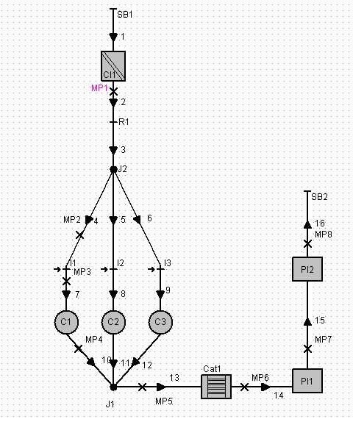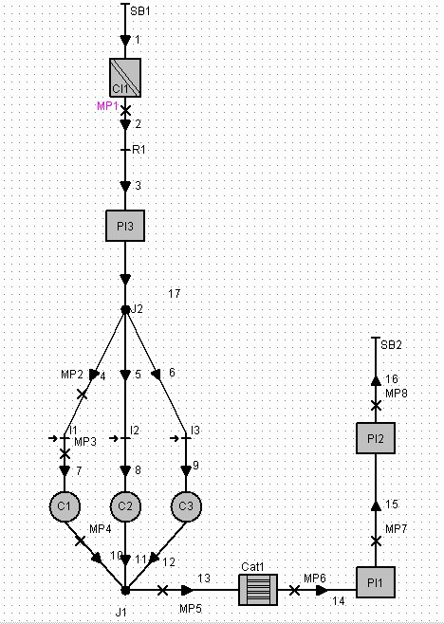
Plenum

Figure 5.12. Baseline configuration and Plenum configuration

The results of this study can be seen in the following graphs. It is possible to observe that the inclusion of this plenum in the place where it was fixed, will not produce any effect at high speeds. On the other hand, at low speeds can improve considerably the torque, producing a quite flat torque curve. Although it will increase the bsfc at very low speeds, the author considered for his last model that the improvements in low speed torque, and therefore in driveability (Tabaczynski, 1982), will overcome this increase in bsfc.
Note that in this plenum a flow coefficient of 0.6 was assumed which that is quite low value. If the analysis were carried out with a flow coefficient of 1, bigger differences would be found and more advantages would be obtained by the inclusion of a plenum. The real value for the flow coefficients could be obtained as a function of the quotient of the plenum and pipe areas.
Note that the effect of plenum inclusion could be an important issue for future work

Figure 5.13. Cylinder power against engine speed for plenum and sidebranch analysis

Figure 5.14. Cylinder torque against engine speed for plenum and sidebranch analysis

Figure 5.15. bsfc against engine speed for plenum and sidebranch analysis

From the below graph can be observed that the side-branch configuration (figure 5.17.) will increase high speed torque and peak power (figures 5.13, 5.14 and 5.15) without any drawback on the bsfc. The problem that this configuration has, is that there is a fluctuation in torque, bsfc and power between each cylinder. This fluctuation is 9.9% at 6000rpm, bigger than the commonly used 8% value, used to reject engines with cylinder (Profesional engineering. Wednesday 25 July 2001).Please note that in the above graphs the values used were the average between each cylinder. In the following graph can be seen the imep cylinder fluctuation produced in the sidebranch configuration that prevent the use of this configuration.

Figure 5.16. Imep cylinder fluctuation for sidebranch configuration

The main reasons for this differences are that each cylinder has different intake runner length and also because the different junction configuration provides the system with different gas dynamics than just with one junction.

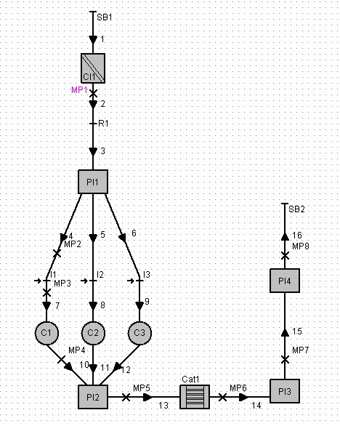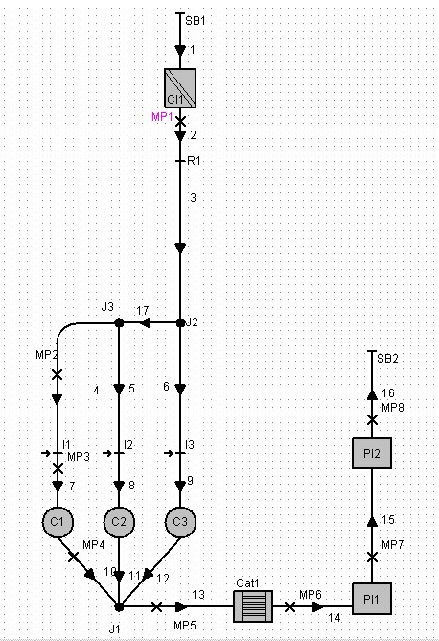
Junctions with plenums
Side branch

Figure 5.17. a) Junction with plenums b) Sidebranch configuration

The effect of locating plenums instead of junctions (figure 5.17) was studied. Although this can present manufacturing problems it was observed that can produce potential improvements to the engine. The results of this configuration are not included in this chapter because the program AVL Boost presented problems with it, as explained before, and it was not possible to produce simulations with similar engine parameters as the included in the chapter.

5.5.5 Swept volume decision
Initially some hand calculations were made, included in section 3.6, to give the author an idea of a minimum theoretical value for the engine swept volume. These calculations reflected a minimum value of the engine size of 0.49 litres. After the first approaches starting with 0.5 litres, it was seen that the smallest swept volume to be able to pass the European test cycle would have 700 cc. This is the reason for which the sensitivity analysis where carry out with 700 cc (0.7 litre) swept volume.
Although initially this configuration was just about to get enough torque to pass the test cycle, after the sensitivity analysis work, the author obtained enough torque from the engine to pass the European cycle. More over, as can be seen in the following graph, with the final configuration obtained, it seemed that may be a 0.6 litres swept volume may achieve the goal, but a more exhaustive analysis should be done.

Figure 5.18 Engine torque required and available from different swept volumes

The above graph was constructed with the data obtained from the calculations shown in chapter 3 and compiled in table 3.7 (torque required to drive the European test cycle) and with the values obtained from Boost at WOT for different swept volumes. The trend line used is a quadratic interpolation because as said in Aparicio et al (1995), this interpolation order will fit perfectly any torque curve.
It was later proved that the 0.6 litre swept volume car was really able to perform the European test cycle when a complete engine map was constructed and when its consumption and feasibility was calculated by the program europeancycleprogram, discussed in section 6.2.1.

