Chapter 4 Initial consideration for the engine modelling

For the simulation work of this thesis is going to be used an engine simulation program called AVL Boost, that will be explained in the next chapter. Although it is one of the best engine simulation programs in the market, it has some limitations and there are some important parameters such as valves configuration, turbulence and combustion stability that it does not take into account. As this elements can make a great contribution to the engine performance a discussion about them is going to be undertaken in this chapter. Also some information about input data needed by the program as the fmep and the flow coefficients of the valves is compelled in this chapter.

4.1 Valves
One of the most important design parameters that will affect the performance of an engine are the valves: number, size and arrangement, motion shape, lift and opening time. All these parameters have a great influence over the final engine characteristics and therefore a deep discussion is going to be made at this point and in appendix 4.1 and section 5.5.1.

4.1.1 Size, number and arrangement of valves per cylinder
The size, number and arrangement per cylinder of the valves not only enables the required amount of charge to enter the cylinder, affecting the volumetric efficiency, it also determines the turbulence inside the cylinder and therefore affects the combustion. The combustion stability and the turbulence are not take into account by AVL Boost therefore it is necessary to do a summary of ideas involved in the valve size, number and arrangement decision.
Heisler (1995) discuss the effect of the number of valves, cylinder head inclination and valve configuration on engine breathing. It is established that to increase engine breathing it is better to have big number of small valves rather than few big valves, because it will provide bigger effective inlet and exhaust areas (Heisler 1995). As a consequence more air can be introduced into the cylinder and hence the volumetric efficiency is increased. As well it is beneficial to incline the chamber roof because it will allow bigger valves.
The number of valves, their configuration and the port design determine the cylinder turbulence. The turbulence will determine the ignition delay, combustion duration and combustion stability. There are two macro-turbulence motions determined by the inlet valves: tumble and swirl.
Tumble is a motion of rotation about an axis orthogonal to that of the cylinder as seen in figure 4.1. It is promoted mainly by four valves per cylinder engine and specially with a pent-roof combustion chamber. This rotary motion degenerates (Wilson et al, 1993 ) into micro turbulence as the piston approaches top dead centre (TDC). This micro turbulence increase the flame velocity during the 10-90% mass fraction burn period, also called the burn period. This tumble motion (Hu et al, 1992), increases cylinder turbulence resulting in higher flame speed and combustion rate, improving cyclic combustion stability and extension of lean operating limit.

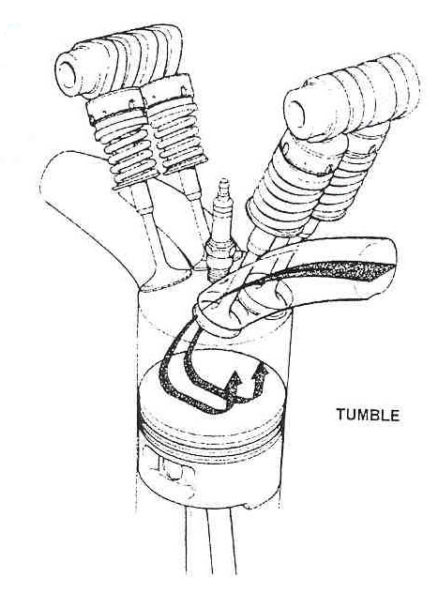
Figure 4.1. Tumble motion. Wilson et al (1993)

Swirl is a motion of rotation about the cylinder axis as seen in figure 4.2. It is promoted by an asymmetric intake port design, or better, by single inlet valve. It is also promoted by the port design. The drawback of the swirl generation is that it increases the flow losses reducing the volumetric efficiency. The swirl motion (Wilson et al ,1993) continues throughout the combustion period and aids the flame kernel development reducing the 0-10% mass fraction period or ignition delay. It also stabilize and improve the combustion. High swirl (Poulton, 1997) breaks down into beneficial turbulence caused by squish at the end of the compression stroke, helping to propagate the flame quickly and enhance combustion. Note that this is only true for those combustions chambers which produce squish. This beneficial effect to the combustion, allows to have lean burn combustion as seen in the AFR tolerance of Wilson et al (1993). This paper also shows that with swirl technique (one operating valve), there is an improvement in the peak cylinder pressure, increasing gross bmep, but it also increases the pumping looses, as can be seen in the following picture. As a result , by using just one inlet valve the bsfc is bigger than using two.
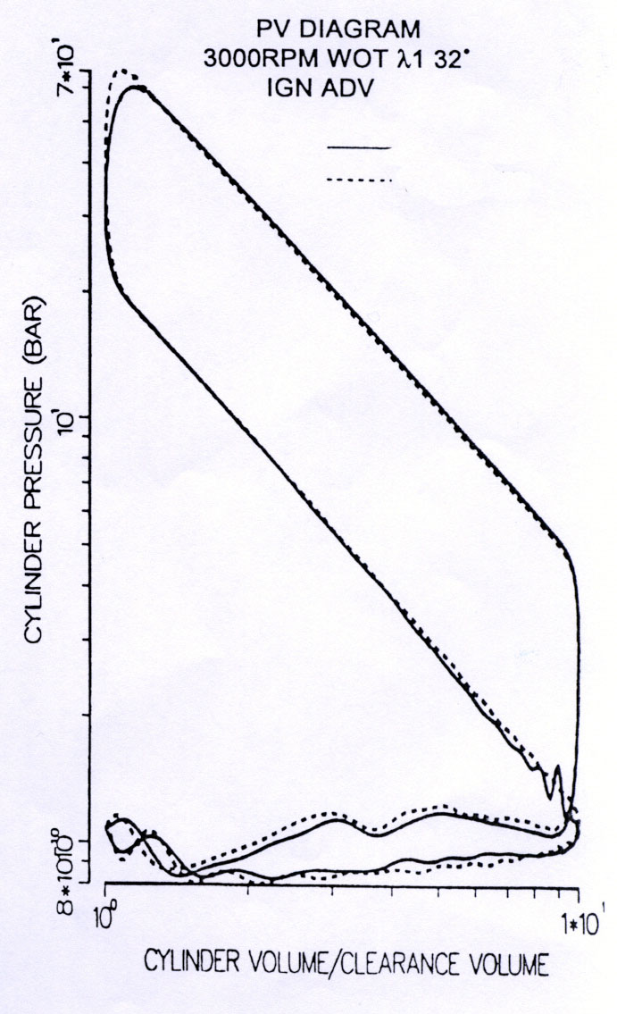
2 valves mode
4 valves mode
Figure 4.2. PV diagram comparison between 4 and 2 valves
Wilson et al (1993)
Also, it is possible to see the improvement in combustion of the swirl motion in the following chart from Soderberg and Johansson (1997).
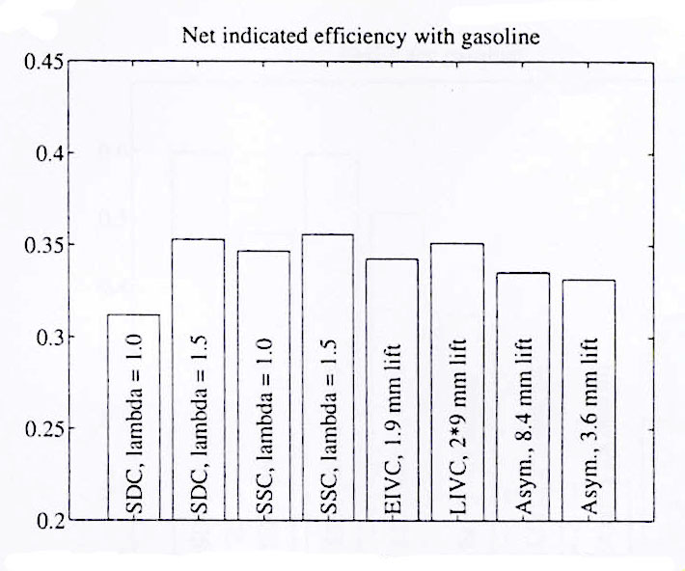
Figure 4.3. Net indicated efficiency for the different valve strategies of gasoline engines.Soderberg and Johansson (1997)
It can be seen that an improvement in indicated efficiency of the standard single cam (SSC) over the standard double cam (SDC). This will not always mean that the single cam will have better fuel economy, because the mechanical losses, where the pumping losses are, are not included.
Soltani and Veshagh (1998) report that a single valve operation mode has the same volumetric efficiency over the engine speed range of 1000 to 3000 rpm than dual intake port mode. However, they report that at higher speeds the volumetric efficiency of the single port mode may be adversely affected by the choking of the flow in the active port. This will offset the advantage of single intake port operation. They also report that the mean turbulence kinetic energy near the end of the compression stroke for the single intake port mode is more than twice as large as for the standard mode.

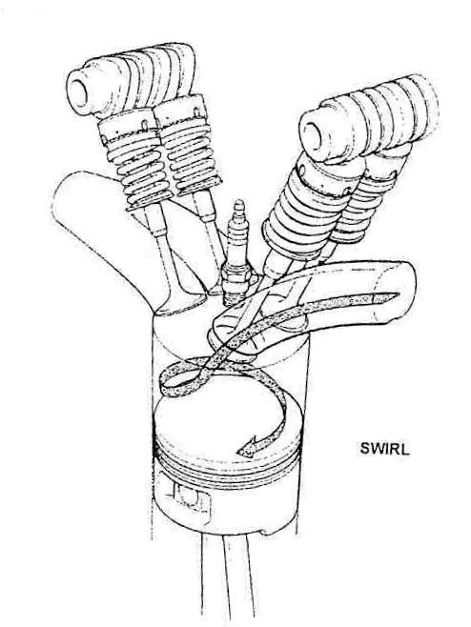
Figure4 4. Swirl motion. Wilson et al (1993)

Gasoline engines (Pearson,1995) with multiple inlet valves (mainly tumble motion) offer large effective flow area which is desirable at high engines speeds in order to produce maximum power but at low engine speeds, and in particular at low loads, gas velocities and hence turbulence levels are low and this limits the propagation speed of the flame and EGR tolerance. Also, as explained in Austin et al, the 4 valve engine produces higher bmep particulary at higher engine speeds and there is no significant deference in bsfc in the region of the map where most operations occurs during normal driving, but 4 valves are better as can be seen the following graph.
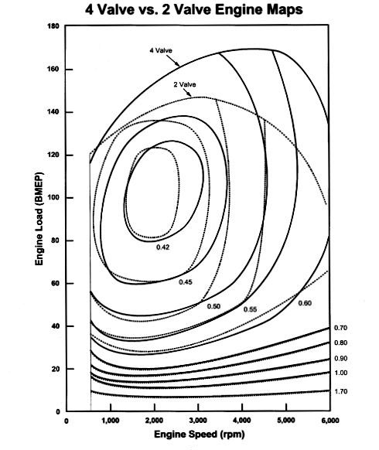
Figure 4.5. 4 Valve vs 2 valve Engine Map. Austin et al.

One inlet valve in gasoline engines became compulsory when a lean burn strategy is used because the swirl motion promoted by the unique inlet valve improves and stabilize the combustion. This technique is used in gasoline engines with regular port injection with a lean burn mode. Examples of this technology are: port deactivation engines and in Honda VTEC-E engines.
Although one valve promotes swirl motion and this produce a great improvement in the combustion it has as a drawback in the reduction of volumetric efficiency. As a result of both effects, a gasoline engine with 4 valves has better fuel consumption than a 2 valves one. Moreover, 4 valves engine can improve fuel consumption by having asymmetric valve opening as proved in Wilson et al and explained in Soderberg-Johansson (1997) or will allow variable valve timing and switching into one valve mode. Therefore for the engine simulations done for this thesis, 4 valves will be used.

4.1.2 Other valve considerations
The number and arrangement of valves with the cylinder head shape determines the position of the spark plug. This position determines the flame front travel distance that should be minimized. This distance is minimized with a 4 valves engine because it situates the spark plug in the centre of the cylinder.
In a two valves engine is better to have twin spark plugs (Heiser, 1995), because it reduces combustion duration and increases combustion stability, reducing cycle-to-cycle variations and improving lean and part load operation conditions.
There is also another important parameter which affects the engine characteristics: the port /valve configuration. It is explained in detail in Pearson et al (1995) and in Heisler (1995)

4.1.3 Valves size
The size of the valves is mainly, as discussed previously, determined by the bore size, the inclination of the chamber roof and the number of valves. Due to the advantages discussed before it was decided to consider a pent roof chamber with four valves. As the maximum valve size will depend in just on the geometry, it was used for the valves size the upper values of the following figure of a pent roof chamber given by Robertson (2000b).
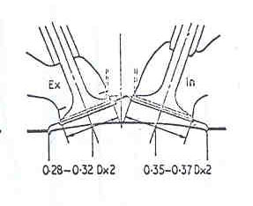

Figure 4.6. Valves sizes for a pent roof chamber with four valves.
Robertson b.(2000)

4.1.4 Valve profile
The most important parameters involving the valves are the valve opening time, the lift and the duration, that are going to be studied in section 5.5.1. It is also important to have a descriptor of the cam profile that will define the valve lift curve. This descriptor should be able to provide a valve lift curve with the desiderate parameters: valve opening time, valve lift and valve duration. For this purpose the author wrote in Visual Basic a program called “Valve lift program”, that is explained in appendix4.1.
This program is a useful tool to analyse the effects of valves in engines by providing a quick descriptor of the valve lift that can be immediately introduced in AVL Boost or in any other engine simulator program.

4.2 Flow coefficient
The flow coefficient is defined as the quotient between the effective area of a section (A_{e)} and the reference area of the section (A_{r)}.
$C_{d}=\frac{A_{e}}{A_{r}}$ (4.1)
Although it is not as important parameter as others, it is mentioned because it is an input to AVL Boost and because there are different definitions of it and it is necesary to explain a method to use any of the different definitions.
Harrison (2000) does a thermo-dynamic calculation and obtains the following expression, used by Boost (2000) (to calculate the pipes and valves flows.
$\overset{\text{.}}{m}=\frac{P_{\text{01}}⋅A_{e}}{a_{\text{01}}}{\left[\left(\frac{2⋅γ^{2}}{γ−1}\right)⋅{\left(\frac{p_{2}}{p_{\text{01}}}\right)}^{\frac{2}{γ}}⋅\left[1−{\left(\frac{p_{2}}{p_{\text{01}}}\right)}^{\frac{γ−1}{γ}}\right]\right]}^{\frac{1}{2}}$ (4.2)
where m is the mass flow rate, p₀₁ in the inlet case is the pressure in the cylinder in stagnation conditions (zero flow velocity) and p₂ is the pressure in the intake manifold and a₀₁ is the sound speed at conditions 01.
Note that the definition is the same if applied to a valve or to a restriction.
In the case of valves flow restrictions, there are three different reference area definitions:
- Curtain area. $A_{r}^{1}=π⋅L_{v}⋅D_{v}$ with L_{v} the valve lift and D_{v} the diameter of the valve. Most of the authors, such as Stone (1999), Heywood (1998), Annand and Roe (1974) use this definition, but has the inconvenience that it defines the flow coefficient as a function of a variable area.
- Valve area.$A_{r}^{2}=\frac{π⋅D_{v}^{2}}{4}$. This is the area adopted by Taylor (1985).
- Pipe area.. $A_{r}^{3}=\frac{π⋅D_{p}^{2}}{4}$This area is the used by Boost (2000).

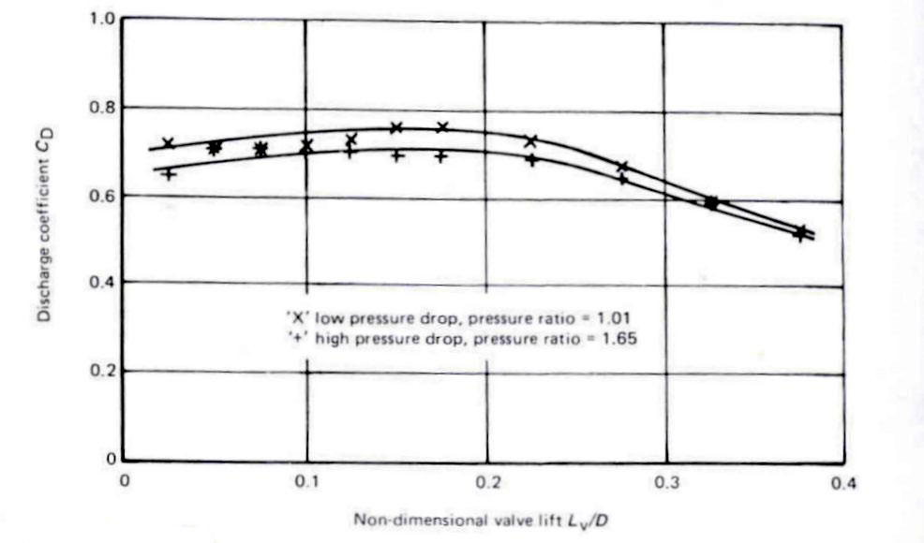
Figure 4.7. Curtain area flow coefficient. Stone (1999)

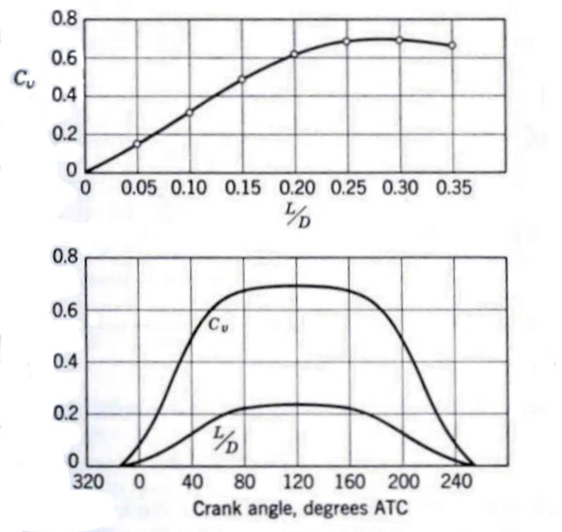
Figure 4.8. Valve area flow coefficient. Taylor (1985)

It is possible to change from each flow coefficient definition, just by equating in all of them the mass flow rate.
Therefore $C_{d}^{1}⋅A_{r}^{1}=C_{d}^{2}⋅A_{r}^{2}=C_{d}^{3}⋅A_{r}^{3}$. (4.3)
Despite AVL Boost using the flow coefficient based in the pipe area for the calculations, it uses as an input the valve flow coefficient. Then a scaling factor it is needed, which expression can be derived from the above relationship.
$\text{fsc}=n_{v}⋅\frac{D_{v}^{2}}{D_{p}^{2}}$ (4.4)
where fsc is the scaling factor, n_{v} number of valves, D_{v} valve diameter and D_{p} pipe diameter.
It is also possible to use in AVL Boost the curtain area flow coefficient by choosing the flow coefficient as a function of the non dimensional valve lift (L_{v}/D) and by multiplying all the curtain area flow coefficient numbers by $4⋅\left(\frac{L_{v}}{D}\right)$. (4.5)
Note that a good discussion of the effects of the valve design over the flow coefficient is done in Annand and Roe (1974)
The flow coefficient values used for the simulations performed during this thesis are those given by Taylor (1985) and shown in figure 4.8

4.3 Friction mean effective pressure (fmep)
One of the key points for improving fuel economy in passenger cars is the reduction of the friction mean effective pressure, as showed in section at the beginning of chapter 2. It is also a parameter that is needed as an input for the engine simulation in AVL Boost, therefore it must be estimated before starting with the simulation. Before explaining the fmep values, it is compulsory to give a brief overview of the fmep, in order to clarify future explanations and in order to show how can it be reduced, as a measure towards the 3 litre car.

4.3.1 Introduction to the fmep
Before moving into the fmep, please note that any mean effective pressure is defined as:
$\text{mep}=\frac{{\text{work}}_{{\text{per}}_{\text{cycle}}}}{V_{d}}=\frac{\text{Power}}{\text{Vd}⋅\frac{n}{2}}$ (4.6)
Where Vd is the swept volume and n the rps.
$η_{m}=\frac{\text{Brake} \text{Power}}{\text{Indicated}\text{ Power}}=\frac{\text{bmep}}{\text{imep}}=1−\frac{\text{fmep}}{\text{imep}}$ (4.7)
Where η_{m} is the mechanical efficiency.
These expressions show the relation between mep and power and mechanical efficiency and fmep. The friction mean effective pressure measures the mechanical losses produced in the engine. It could be defined as the difference of the break mean effective pressure (bmep) and the indicated mean effective pressure (imep).
It is very difficult to predict the fmep of any engine because there are many parameters which differ from one engine to another. To understand the fmep and to estimate it, first of all the elements which produce the fmep will be studied and later some different empirical equations to estimate it will be considered.
The fmep is the sum of three kinds of losses expressed as work per cycle and per unit swept volume: pumping, friction (rubbing) and accessories.

a) Pumping losses.
Losses produced by the work needed to scaverage and fill the piston with air. The work lost per cycle can be seen in the P-V diagram of an engine, as the area between the exhaust and the intake. It is the area marked in the following graph.

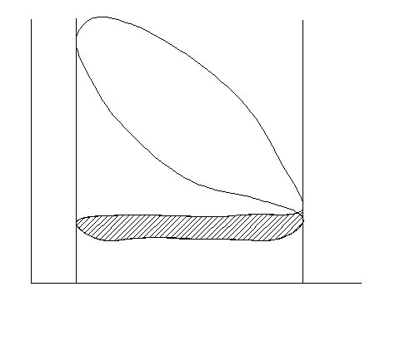
Pressure
volume
Pumping losses
Figure 4.9 Pumping losses

Factors which lead toward high air capacity also reduce pumping losses. Examples are increase valve opening areas and increase valve flow coefficients.
At wide open throttle the pumping loss is minimized. Ferguson (1986) estates that is generally true that (pmep)_{wot} << fmep

b) Friction (rubbing).
Losses produced by the friction produced in the moving parts of the engine. There are four different kinds of frictions: hydrodynamic, mixed, dry and rolling. The common friction mechanism in an engine is the hydrodynamic: pistons, rings and bearings suffer this lubrication most of the time, as shown in the following graph from Rosenberg (1982).
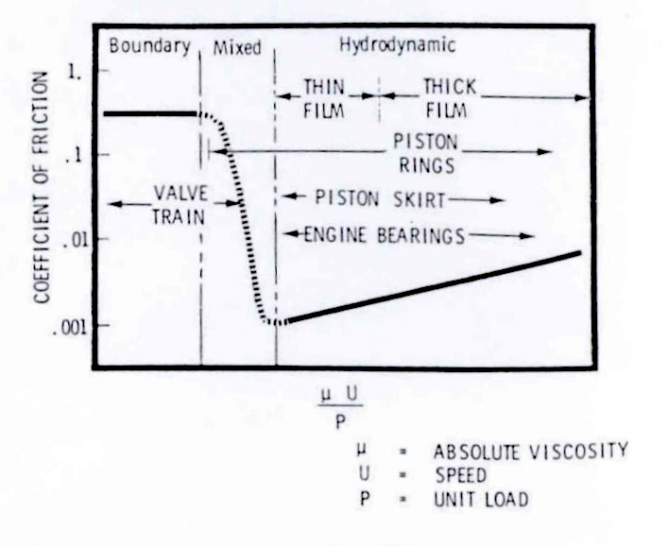
Figure 4.10. Operating lubrication regime for engine components
Rosenberg.(1982)

The hydrodynamic friction coefficient could be expressed as:
$f=f_{0}+f_{1}⋅{\left(\frac{μ⋅N}{p⋅L}\right)}^{n}$ (4.8)
Where f₀ and f₁ are constant which depends on the bearing geometry ,n is a constant which depend on the kind of bearing or in the geometry, μ is the viscosity of the lubricant., P is the pressure and L a characteristic dimension of the bearing
As the load in the bearings, piston and rings is the sum of the weight of the elements, inertia forces and forces due to gases pressure, Muñoz and Payri(1989) obtains the expression, expressed in terms of the mentioned elements.
$\text{Pmep }=\text{ 4}⋅\left(\sum{C_{w}⋅\text{ L }+{\text{ C}}_{i}⋅{\text{ C}}_{{}_{m}}^{2}+C_{g}\text{ imep}}\right)⋅f$ (4.9)
Where C_{w}, C_{i} , and C_{g} are constant which depend in the characteristics of the engine, L a characteristic length and Cm mean piston velocity
From the two above expressions is possible to give possible solutions to reduce the friction loses:
- Reduce velocity of the engine. The engine velocity affects directly the Cm by the relationship: $\text{Cm}=\text{ 2}⋅s⋅n$. Where s is the stroke and n the engine speed (rev/s).
- Viscosity of the lubricant. This affects f directly. Poulton (1997) explains that Renault has demonstrate that it could be reduce the fmep by 10% by using a lower viscosity oil such as 10W30 in stead 15W30, producing a three percent fuel saving during the European urban cycle. Also it is important to have a fast engine oil warm up to have quickly low viscosity of the lubricant. This could be achieved by circulating less volume of lubricant during warm up and then the remainder being introduced as the engine temperature rises.
Both effects can be seen in the following graph given by Poulton (1997).
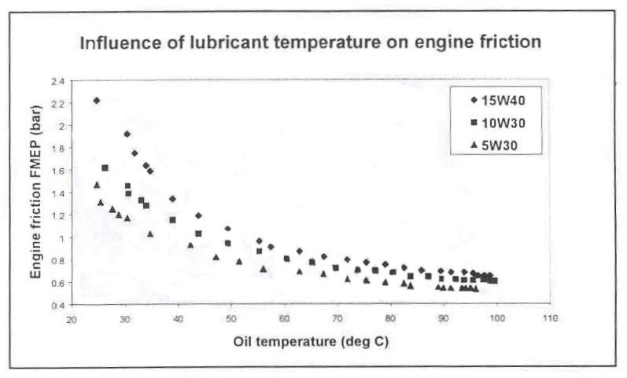
Figure 4.11 Influence of oil temperature and viscosity on engine friction
Poulton (1997).

- Smaller engine and less weight of the movement parts. This would affect Cw and L.
- Others:
- Bigger clearances between the piston and the cylinder.
- Pistons with small skirt.
- Few rings and with small radial pressures
- Big clearances in the bearings.
Note that this last solutions will reduce friction, but will produce other problems such as more oil consumption and more mechanical noises.

c) Accessories.
Work per cycle to drive engine accessories per unit swept volume.
This work varies a lot between one engine and another. When not any data is available Lee et al (1999) and Muñoz et al (1989) suggest to use Bishop (1964) expression:
$\text{pma}=\text{ 2}\text{.}\text{689}⋅{\left(\frac{n}{\text{1000}}\right)}^{1\text{.}5}$ (4.10)
where n is in rpm and pma in kPa.

4.3.2 Observations
Please note that all the imep that the author always refer is gross imep. It is the work delivered to the piston over the compression and expansion strokes only and therefore the pumping losses has not been already subtracted..
Also note that Boost defines imep as: $\text{imep}=\frac{\int_{\text{cycle}}{P⋅\text{dV}}}{V_{D}}$ and therefore it is net imep because it is the work delivered to the piston over the entire four stroke cycle. As Boost (2000) defines fmep = bmep-imep, they are defining as fmep just the contribution of the rubbing friction and the auxiliaries and they are not taking into account the pumping losses. Pumping loses are calculated separately by the main program.
Please note that it is going to be referred as fmep the fmep which includes pumping loses, rubbing friction and auxiliaries, while it is going to be named as Boost fmep the one used by Boost and which includes just rubbing friction and auxiliaries. Please also note that Heywood (1998), Bishop (1964), Ferguson (2001) and most authors call fmep the same as in this thesis, the one that includes pumping losses. The advantage of the Boost definition of fmep is that as it has not included pumping losses, the same correlation will be able for use at part loads.
Therefore the fmep needed as an input to Boost program must be the fmep obtained in any of the correlations discussed between this chapter and appendix 4.2 (total friction mean effective pressure) minus the pumping losses.
The pumping losses are given by Boost program as imep gas exchange. Hence, it is needed to guess the pumping losses (or use one correlation for pumping losses), subtract them from any of the fmep following expressions, simulate in Boost program and then compare the obtained pumping losses with the guessed and iterate.

4.3.3 Quantification of friction and accessories losses.
The different contributions to the fmep and ways of improvement have been mentioned, but no quantifications have been given. In Rosenber (1982), in Bishop (1964) and in Heywood (1988) is possible to find a breakdown of rubbing and accessory friction mean effective pressure, as seen in the following graph from Heywood (1988).
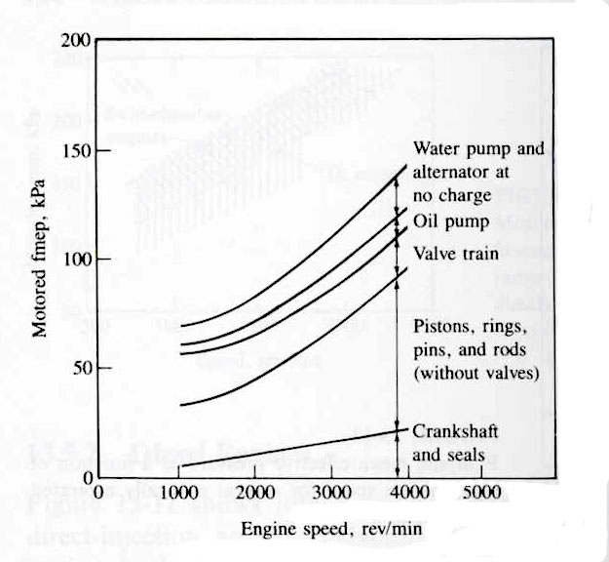
Figure 4.12. Rubbing and accessory mep vs. engine speed.
Heywood (1988).

As a result of this data, Heywood suggest a rubbing and accessory friction break down as follows: piston assembly 50%, valve train 25%, crankshaft bearings 10 % and accessories 15%. Please note that this would be the full break down of the fmep introduced to AVL Boost.

a) Heywood equation
Heywood (1988) obtained the following correlation for SI engines between 845 and 2000cm³ at wide open throttle as a function of the speed. . It usefulness will be discuss in part c of this section.
$\text{tfmep}(\text{bar})=\text{ 0}\text{.}\text{97}+0\text{.}\text{15}⋅\left(\frac{N}{\text{1000}}\right)+0\text{.}\text{05}⋅{\left(\frac{N}{\text{1000}}\right)}^{2}$ (4.11)
This is the only empirical equation that it is possible to use with the information of the engine available and therefore the only correlation explained in this chapter. More complex models are discussed in appendix 4.2.
Please note that this study about fmep models was done because friction is one of the most important energy looses in the car as shown in figures 1.1 and 2.2 and because it will be useful as a reference for future engine simulation works.

b) Bishop. Further models.
The more complex the model and the more parameters it has, hopefully the better descriptor of the fmep phenomena it will be. For this thesis these models are useless because they require a great amount of data from the engine, that will be obtained in later steps of the engine design. But it is important to highlight the importance at early stages of the engine design, in order to improve the engine performance and fuel economy.
In addition to the simple models explained in this chapter and appendix 4.2, more complex models with equations for each of the elements of the fmep break down are available in Heywood (1998), Bishop (1964) or in Lee et al (1999).
For example Bishop (1964) divides the fmep into five components: crankcase mechanical friction, compression-expansion pumping loop losses, exhaust and inlet system throttling losses, combustion chamber and valve pumping loop losses and piston mechanical friction. He also divide some of them and study them separately, giving a expression for each of the elements he studies.
The importance of Bishop’s paper (1964) to this thesis is that he does a deep analysis of many design and operating engine variables on friction and economy. Some of his conclusions are:
- Moderate amounts of inlet system pressure loss have a pronounced effect on high speed power and full – throttle specific fuel economy.
- At high speeds, motoring friction decreases as the engine is throttled because of the predominance of mechanical piston friction relative to pumping friction. At the lowest speeds the converse is true.
- There is some speed at which the best compromise between heat losses and frictional losses exists and the specific fuel consumption is optimised.
- The friction and economy are improved with less number of larger cylinders.
- Although the friction increases with compression ratio, mechanical efficiency either stays constant or improves at higher ratios.
- Increasing engine displacement has an adverse effect on economy.
- The effect of valve size is quite small at the lowest speeds but are appreciable a the highest speeds.
- Bore/stroke ratio it has very small effect on fuel economy, in contrast with what it was thought before the author published the paper. Moreover, it has more effect with high speed engines than with low speed ones.

c) Friction used
At the depth of this thesis, it is not possible to use refined models and therefore the only available formula to estimate the friction is Heywood’s (1988). But even to apply this formula, it is necessary to subtract the pumping loses, therefore it is needed to do a first simulation to obtain an idea of pumping values. For the first simulation the friction used in the Boost Demo ottoserie was used. In order to compare the value obtained with Heywood’s (1988), the pumping loses are added to Boost fmep, obtaining the following graph.
The values used in the Boost Demo file are from an Opel Astra 2 litres as said in exercise 6 of the web page of Chalmers university, Sweden, in the address http://www.tfd.chalmers.se/~ronny/apm/apm_design_task.html.

Eq (4.11)
Figure 4.13. Fmep comparison

It can be observed that Heywood (1988) gives bigger values, the reason for this is that he used American car data, that are more inefficient cars than European cars and because it is based in quite old cars (before 1988).
As the values given in Boost are from a market car and give lower values, it was decided to use the Boost fmep values.
Note that the values of fmep of a small engine of about 0.7 litres swept volume will be even smaller that the Opel’s values due to the reasons mentioned in 4.3.1 and in 2.9.2, but the author has not any tool at the depth of this thesis to estimate the effect of smaller engine.

