CHAPTER 3. Assumptions and initial calculations

This chapter contains the necessary calculations and assumptions for calculating the minimum required break mean effective pressure (bmep) and torque from the engine that is going to be modelled when performing the European emissions and fuel consumption test: EC Type I test, defined in the EEC Directive 70/220/EEC.
In this chapter the bmep and torque are just calculated in the points of the cycle where there is increased velocity, increased acceleration or a combination of both, because this points require, for a fixed gear, the maximum bmep or torque. In chapter 6 a computer program written by the author that calculates them each second of the cycle will be described.
For the calculation performed for this chapter and for chapter 6, it is necessary to make some assumptions about the car where the engine that is going to be modelled in the thesis would be mounted in, such as: inertia of the car, drag coefficient or gear ratios.

3.1 Mass and drag coefficient of the car

3.1.1 Mass

Is necessary to choose a mass as low as possible but remaining realistic. Here it can be seen a table of the weight and length of some cars of the current market.
 | Weight (Kg) | Length (m)
F.Ka concept | 610
R.Smile | 650 | 3480
F Panda 0.9ie | 715 | 3410
S.Marbela 0.9 | 720 | 3475
Smart | 720 | 2500
Su.Alto 1.0 | 730 | 3490
O.G90 | 750
K Pride 1.3 | 795 | 3560
V.Lupo | 800 | 3520
P.106 1.0 | 815 | 3680
H. Insight | 835 | 3945
N. Micra 1.0 | 835 | 3720
R.Twingo | 845 | 3480
F.Ka 1.3i | 870 | 3620
O.Corsa 1.0 | 940 | 3740

Table 3.1 Weights of cars. Autocatálogo 2001.

Figure 3.1 Weight of cars. Autocatálogo 2001

A mass of 800 Kg will be assumed, which is quite small but it would allow any security devises such as airbags or ABS and it will not be too costly.
As can be seen from the table is not very unrealistic to consider a car with 800 Kg and perhaps a total length around 3.7 m.

3.1.2 Drag coefficient
In the following table and graph are compiled some drag coefficients, from internet sources.

 | Cd
O. G90 | 0.22
H Insight | 0.25
Lexus LS430 | 0.25
R Smile | 0.25
Lupo 1.2 Tdi | 0.29
O.Calibra | 0.29
T.Echo | 0.29
S. Octabia | 0.3
T Celica | 0.31
R.Twingo | 0.35

Table 3.2 and figure 3.2. Drag coefficients
http://www.motorshow.or.jp/show99/English/CONCEPT/opl01.html
http://www.honda.co.uk/news/technicalinfo.html
http://www.volkswagen.vw-audi.es/lupo3L/index_m.htm

A drag coefficient of 0.25 will be assumed as far as the Honda Insight or the Renault/Greenpeace Smile. Also a frontal area of 1.9 m² will be assumed, which is what the Smile has. This frontal area could be a little small for a length of around 3.7 m. This fact will derive into a car with small frontal area, but large length, similar to a small van, like the Dahaitsu move wagon, but less tall.
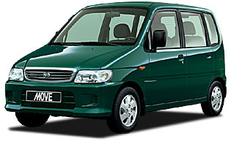

Figure 3.3 Dahaitsu move wagon.
(from http://www.ingway.co.jp/~daihatsu/catalogue/move/index.html)

3.2 Formulae and other assumptions

For calculating the brake mean effective pressure the following relationships are going to be used:
P_{require} = (F_{Drag resistance} + F_{rolling resistance} + F _{acceleraion resistance} + F_{climbing resistance) *} V (3.1)
$F_{\text{Drag resistance}}=\frac{1}{2}C_{D}ρ⋅A⋅V^{2}$ (3.2)
C_{D} is the drag coefficient, ρ is the air density, A is the vehicle frontal area and V is the vehicle velocity.
For the rolling resistance there are several empirical relationships. The most important factors that affect the rolling resistance are the kind of tire, the inflation pressure and the velocity. In Aparicio ( 1995) and in Bosch (1996) is possible to find a relationship similar to:

$F_{\text{rolling resistance }}=\text{Mg}\left(f_{0}+f_{r}⋅V^{n}\right)$ (3.3)
Where M is the mass of the car, g the gravity
fo , fr and n depends on the kind of tyre, on the road surface and on the inflation pressure.
As fr do not affect to the final resistance too much, and this is a first approach to the problem, it is going to be considered null.
The value for fo is it going to be fo = 0.013, as can be seen in both references that is a common value.
${\text{F }}_{\text{acceleraion resistance}}=(M+\text{me})⋅\frac{\text{dV}}{\text{dt}}=γ⋅M⋅\frac{\text{dV}}{\text{dt}}$ (3.4)
Where me takes into account the inertia of the rotating parts. It is most commonly expressed the effect of the rotating masses with the rotating mass factor ($γ$), as shown in (3.4).
Aparicio ( 1995 ) shows the next expression for $γ$:
$γ=1\text{.}\text{04}+0\text{.}\text{0025}⋅G^{2}$ (3.5)
Where G is the gear ratio.
For the climbing resistance, the following formula would be used
$F_{\text{climbing resistance}}=\text{Mg}\text{sin}α$ (3.6)
Where $α$ is the angle of the incline.
As the ECE 15 is performed in a flat road, F_{climbing resistance} = 0
Formula (3.1) shows the power required by the car. The power required from the engine is given in (3.7) by doing (3.1) over the gear chain efficiency η and adding to (3.1), (3.2) to (3.6).
$P_{\text{engine}}=\left\{\frac{1}{2}C_{D}ρ⋅A⋅V^{2}+\text{Mg}\left(f_{0}+f_{r}⋅V^{n}\right)+γ⋅M⋅\frac{\text{dV}}{\text{dt}}\right\}⋅\frac{V}{η}$ (3.7)
The relationship between power and pressure is:
$\text{pressure}=\frac{P_{\text{engine}}}{V_{H}\frac{n_{e}}{2}}$ (3.8)
Where V_{H} is the sweep volume and n_{e} is the engine velocity that can be obtained from:
$n_{e}=G⋅\frac{V}{2π⋅r}$ (3.9)
Where r is the rolling wheel radius.
The density of air ρ at sea level, 1 atm and 288º K is 1.225 Kg/m³ (Aparicio 1995)
For the gear chain efficiency η it is going to be considered η= 0.95. as suggested in Bosch (1996).
The next step is to estimate the radius of the wheel. Before choosing it, it is necessary to point that a tire specification is usually presented in this form: b/s R d (Aparicio,1995). Where b is the width and s is the shape value, R means radial ply and d is the wheel diameter in inches.
Hence:
$s=\frac{h}{b}⋅\text{100}$ (3.10)
Total diameter = d + 2h (3.11)
Some examples of tyres cars with good economy are (autocatálogo 2001): Smile tyres: 145/60 R14 (Total radius = 265 mm), Honda Inshight tire: 165/65 R14 (Total radius = 285.25mm), Opel Agila and Astra: 155/65 R14 (Total radius = 278.75mm), Hyundai Atos: 155/70 R13 (Total radius = 273.5 mm).
It is going to be used the tires of the Opel (155/65 R14) because it gives an intermediate radius and are more common.
Other important parameters for calculating the bmep and torque are the gears ratios. These gear ratios should be obtained from a gasoline vehicle and with similar swept engine volume to the supposed vehicle, in order to obtain an adequate configuration. In section 3.7 could be found a sensitivity analysis of the bmep with mass, gear ratios and drag coefficient.
As mentioned before, to make calculations about the bmep and torque required to pass the ECE cycle, it is needed to define a vehicle. As the defined vehicle for a starting point is 800 kg and 1000cm³, the gear ratios used are from the Hyundai Atos (999 cm³ and 818 Kg), from Autopista 26 (December 2001).
Note that the gear ratios are very important for fuel economy and must be designed by for a specific engine, as discussed in chapter 2. As it is impossible for the author to design an engine and also the gear ratios due to the time available, the gear ratios are going to be fixed to the ones of Hyundai Atos, which characteristics can be seen below.
Please note that this is an important parameter and should be studied in future work.

Gear number | Gear ratio | Total gear ratios | $γ$$γ$
1 | 3.54 | 16.04 | 1.68
2 | 1.95 | 8.83 | 1.24
3 | 1.31 | 5.93 | 1.13
4 | 0.92 | 4.17 | 1.08
5 | 0.78 | 3.53 | 1.07
Final | 4.53

Table 3.3 Gears ratios
Autopista. 26 December 2001

3.3 Summary of car parameters assumed
In the following table are collected a summary of the main car parameters that have been assumed and are going to be maintained during the whole thesis.

Main car parameters assumed
Mass | 800 Kg | (3.1.1)
Drag coefficient | 0.25 | (3.1.2)
Frontal area | 1.9 m2 | (3.1.2)
Gear ratios | Hyundai Atos | (3.2)
Tires | 155/65 R14 | (3.2)
Gears efficiency | 0.95 | (3.2)

Table 3.4 Main car parameters assumed

3.4 Bmep calculation
In this section is going to be calculated the bmep required from a 1000 cc car with the car data assumed over this chapter and mainly compiled in the previous table. This, in order to validate the assumed data.

The EC Type I test has two parts: urban test called ECE 15 and extra urban test called EUDC. The numeric definition of both cycles is contained in EEC Directive 70/220/EEC and if the reader is member of Dieselnet he/she can find it in: http://www.dieselnet.com/standards/cycles/ece_eudc.html

3.4.1 ECE 15
In this chapter for the calculation of the torque and bmep required to perform the ECE 15 are going to be used the gears shown in the following graph from Robertson (2000). In this graph is also presented the numeration of the point where the calculations were made. Note that at points where the car passes from accelerating to constant speed the condition taken is the acceleration one.

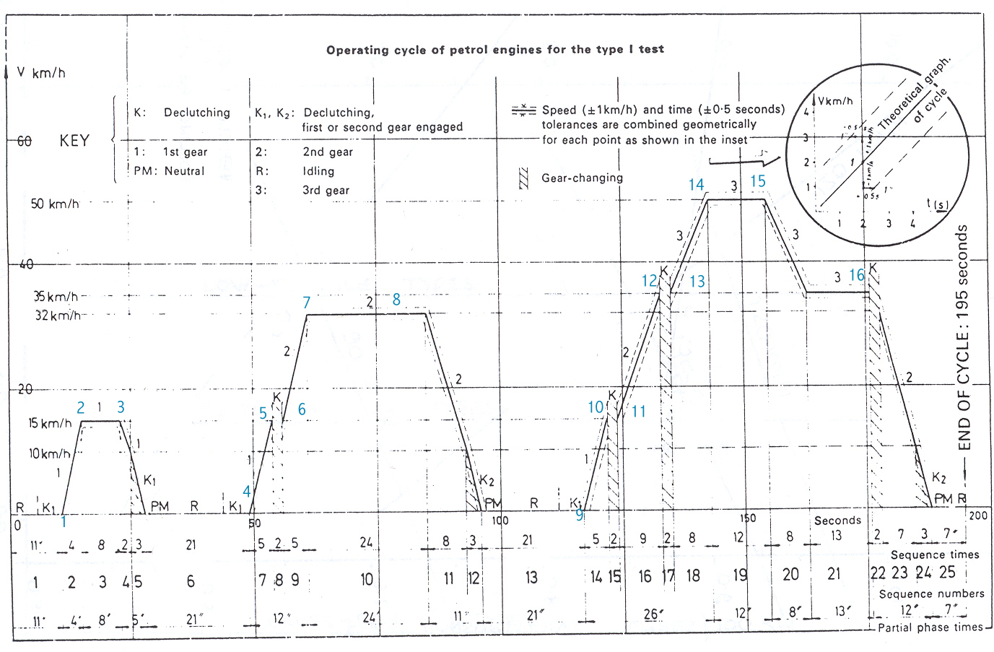

Figure 3.4 ECE 15 cycle
Robertson 2000

The results of the calculations are summarized in the following table.

Points | Velocity (Km/h) | Acceler  (m/s²) | Gear | Drag Force (N) | Rolling R (N) | F acceler  (N) | Total Force  (N) | Power  (W) | Ne  (rev/min) | bmep  (bar)
1 | 0 | 1.04 | 1 | 0.00 | 102.02 | 1402.53 | 1504.55 | 0.00 | 0.00 | !
2 | 15 | 1.04 | 1 | 5.05 | 102.02 | 1402.53 | 1509.60 | 6621.07 | 2290.17 | 3.47
3 | 15 | 0.00 | 1 | 5.05 | 102.02 | 0.00 | 107.07 | 469.63 | 2290.17 | 0.25
4 | 0 | 0.83 | 1 | 0.00 | 102.02 | 1122.02 | 1224.05 | 0.00 | 0.00 | !
5 | 15 | 0.83 | 1 | 5.05 | 102.02 | 1122.02 | 1229.10 | 5390.78 | 2290.17 | 2.82
6 | 15 | 0.94 | 2 | 5.05 | 102.02 | 933.13 | 1040.20 | 4562.28 | 1261.53 | 4.34
7 | 32 | 0.94 | 2 | 22.99 | 102.02 | 933.13 | 1058.14 | 9900.70 | 2691.27 | 4.41
8 | 32 | 0.00 | 2 | 22.99 | 102.02 | 0.00 | 125.01 | 1169.70 | 2691.27 | 0.52
9 | 0 | 0.83 | 1 | 0.00 | 102.02 | 1122.02 | 1224.05 | 0.00 | 0.00 | !
10 | 15 | 0.83 | 1 | 5.05 | 102.02 | 1122.02 | 1229.10 | 5390.78 | 2290.17 | 2.82
11 | 0 | 0.62 | 2 | 0.00 | 102.02 | 609.96 | 711.99 | 0.00 | 0.00 | !
12 | 35 | 0.62 | 2 | 27.50 | 102.02 | 609.96 | 739.49 | 7567.85 | 2943.57 | 3.09
13 | 35 | 0.52 | 3 | 27.50 | 102.02 | 470.05 | 599.58 | 6136.03 | 1977.48 | 3.72
14 | 50 | 0.52 | 3 | 56.12 | 102.02 | 470.05 | 628.20 | 9184.22 | 2824.97 | 3.90
15 | 50 | 0.00 | 3 | 56.12 | 102.02 | 0.00 | 158.15 | 2312.08 | 2824.97 | 0.98
16 | 35 | 0.00 | 3 | 27.50 | 102.02 | 0.00 | 129.52 | 1325.54 | 1977.48 | 0.80

Table 3.5 Bmep calculation in the ECE 15 cycle

3.4.2 EUDC
The following graph presents the EUDC cycle with the points were the calculations were made.
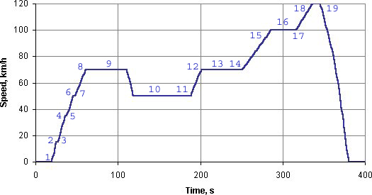

Figure 3.5 EUDC cycle
http://www.dieselnet.com/standards /cycles/ece_eudc.html

The results of the bmep are summarized in the following table.

Points | Velocity (Km/h) | Acceler (m/s²) | Gear | Drag Force (N) | Rolling R (N) | F acceler (N) | Total Force (N) | Power (W) | ne (rev/min) | bmep (bar)
1 | 0 | 0.83 | 1 | 0.00 | 102.02 | 1121.93 | 1223.96 | 0.00 | 0.00
2 | 15 | 0.83 | 1 | 5.05 | 102.02 | 1121.93 | 1229.01 | 5390.39 | 2290.17 | 2.82
3 | 15 | 0.62 | 2 | 5.05 | 102.02 | 609.91 | 716.99 | 3144.69 | 1261.53 | 2.99
4 | 35 | 0.62 | 2 | 27.50 | 102.02 | 609.91 | 739.44 | 7567.35 | 2943.57 | 3.08
5 | 35 | 0.52 | 3 | 27.50 | 102.02 | 470.02 | 599.54 | 6135.65 | 1977.48 | 3.72
6 | 50 | 0.52 | 3 | 56.12 | 102.02 | 470.02 | 628.16 | 9183.67 | 2824.97 | 3.90
7 | 50 | 0.43 | 4 | 56.12 | 102.02 | 370.40 | 528.55 | 7727.29 | 1983.95 | 4.67
8 | 70 | 0.43 | 4 | 110.00 | 102.02 | 370.40 | 582.42 | 11920.96 | 2777.53 | 5.15
9 | 70 | 0.00 | 4 | 110.00 | 102.02 | 0.00 | 212.02 | 4339.66 | 2777.53 | 1.87
10 | 50 | 0.00 | 4 | 56.12 | 102.02 | 0.00 | 158.15 | 2312.08 | 1983.95 | 1.40
11 | 50 | 0.43 | 4 | 56.12 | 102.02 | 370.40 | 528.55 | 7727.29 | 1983.95 | 4.67
12 | 70 | 0.43 | 4 | 110.00 | 102.02 | 370.40 | 582.42 | 11920.96 | 2777.53 | 5.15
13 | 70 | 0.00 | 4 | 110.00 | 102.02 | 0.00 | 212.02 | 4339.66 | 2777.53 | 1.87
14 | 70 | 0.25 | 4 | 110.00 | 102.02 | 218.87 | 430.90 | 8819.52 | 2777.53 | 3.81
15 | 100 | 0.25 | 4 | 224.49 | 102.02 | 218.87 | 545.39 | 15946.96 | 3967.90 | 4.82
16 | 100 | 0.00 | 4 | 224.49 | 102.02 | 0.00 | 326.51 | 9547.16 | 3967.90 | 2.89
17 | 100 | 0.28 | 4 | 224.49 | 102.02 | 240.76 | 567.27 | 16586.94 | 3967.90 | 5.02
18 | 120 | 0.28 | 4 | 323.26 | 102.02 | 240.76 | 666.05 | 23370.12 | 4761.47 | 5.89
19 | 120 | 0.00 | 4 | 323.26 | 102.02 | 0.00 | 425.29 | 14922.38 | 4761.47 | 3.76

Table 3.6 Bmep calculation in the EUDC cycle

In the following graph are compiled both tables to show clearly the bmep required to pass the European test cycle:

Figure 3.6 Bmep required to perform the EC Type I test.

As there have been many assumptions, is necessary to validate the results obtained. It can be seen that the calculations are realistic by comparing the calculated graph with the one obtained via testing by Shillington (1998) and observing that the values are very similar.

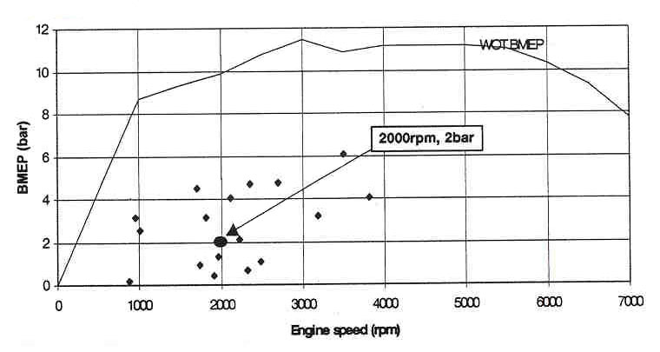

Figure 3.7 European urban driving cycle, speed and load conditions
Shillington (1998)

The strategy for this thesis is design a small engine, with just enough torque to drive the European test cycle. As this engine will have lower swept volume, the bmep required to perform the European test cycle will be higher and therefore it will have good fuel consumption because it will perform the ECE cycle near WOT, near the optimum point of bsfc.
Please note that the bmep required will change mainly with the variation of the gear ratios, rolling radius, weight of the car and the drag coefficient as will be seen in section 3.7.

3.5 Minimum torque required to perform the ECE test cycle

It is not possible to use a bmep approach to find out the minimum engine size able to perform the European test cycle because in the definition of the bmep the swept volume is included and therefore each time it is done a change in the swept volume the above tables should be recalculated. On the other hand, the torque will not change with the swept volume, it will just change with the gear ratios. As the gear ratios are going to be maintained fixed, the maximum torque obtained in the following calculations must be possible to achieve it with the designed engine.
The new formulae used are the following ones.
The total resistance force F is
$F=\left\{\frac{1}{2}C_{D}ρ⋅A⋅V^{2}+\text{Mg}\left(f_{0}+f_{r}⋅V^{n}\right)+γ⋅M⋅\frac{\text{dV}}{\text{dt}}\right\}$ (3.12)
While the torque required at wheels is
$T_{w}=F⋅r$ (3.13)
By definition of gear efficiency, the gear efficiency ηis
$η=\frac{T_{w}⋅w_{w}}{T_{e}⋅w_{e}}$ (3.14)
where T_{w} torque at wheels, w_{w} the angular speed at wheels, T_{e} torque at the engine and w_{e} angular speed at the engine
With this formulae is derived the following formula for the torque at the engine:
$T_{e}=\frac{F⋅r}{η⋅G}$ (3.15)
where G is the gear ratio.
The following table is obtained by using the data assumed all over this chapter, in the points were the bmep calculation were made and with the formulae from (3.12) to (3.15).
EUDC |  |  | ECE 15
Points | ne (rev/min) | Torque (Nm) | Points | ne (rev/min) | Torque (Nm)
1 | 0 | 22.4 | 1 | 0 | 27.5
2 | 2290 | 22.5 | 2 | 2290 | 27.6
3 | 1262 | 23.8 | 3 | 2290 | 2.0
4 | 2944 | 24.6 | 4 | 0 | 22.4
5 | 1977 | 29.6 | 5 | 2290 | 22.5
6 | 2825 | 31.1 | 6 | 1262 | 34.6
7 | 1984 | 37.2 | 7 | 2691 | 35.1
8 | 2778 | 41.0 | 8 | 2691 | 4.2
9 | 2778 | 14.9 | 9 | 0 | 22.4
10 | 1984 | 11.1 | 10 | 2290 | 22.5
11 | 1984 | 37.2 | 11 | 0 | 23.6
12 | 2778 | 41.0 | 12 | 2944 | 24.6
13 | 2778 | 14.9 | 13 | 1977 | 29.6
14 | 2778 | 30.3 | 14 | 2825 | 31.1
15 | 3968 | 38.4 | 15 | 2825 | 7.8
16 | 3968 | 23.0 | 16 | 1977 | 6.4
17 | 3968 | 39.9
18 | 4761 | 46.9
19 | 4761 | 29.9

Table 3.7. Torque required to perform the European test cycle.

From the above table, the target of this thesis will be obtain a small engine that gives at least 47 N m at 4750 rpm.
Please note that although this is the maximum it should be checked that the engine produces enough torque at all the specified speeds.

3.6 Theoretical calculation of the minimum engine size required
In this section some theoretical formulae will be used with some empirical efficiency data, to obtain an idea of the minimum engine size required to perform the ECE cycle.
Using Bosch handbook (1996) notation, the overall efficiency η_{e} is related with the mechanical efficiency η_{m} and the indicated efficiency η_{i} by the following expression
$η_{e}=η_{m}⋅η_{i}$. (3.16)

From Harrison (2000), it can be seen that the indicated efficiency (which he calls fuel efficiency) is around 35-40%. He also writes, as Heywood (1988), that a typical value for the mechanical efficiency at WOT is 90%.
Taking this values in (2.16) $η_{e}=0\text{.}4⋅0\text{.}9=0\text{.}\text{36}$
By definition $η_{e}=\frac{P_{e}}{{\overset{\text{.}}{m}}_{f}⋅H_{c}}$ (3.17)
where P_{e} is the effective Power required, m_{f} the fuel mass flow rate and H_{c} specific calorific value of the fuel. For gasoline engines, typical value s are between 42- 44 MJ/Kg.

Taking the Power of the point which requires most power and torque (23370 J/s at 4761 rpm), the following fuel mass flow rate is obtained.
$${\overset{\text{.}}{m}}_{f}=\frac{\text{23370}}{0\text{.}\text{36}⋅\text{44}⋅{\text{10}}^{6}}=0\text{.}\text{001475}{\text{kg}}/s$$
Supposing stoichiometric mixture, the air mass flow rate would be 0.02154 kg/s.
By rearranging the definition of volumetric efficiency the following formula is obtained.
$V_{T}=\frac{{\overset{\text{.}}{m}}_{a}}{η_{v}ρ⋅\frac{n}{2}}$ (3.18)
Substituting with density of air 1.225 , volumetric efficiency 0.9 and at 4761 rpm, all in proper units, it is obtained a minimum swept volume required of 0.49 litres.
This value will allow a check of the order of magnitude of the computational results and to show the differences between a very simple calculation and a computational calculation. Note that many of the values taken are quite big and therefore this will lead into a quite small swept volume. This means that this value would be a low limit for the swept volume that will be obtained by simulating in AVL Boost.

3.7 Sensitivity analysis of the bmep versus weight, drag coefficient and gear ratio

In this chapter many assumptions have been made about the car in which the engine designed in this thesis would fit. In order to show the influence of some parametersa sensitivity analysis will be performed.
For the mass and the drag coefficient sensitivity analysis will be used points 7 and 14 from the ECE 15 and points 8 and 18 from the EUDC, because are the ones with higher bmep and with different characteristics.
These analysis could have been done in torque or in bmep, but it was preferred to do it in bmep, because the reader could check the values obtained with those presented in figure 2.7 from Shillington (1998).

3.7.1 Mass

Figure 3.8 Effect of the mass in the bmep
As expected, increasing the mass, the bmep required increases. The mass has bigger influence in the urban cycle (blue line) because in this cycle all the mass has to be accelerated many times. But also is important to highlight that it also makes an important contribution in the EUDC due to the term of the rolling resistant and by the acceleration produced also in this cycle.

3.7.2 Drag coefficient

Figure 3.9 Effect of the drag coefficient in the bmep

As expected, the drag coefficient does not affect in the urban cycle because it is defined by low speeds operations and therefore low aerodynamic drag forces as they depend on the square of the velocity as seen in formula (3.2).

3.7.3 Gear ratios

For this purpose are analysed the gears of the Hyundai Atos of 1litre, the Opel Agila of 1litre and Ford Ka of 1.3litre.The data of the gear ratios was obtained from Autopista number 2163 (2001) and Deacon et al.
It is included also the same gear ratio of the Ka as it would have 1litre.

Figure 3.10. Influence of the gear ratio to the bmep.

It is possible to see that both the sweep volume and the gear ratios will affect the final bmep required from the engine and therefore fuel consumption.
Some modification in gear ratios for improving fuel consumption can be found in Deacon et al.

