CHAPTER 2 Improvements to achieve the 3 litre car, 3 litre per 100 km fuel consumption

This thesis is going to focused on the feasibility of a small gasoline car with regular port injection which consumes 3 litre per 100 km. This chapter will give an overview to the 3 litre car problem and some possible solutions. There are two different ways to reduce fuel consumption: by minimizing the propulsion energy required to move the car and by maximizing the efficiency with which fuel is converted to mechanical energy and then to movement. The thesis is focused in the second approach, specially in the engine. Therefore it is done a brief overview of the first approach and of some non engine factors that affect the second. Then, at the end of the chapter are studied possible engine solutions.
A summary of the possible improvements to fuel economy and the technical approach to achieve them can be found in the following chart presented by the OECD (Organisation for Economic Co-operation and Development) ,1993.

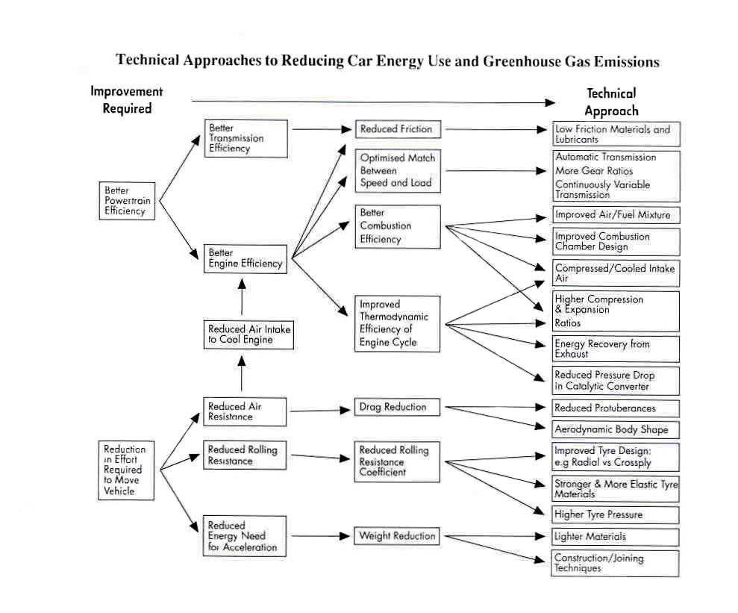

Figure 2.1 Technical approaches to reduce car energy use. OECD (1993)

It is possible to give an idea of the importance of each measure to improve fuel economy by examination of the contribution that each loss makes to the power required. This is done in the following chart presented in Hilliard and Springer (1984).

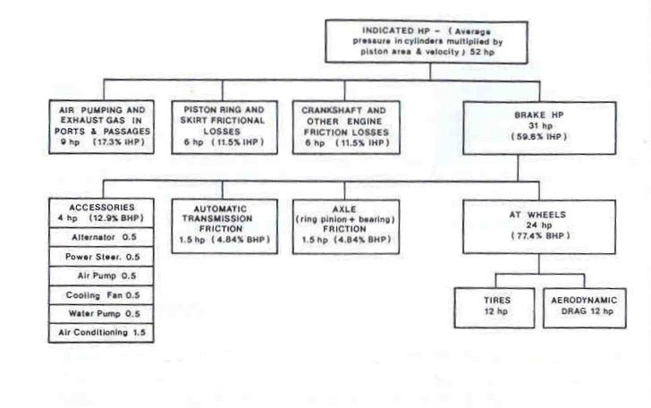

Figure 2.2. Frictional losses in a 348 in³ gasoline engine passenger car at 50 mph
Hilliard and Springer (1984)

In the above chart it is possible to see that the bigger losses are in the engine, being a 40.2% of the indicated HP. Then the other important losses are the aerodynamic drag, tires and accessories. Also, it is important to note that the overall friction makes a great contribution to the car losses. Therefore the biggest improvements will be achieved by improving the engine and by reducing the friction.

2.1 Energy parameters
It is possible to express the power required by a moving car with the following formula explained in detail in next chapter.
P_{required} = ( F_{Drag resistance} + F_{rolling resistance} + F _{acceleraion resistance} + F_{climbing resistance} ) * V
From examination of the above formula, it is possible to derive that to achieve good fuel economy, one needs:

2.1.1 Low weight.
Weight is more important during city driving because of the power required for accelerating all the mass as can be seen in the following chapter. However, weight also affects to fuel economy at high velocities due to its contribution in the rolling resistance term.
Nowadays the weight of the vehicles tends to increase due to the improvements in safety and new devices. But on the other hand, it is necessary to reduce weight for improving fuel economy. This reduction can be achieved by:
- Packaging improvements
- High strength steel bodies
- Lightweight interior
- Lightweight chassis
- Aluminium body closures
- All aluminium body.
- Aluminium cylinder heads
- Aluminium engine block.
Examples of this improvements can be seen in the Honda Insight, Renault/ Greenpeace Smile or in Deacon et al.

2.1.2 Low rolling resistance
Traditionally to achieve low rolling resistance, tyres needed to be composed of hard compounds and inflated to high pressures, which would produces poor ride quality and compromised grip. New materials and new technologies allow lower rolling resistance without compromising the handling and comfort characteristics. Some examples of low rolling resistance tires (Poulton, 1997) are: Bridgestone Potenza, Continental EcoContact, Goodyear Invicta GFE or Michelin energy MXT and MXV.
Some of the possible improvements to reduce tyre rolling resistance are given by Poulton (1997) in the following table:
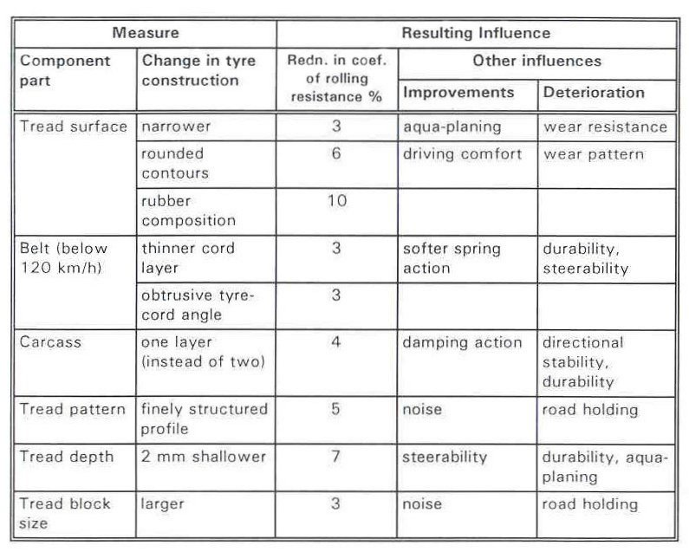
Table 2.1 Measures to reduce tire rolling resistance and resulting influences
Poulton (1997)

2.1.3 Low aerodynamic drag
The aerodynamic drag has an important influence at high speeds. It is improved by streamlining the vehicle shape and minimizing the frontal area. Poulton (1997) and Aparicio (1995) do small analyses of the influences of each shape element to the drag coefficient. Although, Poulton (1997) suggests the possibility of achieving a drag coefficient of 0.22, and Opel G90 achieved this value, it would be difficult in most cases to achieve it without unpractical shapes.

2.1.4 Speed limiters
At high speeds the drag force increase too much producing a waste of energy. It would be possible to include speed limiters to the cars, in order to not allow them to pass the legislation speed limits. This solution has two main disadvantages: it is politically controversial and could raise into a safety problem in determinate conditions.
Some “Green parties” in some European countries are claiming for a legal maximum speed reduction in highways in order to reduce the global CO₂ emissions, e.g. is izquierda unida in Spain ( http://www.izquierda-unida.es/ ).

2.2 Power train
In this point there are four possible sources of improvement: improve gears efficiency and gear ratios, continuous variable transmission (CVT), hybrid powertrain or fuel cells.

2.2.1 Redesign of gears
Redesigns of the gear ratios can produce an improvement in fuel economy. They can improve the gear efficiencies, increase the number of gears or improve the gear ratios.
The increase in number of gears will lead into an improvement in fuel economy, but it will increase size, complexity and cost. This approach is being adopted by this year’s cars that are moving from 5 to 6 gears.
Deacon et al, suggested that just optimising the gear ratios, it is possible to improve the fuel consumption by 0.15 litres / 100 Km.

2.2.2 Continuous variable transmission.
In principle CVT have two advantages compared with conventional transmission: at part load they improve fuel consumption and when needed, they can maintain high the power or torque.
At part load condition they allow the engine to operate at the point of load and engine speed that produce minimum fuel consumption. And when maximum power or torque is required, they allow to operate at the speed that provides peak torque or peak power.
Austin et al. consider a theoretical maximum improvement of 30% in fuel economy. However, there are two restrictions to this, the practical limit to infinite speed ratio and low efficiency of current CVTs.
Current CVTs has low efficiency, Poulton (1997) suggest an efficiency between 70-90% whereas manual transmissions have an efficiency between 91-95% (Bosch, 1996).
They are a promising technology that needs to be improved to provide the desiderated fuel consumption improvement. Although nowadays they are inefficient, there are some commercial applications like: Ford CTX, Nissan N-CVT or Volvo VCST, (Poulton, 1997).
Some improvements related with the transmission and their fuel economy quantification are collected in Poulton (1997) in the following table.
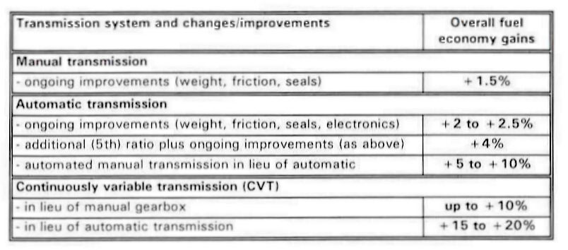
Table 2.2 Transmission system improvements. Poulton (1997)

2.2.3 Hybrid power train
Hybrid powertrain improves the fuel consumption of a car due to the following points:
- Smaller engine. With smaller engine, the car is more efficient than a conventional one as explained in section 2.9.2. The engine of the hybrid car is powerful enough to move the car along on the free way, but when it needs to get the car moving in a hurry, or go up a steep hill, it needs help. That "help" comes from the electric motor and battery, which steps in and provides the necessary extra power.
- Regenerative braking: recover energy and store it in the battery - Whenever one steps on the brake pedal in the car, energy is removed from the car. Instead of just using the brakes to stop the car, the electric motor that drives the hybrid can also slow the car. In this mode, the electric motor acts as a generator and charges the batteries while the car is slowing down.
- Shut off the engine. A hybrid car does not need to rely on the gasoline engine all the time because it has an alternate power source , therefore it can switch off the engine when the vehicle is stopped at a red light or in similar road conditions.
There are two kinds of hybrid cars: parallel and series. The difference is that the in a parallel hybrid both the engine and the motor can turn the transmission, whether in the series, just the motor turns the transmission.
Examples of some hybrid cars are the Honda Insight and the Toyota Prius.

2.2.4 Fuel cells
Fuel cells are based on the hydrogen oxygen reaction producing only electricity, water and heat. A fuel cell generate high currents at low volts and therefore for high volts are needed many of them, making big devices.
In principle they are very clean because they are based in the reaction H₂+1/2 0₂ = H₂O, that produces zero unwanted emissions. This is true just only if the energy needed to obtain the H₂ comes from an alternative source of energy or from a nuclear power plant. If the energy comes from a thermal power plant, it will produce more global emissions than if the fuel is burned in the internal combustion engine of the car.
Some fuel cells can run by feeding them with a hydrocarbon, just by adding a converter to the system. These cells consumes less fuel than a conventional car because fuel cells are more efficiency than internal combustion engines as they are not Carnot limited Newborough (2000).
Another alternative to reduce the global warming would be an electric car: which has a set of batteries that provides electricity to an electric motor. But they can go just 80-160 Km between charges (Poulton 1997). Also it will contribute positively to the global warming depending on the kind of source that produce the electricity, as discussed with the H₂.

2.3 Alternative fuels

The main objective of the 3 litre car is to reduce global CO₂ emissions. This target can be achieved by changing the fuels used to propel the car. Some examples of better fuels from this point of view are: hydrogen, CNG (Compressed Natural Gas) or LPG (liquid petroleum gases). All of these fuels contain bigger fraction of hydrogen and therefore they will produce less CO₂ emissions and also more specific energy.
The CO₂ emissions of different fuels and also the emissions of CO₂ related the fuel supply and vehicle manufacturing can be seen in the following graph from OECD (1993).
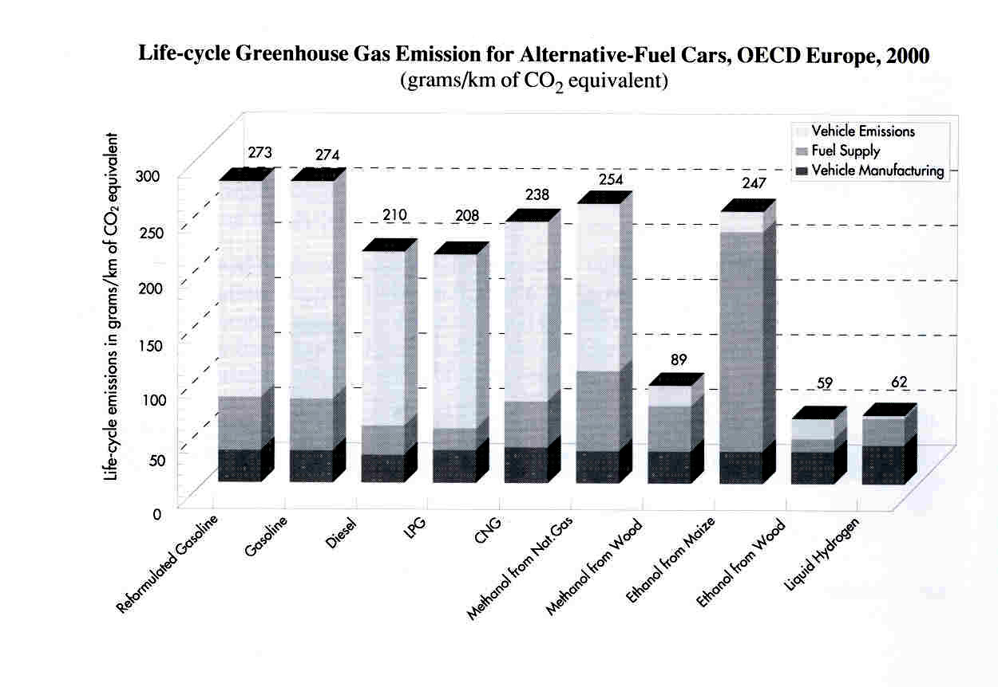
Figure 2.3. CO₂ emissions of alternative fuels OECD (1993)

Just the hydrogen will produce zero CO₂ emissions, but when considering global warming it is necessary to say where this H₂ came from, as mentioned before.
The problem with alternative fuels is the transition to them from existing fuels. In the transition there are not many fuel stations with facilities to these new fuels, making them less attractive than conventional vehicles. A possible solution to make the transition easily is the one adopted by Ford, Vauxhall and Volvo: bi-fuel engines. They can run on petrol and either LPG or CNG. Autocar, 6 June of 2001, says that the LPG reduces CO₂ emissions by 10 percent and CNG by 20 percent. The advantage of theses cars is that they will consume less fuel and that they will be benefit by taxes rates.
An example of a bi-fuel system is now presented, from the mentioned Autocar magazine.
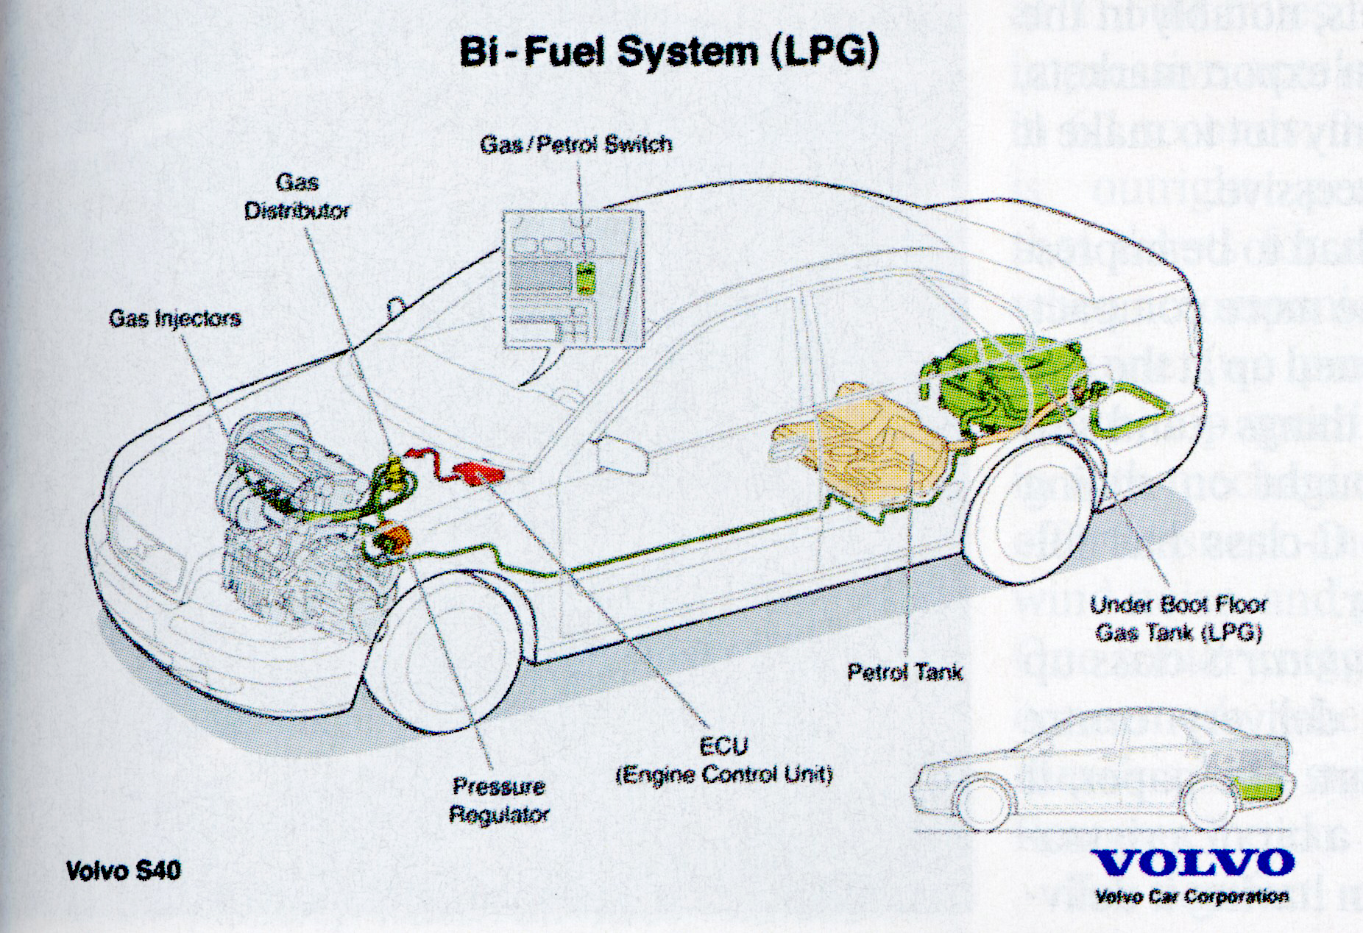

Figure 2.4. Volvo bi-fuel system (LPG)
Autocar, 6 June of 2001

Further information about the effects of the fuels to the 3 litre car target can be found in Mallet (2001).

  - Engine improvements

The main target of this thesis is to study the feasibility of a 3 litre car with regular port injection using engine simulation. For the engine simulation, many possible solution can be adopted and therefore, in this section are going to be explained those that has not been adopted in the final engine model.

2.5 Lean burn and EGR
EGR and lean burn are two related technologies and therefore are studied together. Both technologies dilute the fuel mixture but with different diluents, exhaust gas or air, and with different results.

2.5.1 Lean burn
To obtain lean burn combustion, the dilution tolerance of the combustion chamber needs to be increased. There are two approaches to increase the AFR tolerance: open-chamber stratified charge and high activity homogeneous charge.
In the stratified charge approach, the fuel rich mixture is concentrated around the spark plug, so that a charge which is lean overall could be ignited and burnt. This is the approach used by gasoline direct injection (GDI). In the high activity homogeneous charge, lean burn is achieved by careful control of the air motion around the spark plug in a highly turbulent flow field. As discussed later this in chapter, this is achieved by using asymmetric intake port design, or better, by shutting off one of the intake ports. This approach is studied in Soltani and Veshagh (1998). Also it is possible to improve the high turbulence by adding to the port configuration strategy a modification of the chamber shape, as shown in Horie et al (1992).
Honda system VTEC-E, explained in Horie et al (1992), takes advance of both approaches to increase the AFR.

The reasons by which the fuel economy is improved by the lean burn are:
- Higher thermal efficiency. Doing simple calculations to the theoretical Otto cycle is possible to obtain that
$η_{\text{th}}=1−\frac{1}{r^{γ−1}}$
where r is the compression ratio and γ is the ratio of specific heats.
Using leaner mixtures, the thermal efficiency is increased because γ dry air = 1.4 and γ stoichiometric mixture is about 1.35.
- Complete combustion. As in the lean operation there is excess of air, nearly complete combustion is obtained, unless misfiring problems occur. The complete combustion will produce an improvement in fuel consumption and a reduction of HC and CO emissions. Austin et al writes that there is also an increase in the ratio of specific heats.
- Reduce pumping losses. As shown in Soderber and Johanson (1997), lean burn reduces the pumping losses and it also increases the ratio of specific heat during compression and expansion. Austin et al explain the reduction in pumping losses by the reduction in throttling required at any given power level due to the bigger AFR used. Although the combustion gets more unstable with lean burn, it can be improved with the generation of higher turbulence as shown later in this chapter.
All these advantages will lead into an improvement in fuel consumption. Horie et al (1992) report that with a VTEC-E engine is possible to obtain a 12% reduction of bsfc in an engine bench cell as can be seen in the below figure. Note that they obtained this 12% reduction in a highway mode, but just 8% in LA-#4 mode. Austin et al and also Poulton (1997) report a fuel economy improvement between 8% and 10% with lean burn engines.
In the following graph it can be seen the effects of AFR to the bsfc and the 12 % improvement obtained in Horie et al (1992). Also it can be seen the effects of the AFR to the NO_{x} emissions.
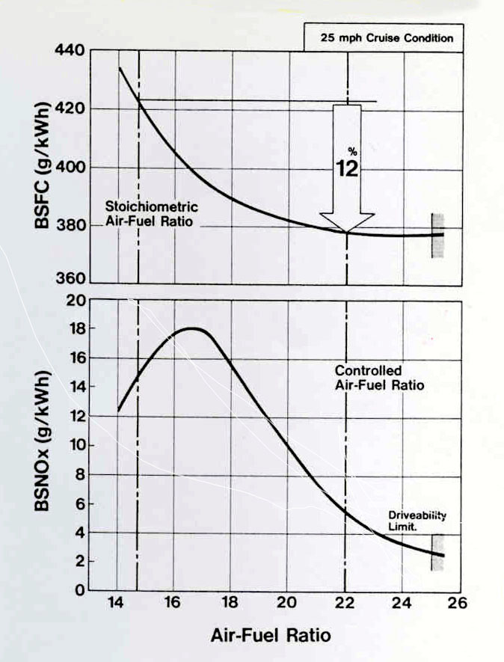

Figure 2.5 bsfc and bsNO_{x} as a function of AFR..
Horie et al (1992)

The main problem of the lean burn operation is the NO_{x} emissions, because although NO_{x} produced in the combustion is much lower, as can be seen in the above picture , the oxygen in the exhaust gas precludes the use of a conventional NO_{x} reduction catalyst. There is a promising technology to reduce the NO_{x} emissions that is the DENO_{x} catalyst. As said in Austin et al Toyota has reported a 90% NO_{x} conversion using a system that normally runs at a 21:1 AFR and cycles back to a 14.5:1 AFR for less than one second once every one to two minutes. The fuel economy loss associated with this infrequent rich operation is less than 1%. It should be noted that this catalyst is poisoned by sulphur and will require gasoline with sulphur levels of 30 ppm or lower, depending on the stringency of the NO_{x} emission standard.
Lumsden et al (1997) report that one way to improve the emissions in the lean burn scenario is to use spark retard to further control combustion temperature. For example, retarding the spark advance from 39º btdc (the MBT –1 % timing) to 34º, NO_{x} is reduced by 52%, resulting in an overall reduction of 63% compared to stoichiometric operation. HC emissions increase by 10% but fuel consumption rises by less than 1%.
Austin et al conclude that throttled lean burn engines are likely to be able to meet the target emission levels of the US federal emission regulation Tier 2, but there is no evidence that unthrottled engines will comply with it. Also Horie et al (1992) writes that lean burn VTEC-E passes the Tier 2 regulations, although it will not pass the California state standard.

2.5.2 Exhaust gas recycle (EGR)
EGR is the principal technique used to control NO_{x} emissions in spark ignition engines. A fraction of the exhaust gases are recycled through a control valve from the exhaust to the engine intake system or a fraction of exhaust gases are trapped in the cylinder at the end of the exhaust stroke (internal EGR). EGR acts, at part load, as an additional diluent in the unburned gas mixture, thereby reducing the peak burned gas temperatures and NO_{x} formation rates.
The effects of EGR in bsfc is shown by Heywood (1988) in the following graph. He also explains the improvements of EGR on fuel consumption due to three factors:
- Reduce pumping work because increases intake pressure
- Reduce heat loss to the walls because decreases the burned gas temperature
- Reduce degree of dissociation because reduce the temperature and hence, less chemical energy is lost in dissociation. This effect is less important than the two others.
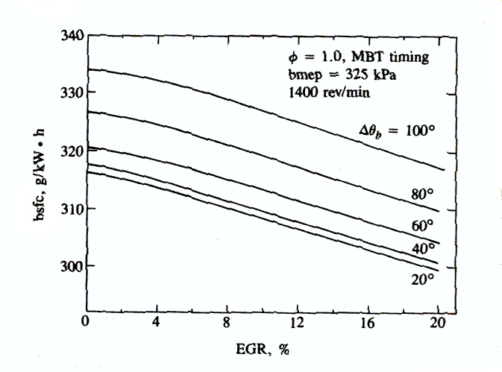
Figure 2.6. Effect of EGR in bsfc.
Heywood (1988)

Lumsden et al (1997) report that the best fuel consumption point is obtained with 20% EGR, producing a 5.5 % reduction in fuel used. But if the optimum emission strategy (minimum HC+NO_{x} emissions) is selected, then a 17% EGR is used and it will provide a 5.3% fuel consumption reduction.

2.5.3 Comparison between EGR and Fuel economy.
As a conclusion of the mentioned before, if the target is to reduce fuel economy is more efficient to use lean burn, but if the target is to reduce NO_{x} then EGR become compulsory. This results can be seen in the following table from Lumsden et al (1997) and in the following graph from Horie et al (1992).

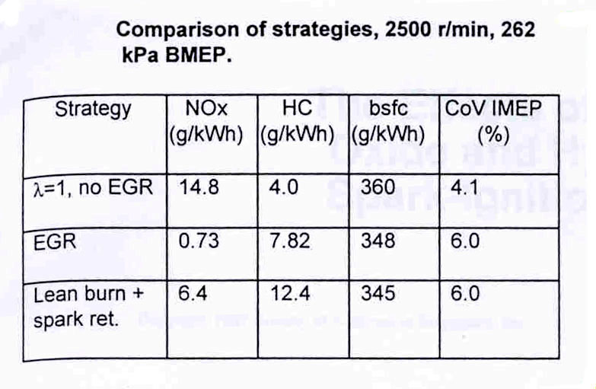

Table 2.3 Comparison between EGR and Lean burn
Lumsden et al (1997)

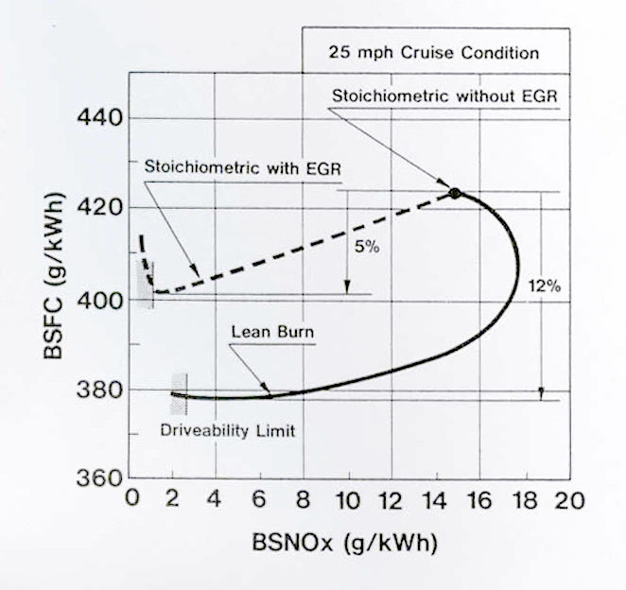
Figure 2.7EGR and Lean Burn compared
Horie et al (1992).

2.6 GDI
In the Gasoline Direct Injection (GDI) the fuel is injected directly into the cylinder during the compression stroke. It has two combustion modes, as explained below and as shown in the following picture from www.machinedesign.com .
Stratified charge. Where there is an ultra lean combustion. The injection is done during the late stage of compression stroke, towards the curved top of the piston crown. This mode allows having lean burn and therefore better fuel economy at part loads.
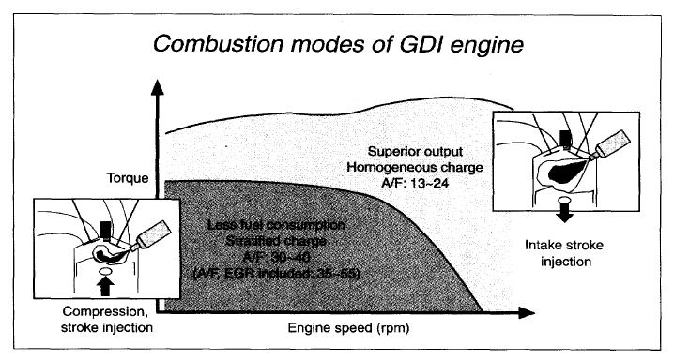
Homogeneous charge. Injection during the intake stroke. The behaviour is like a regular port injection.

Figure 2.8. GDI modes
www.machinedesign.com

The main advantages of this injection is that allow lean burn (see previous section) and higher compression ratios. Higher compression ratios lead into a fuel economy improvement due to its increase in thermal efficiency.

2.7 Turbocharge and supercharge
Turbochargers and superchargers increase the air pressure available in the intake manifold and therefore increase the engine torque. This can produce an advantage on fuel economy because allow to have a small engine, advantage discussed later in this chapter, but with good torque and power output. This is the option adopted by the MCC Smart, as disused in chapter 6.
As mentioned before both technologies could improve fuel economy because they allow the reduction of engine size. But the common disadvantage of both technologies is that they increase intake charge temperature, increasing knock tendency and forcing to reduce the compression ratio, losing thermal efficiency. Also the driving style is more sporty when using turbocharge or supercharge than in natural aspirated engines and therefore it will produce worst fuel consumption.
The main disadvantage for the supercharger is that it increases the parasitic losses of the engine, and therefore, it will diminish engine efficiency. On the other hand turbochargers do not have this problem, because they recover energy from the exhaust. But the recovering energy presents three problems: increases the backpressure, at idle there is not sufficient energy in the exhaust of the engine to provide boost and it has a time lag to obtain the boost, while the supercharge has it immediately, affecting driveability.
As a result of all mentioned before, Austin et al suggest that some manufacturers estimate that there is not fuel economy benefits and others say that could go up to 12% improvement.

2.8 valve timing technologies
Valve timing is one of the most influencing elements in the performance of an engine and it is also a possible source of improvement. A summary of the possible influences that valve timing has in the engine characteristics and therefore the possible sources of improvement are compiled in the following diagram from Kreuter et al (1992) .
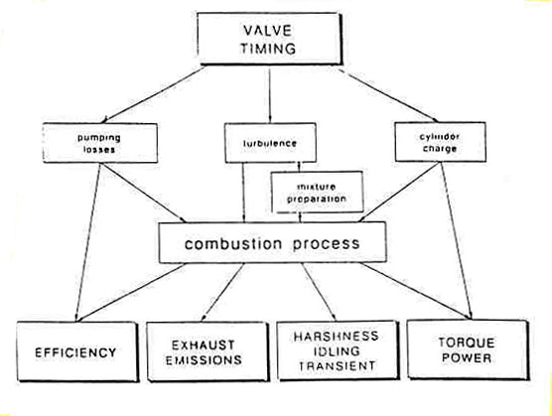
Figure 2.9. Influences of variable valve timing in engine characteristics.
Kreuter et al (1992)

2.8.1 Concepts involved in valve timing
In fixed timing a compromise between the following elements that will determine torque, idle stability and power is sought:
- Late inlet valve closing (IVC). By this strategy, it is possible to introduce more air in the cylinder, increasing the volumetric efficiency and hence, engine performance. The increase in volumetric efficiency is achieved by three elements:
- At bottom dead centre (BDC) the pressure in the cylinder is lower than in the inlet manifold, therefore, it is possible to put more air in the cylinder.
- Wave effect. The valves are closed after a positive pressure wave in the inlet manifold. This tuning element, it is only optimum at one engine speed. By using variable valve timing it is possible to have the engine tune at more engine speeds.
- Inertia or ram effect. After BDC when the pressure in the cylinder is around the pressure in the manifold, the flow is moving towards the cylinder and therefore it has a kinetic momentum that allow introduce more air in the cylinder, this effect is more important at high speeds.
The drawback of this strategy is that at low speeds produces reverse flow, decreasing volumetric efficiency.
  - Early exhaust valve opening (EVO): accentuates the effect of the exhaust blow down reducing the pumping work needed to scavenge the engine.
  - Overlap. It is produced by early IVO and late EVC. At high speeds is good for filling and scavenging, but at low speeds produce reverse flow, reducing volumetric efficiency and idle quality because residual gases mixes with fresh charge.

2.8.2 Variable valve timing and lift for fuel economy in throttled engines and stoichiometric mixture
With variable valve timing is possible to improve power and torque of an engine by taking advance of the phenomena explained in the previous section. This improvement is reflected in the following PV diagram presented in Kreuter et al (1992).
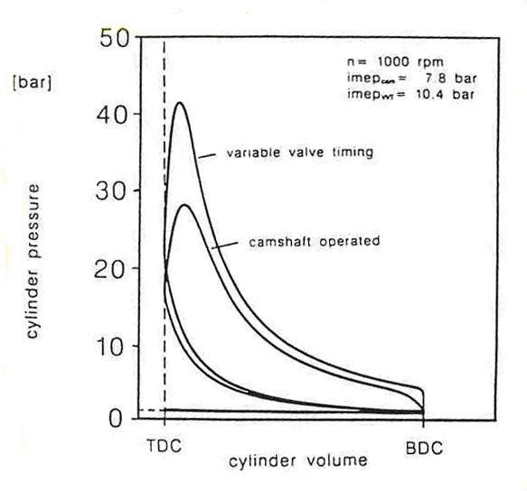
Figure 2.10. Full load P-V diagram: Variable valve timing versus camshaft controlled.
Kreuter et al (1992)

From the above graph can be seen that the work per cycle, area enclosed by the curve, is increased by the variable valve timing and therefore so is the power. The effect of this improvement will be reflected in fuel economy by improving bsfc and by allowing to reduce the size of the engine and therefore take advantage of the small engines features. It also will improve the fuel economy by reducing the throttling losses and improving thermal efficiency.
It is difficult to estimate the improvements in fuel economy of this technique because depends a lot in the flexibility of the variable valve timing system. Austin et al write that Mitsubishi with the system MIVEC improves fuel economy by 7.4%.
There are several variable valve systems based in different systems: two different valves profile as Honda VTEC, rotation of the crank shaft as Alfa Romeo or Mercedes and infinitely valve timing as Fiat , Ferrari and others.

2.8.3 Variable valve timing and lift for fuel economy in throttled engines and lean burn.
There are some current specific technologies of valve management for fuel economy where the most important ones are port deactivation and VTEC-E.
The port deactivation (Pearson et al, 1995) and the Honda VTEC-E (Horie et al, 1992) are two technologies created to improve the vehicle performance, allowing high power at WOT and good fuel economy, due to lean burn, at parts loads. Both technologies have 4 valves and two modes:
- Lean burn mode at part loads, where one of the inlet ports (port deactivation) or one of the valves (VTEC-E) is deactivated. This produces a swirl motion in the cylinder that allows the lean burn and therefore improves fuel economy at low loads.
- Both valves or ports activated. The engine behaves like a regular port injection.
The advantages of both technologies are registered in the following graphs. Note the advantage in drivability produced by the flattening of the torque curve.
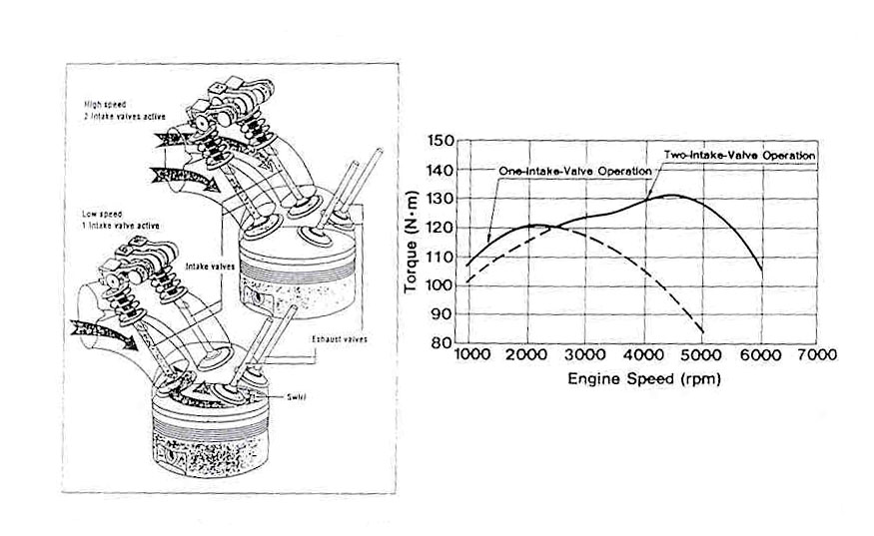
Figure 2.11. VTEC. Poulton (1997)
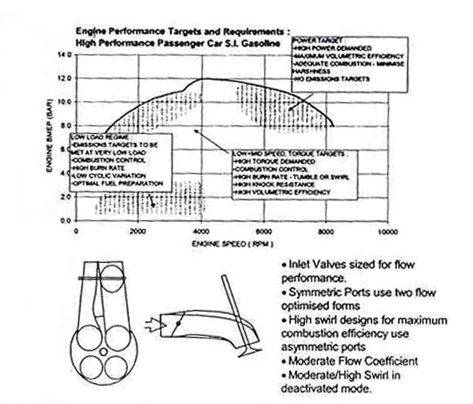

Figure 2.12. Port deactivation. Pearson et al (1995)

2.8.4 Variable valve timing and lift for fuel economy in un-throttled engines.
There are several papers about the advantage of un-throttled load control for fuel economy, such as Kreuter et al (1992) and Soderber-Johansson (1997) .
As a result of the throttle control the pumping losses in a regular gasoline engine increase with decreasing load and rises to more than 30% of the imep at low load. By using un-throttled control, these pumping loses will be eliminated. It is important to highlight the potential improvement in fuel economy by eliminating the pumping losses at low loads because in the European test cycle and in the US federal test procedure, most of the time the engine is working with low loads, and 80% of the fuel consumption is produced in this low load areas. Soderber-Johansson (1997) and Kreuter et al (1992) suggest an improve in fuel economy up to 15% by un-throttled engine
There are two strategies to achieve the un-throttled load control: Early intake valve closing (EIVC) and Late intake valve closing (LIVC).
In the EIVC the intake valve is closed early during the intake stroke of the engine. This kind of load control requires very short valve lift periods for low load conditions as well as high accuracy and good repeatability.
In the LIVC the intake valve remains open during the complete intake stroke and it is closed when the excess charge is pushed back into the intake manifold during the compression stroke.
The improvements in pumping losses of the EIVC can be seen in the following graph from Kreuter et al (1992).
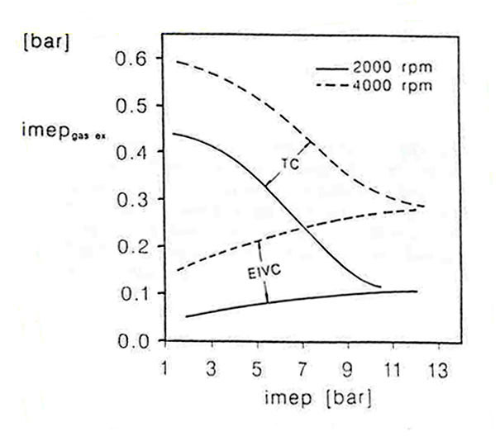
Figure 2.13. Change in exhange losses for a throttled control (TC) and EIVC.
Kreuter et al (1992)

Also it is possible to see the improvement thermal efficiency of the EIVC and the LIVC over standard double cam configuration in figure 4.3 Note that in this graph, it seems that the standard single cam will have bigger efficiency and therefore less fuel consumption that these two systems, but in the indicated efficiency the pumping losses are not included, where these systems offer a great improvement.

2.8.5 Camless
It is done a separate discussion about camless because although un-throttled control will imply the use of camless, the use of camless does not imply un-throttled control. Also camless technology implies advantages that un-throttled control may be not imply.
There are two mechanisms for camless valve control: electrohydraulic and electromagnetic designs. A deep discussion of the electro hydraulic technology can be find in Schechter and Levin (1996).
With camless engines is possible to have variable intake timing, exhaust timing and lift. Each of them has different improvements to the engine performance, that are summarised below, mainly from Schechter and Levin (1996).
Variable inlet timing
The main advantages of this are:
  - Reduce throttling loss.
  - Faster burn rate at low speeds, where the air turbulence in the cylinder is often insufficient. It is achieved by delaying the opening of the intake valve past the top dead centre until the piston acquires significant down stroke speed, increasing the inlet air velocity and therefore promoting faster burn rate.
  - Increase torque. It is possible to improve the volumetric efficiency at all speeds, by tuning the ram and wave effects, producing a bigger and flat torque curve.
  - Variable compression ratio. It is done by varying the timing of the intake valve closing, producing a variation in the effective compression ratio without a corresponding change in the expansion ratio.
- Variable exhaust timing.
The main advantages are:
  - Optimised expansion ratio. At low speeds is possible to retard the EVO because is more time for the blow-down, producing an increase in the expansion stroke and therefore in torque and fuel efficiency.
  - Internal EGR. Reducing NO_{x} emissions (up to 90%, Schechter and Levin (1996)) and improving fuel economy.
- Variable valve lift
The main advantages are:
  - Improve fuel efficiency at low speeds by reducing both inlet and exhaust lifts when the engine speed is reduced. The reason for this is that the energy consumed by the valvetrain goes down with reduction in the valve stroke, therefore varying the valve lift as a function of the engine speed can improve fuel efficiency at lower speeds.
  - Promote swirl and therefore increasing burn rate and combustion stability by unequal inlet lifts. Also as discussed before, it will allow lean burns.
There are also three other important advantages of the camless engine that will also improve fuel economy (Schechter and Levin ,1996).
:
- Deactivation of some engine cylinders, in order to operate the others at higher loads to maintain a given engine output and therefore reduce fuel consumption.
- Packaging advance and weight reduction.
- Valve lift profile will have nearly rectangular shape at low speeds and trapezoidal at high speeds. These will increase the volumetric efficiency and therefore the torque.
Although the fuel economy and engine performance can be greatly improved with camless valve control, it has three main problems that make it a hope more than a reality. The three main problems are that hydraulic or the electromechanical systems are costly, complex and inefficient. Therefore, it is needed to improve fuel economy, emissions and engine performance by using actual variable valve systems and wait until these valve systems are efficient and cheap.

2.9 Improvements in which this thesis is based: Small gasoline engine

This thesis studies the feasibility of a 3 litre car from the point of view of small gasoline engine with regular port injection. This section outlines the advantages of taking this approach.

2.9.1 Reasons for gasoline engine.
There are several advantages for the gasoline engine rather then the diesel.
- Cancer risk. As said in http://www.greenpeace.org/~climate/smile/ almost two thirds of the cancer risk created by air pollutants is due to diesel engine emissions. The particles contained in the diesel exhaust gases and the polycyclics deposited on them penetrate deep into the lungs because of their small size, producing cancer.
- Diesel engines pollutes more than the gasoline engine. Example of this could be seen in the VCA that shows that 208 car models compliance with Euro IV, but not one is Diesel, even though Diesel emissions limits are less tough than the gasoline ones.
- A litre of diesel" is not "a litre of gasoline". ". Diesel fuel is more dense than petrol and has a higher carbon content, as a result a litre of gasoline produces 2.32 kg of CO₂, but a litre of diesel produce 2.63 kg of CO₂. This means that 13.4 per cent more CO2 is emitted per litre of diesel than per litre of petrol
- Diesel engines are heavier and more expensive in manufacture
The main advantages of Diesel fuels are:
- No throttle. As Diesel has not throttle it does not have the pumping losses associated with throttle control and therefore better efficiency.
- Economic. Liquid fuels are bought by volume and as diesel has more density it gives more energy per litre.
- Diesel engines allow bigger compression ratios and therefore they have bigger thermal efficiency.
In this comparison, just the gasoline and diesel engines are compared because they are the common fuels current 3 litre concept cars. It is necessary to highlight that for future studies of the 3 litre car it is necessary to study alternative fuels such as: hydrogen, CNG (Compressed Natural Gas) or LPG (liquid petroleum gases). This study is done by Mallet (2001).

2.9.2 Small engine
A small engine has better efficiency compared with a big one. The reasons for this are:
- Reduce engine weight, which will reduce fuel consumption as said before.
- Improves packaging, making possible to reduce exterior size of the vehicle while maintaining the interior volume, and therefore reducing a lot the body weight.
- Less friction forces because the cylinder and the pressures are smaller, producing smaller forces.
- Smaller and lighter parts require less energy to move them
- Less cylinders, therefore less fires while the car is not moving
- In the case of gasoline engine, running a car with a small engine, will require the driver to drive the car with the accelerator pressed deeply most of the time. This is producing to run the engine high loads, near WOT and close to the operation region with better fuel consumption.

2.9.3 Regular port injection
This thesis is focus in an engine where the fuel is injected in the intake port. This is the injection that most cars have and does not requires any further study.

