CHAPTER 1 INTRODUCTION

Nowadays cars have become indispensable. They have improved in design, safety and performance over the last years. Even though they are still an inefficient machine, which only uses one fourth of the energy of the fuel to motor the car. For an idea of the lost energy distribution of a passenger, the following graph is presented.

Figure 1.1 Passenger car energy distribution. Data from Poulton (1997)

Cars not only waste the limited source of energy that are fossil fuels, they also produce high levels of pollution. The main problem associated with the inefficiency of the cars is the quantity of CO₂ produced. The CO₂ contributes to the global warming, produced by the greenhouse effect.
The target of this thesis is to study the feasibility of a car which consumes 3 litre per 100 km, usually named as the 3 litre car. The study of this thesis is it going to be focused on a small gasoline engine with regular port injection.
The main motivation for the 3 litre car is the reduction of CO₂ emissions, to reduce global warming. As well is a target for many manufacturers because it implies a very efficient car and one more step in the technology race. Although the 3 litre car target is well known in the automotive industry (as can be reflected in Shillington (1998), Poulton (1997) and Deacon et al for instance) the most efficient commercial cars are far from achieve it. Excluding the Honda Insight that it is a hybrid car and achieves 3.4 l/100 km, the 10 best fuel consumption commercial cars are achieving around 5.5 litres per 100 km in gasoline engines and 4.8 l/100km in diesel as can be seen later in tables 1.2 and 1.3.
In this introduction, as the 3 litre car is under the CO₂ reduction frame for reducing the global warming, it is going to be include a brief overview of the greenhouse effect and the international actions against CO₂ emissions.

1.1 Greenhouse effect
This is an atmospheric effect produce by a gas layer formed by gases which mainly include carbon dioxide , water vapour, methane , nitrous oxide and chlorofluorocarbons ( CFCs). This layer allows radiation from the sun to pass through the atmosphere, but do not allow the reflected radiation go back to the space, producing a global earth warming. The layer of greenhouse gases is becoming thicker because of the increase of these gases. This increase is mainly produced by human activities and particularly, by the burning of fossil fuels.
Possible impacts might be seen as both positive and negative. A negative is the increase in temperatures of the Earth, which is promoting a climate change and might rise the oceans, covering land areas. A positive view is that the increase in CO₂ concentrations, increase vegetable life.
The concentration of CO₂ has risen to 25% more in the atmosphere than there was in the early 1800s (http://users.aber.ac.uk/eij7/greenhouse%20effect.htm). One third of the world’s CO₂ emissions can be attributed to the movement and transportation of people, and cars contribute 80% of this.
Further information can be found in: http://www.greenhousenet.org/action/ncse.html

1.2 Overview of International actions against CO₂ emissions
The main international events against CO₂ emissions are (quoting in part from http://www.unfccc.de/, http://www.greenhousenet.org/action/ncse.html and http://www.environment.fgov.be/Root/tasks/atmosphere/klim/pub/eu/raad/milieu/volledig/2153_en.htm ):
- U.N. Framework Convention on Climate Change (FCCC) (http://www.unfccc.de/). Opened for signature at the 1992 UNCED conference in Rio de Janeiro. It was signed by 154 Nations for reducing atmospheric concentrations of greenhouse gases with the goal of "preventing dangerous anthropogenic interference with Earth's climate system." These Nations showed their intention of stabilizing their emissions of greenhouse gases at 1990 levels by the year 2000.
- The Berlin Mandate, 1995. Result of the first Conference of Parties (COP) of the FCCC which established a 2-year Analytical and Assessment Phase (AAP), to negotiate a "comprehensive menu of actions" for countries to pick from and choose future options to address climate change.
- Kyoto Protocol on Climate Change (COP-3), 1997. It was agreed legally binding reductions in greenhouse gas emissions of an average of 6%-8% below 1990 levels between the years 2008-2012 (first emission budget period).
- Subsequent COPs decided mechanisms for implementing the Kyoto Protocol and future possible actions.
- 2153rd Council meeting, Luxembourg, 6 October 1998 claimed for “A Community strategy to reduce CO2 emissions from passenger cars and improve fuel economy . It claimed for the need of a comprehensive strategy to get an agreement with industry, in combination with market incentives and consumer information, in order to reduce the average CO2 emissions of newly registered passenger cars to 120 g (5 l/100Km) of CO2 per kilometre by 2005 or 2010 at the latest.”
It was also set that the main commitment of ACEA (Automobile Manufacturers Association) is to achieve an emission target of 140g of CO2 per kilometre for the average of the new car sales by ACEA members in the EU by 2008.
- It is expected that in the near future the Community target will be the 3 l / 100 Km car.

1.3 Relation between fuel economy and CO₂ emissions
For this thesis the fuel economy improvement is going to be related directly to the CO₂ emissions. Although this relationship is obvious due to the combustion process, it is include here the relation ship given by the Diretive 93/116/EC between fuel consumption and CO₂ emissions. As this thesis is based in gasoline engines, only the relationship for gasoline engines is included.

$$\text{FC}=\frac{0\text{.}\text{1154}}{D}\left[\left(0\text{.}\text{866}⋅\text{HC}\right)+\left(0\text{.}\text{429}⋅\text{CO}\right)+\left(0\text{.}\text{273}⋅{\text{CO}}_{2}\right)\right]$$
FC = fuel consumption in litres per 100 km;
HC = measured emission of hydrocarbon in g/km;
CO = measured emission of carbon monoxide in g/km;
CO2 = measured emission of carbon dioxide in g/km;
D = density of the test fuel in Kg/litre.
There are two units where the fuel consumption can be expressed, in miles per gallon (mpg) and in litres per 100 km.
It is necessary to point that the USA gallon is different to the UK and therefore, in data compiled from USA or UK sources, could seem to be different. To clarify this aspect, here are presented the relationships of both mpg to the SI units.
1 mpg in USA is 0.425144 Km/ l
1 mpg in UK is 0.3539 Km/ l.
Therefore the target of 3 litres per 100 km fuel consumption is equivalent to 78.4 mpg USA or 94 mpg UK.
Here there is an example of the conversion between data that could be checked with the values given by different sources
Honda Insight consumes 83.1 mpg UK (http://www.vcacarfueldata.org.uk/) = 29.41 km / l = 3.39 l/ 100Km (http://www.honda.co.uk/news/technicalinfo.html)

1.4 Measures to reduce the fuel consumption
There are several measures that countries can do to reduce fuel consumption in cars. Most of these measurements are already applied the European countries.
- Points of sale and all promotional literature (advertising) referring to a particular model would have to include information on fuel consumption and CO2 emissions.
- The 2153rd Council meeting estates: “Member States would have to ensure that a fuel economy guide is produced, in consultation with manufacturers, at least on an annual basis and that it is available to consumers free of charge, including from the dealers. It would provide information on the fuel consumption of all new passenger car models on sale in that Member State, grouped by makes in alphabetical order. The guide would have to include a prominent listing of the 10 most fuel-efficient new car models ranked in order of increasing specific CO2 emissions for each fuel type. It would also include an explanation of the effects of carbon dioxide on the climate. Furthermore, it would offer motorists advice on how to economize on fuel when driving. Dealers would be under an obligation to make consumers aware of the guide's existence. The Commission will produce a guide at Community level, available on the Internet.” This is already done by the UK vehicle certification agency in the web: http://www.vcacarfueldata.org.uk/.
- Reduce taxes of those cars that emit lowest levels of CO₂. Also reduce road license for these cars.
- New agreements with the manufacturers to reduce fuel consumption.
- Invest in new technologies and fuel economy studies
- Reduce maximum legal speed in highways

1.5 Non technical problems to overcome
There are two main non-technical problems for achieving a three-litre car: cost and customer expectation.

1.5.1 Cost
Most of the improvements that allow reduce fuel consumption will increase the cost of the car. As this thesis is not going to talk about the economic aspects, some references are given here where some economic studies of the impact of new technologies to reduce fuel economy to the cost of the car can be found: Austin et al, Weiss et al, OECD (1993) or http://www-cta.ornl.gov/Publications/ORNL-TM-2000-26.pdf
The following table is extracted fro Weiss et al, just to give a brief idea of the economic implications of the improvements in fuel economy.
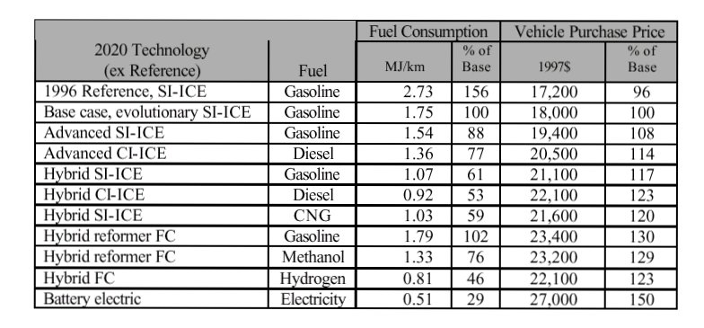
Table 1.1 Summary of vehicle operating fuel consumption and price.
Weiss et al

1.5.2 Customer expectation
There is always a conflict between power or torque and fuel economy. High power is desired to obtain high maximum speed while high torque is desired to obtain quick accelerations. Moreover, not only high torque is desired, it is also desired a flat torque curve to obtain good driveability. Therefore the ideal car will have high power, high and flat torque curve and low fuel consumption. This ideal car is impossible to obtain because factors which contribute positively to one these elements can contribute negatively to another, and therefore a compromise between power, torque and fuel consumption has to be made.
If a car with 3 litre per 100 km fuel consumption is achieved, it will be likely that it will be small and with not much power or torque. Small values of torque and power could produce a problem for selling this car. The only way to achieve the selling of these cars is by changing customer expectation. This can be done by measures like the ones presented in the previous section.
Also it is important to note that nowadays the number of cars is increasing and therefore there is more traffic each year. The increase in traffic is producing a decrease in the average speed on roads. Hence, it is possible that due to the traffic problem the customer expectation changes itself.
A possible pattern for this could be seen in the shrink of the upper medium car sector that we are leaving these days, while small cars are increasing in sales. With the increase in Diesel sales, these could be seen as a movement of customers to better fuel economy cars. ( Automotive news Europe, January 15, 2001)

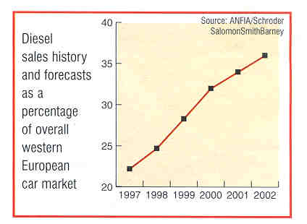
Figure 1.2 European Diesel sales
Automotive news Europe, January 15, 2001

Also is important to notice the trend of commercial vehicles to improve in fuel economy over the years and therefore to reduce the CO₂ emissions. It can be seen in the graph presented by Pitstick and Danilo (1992) the improvement on trucks fuel economy.
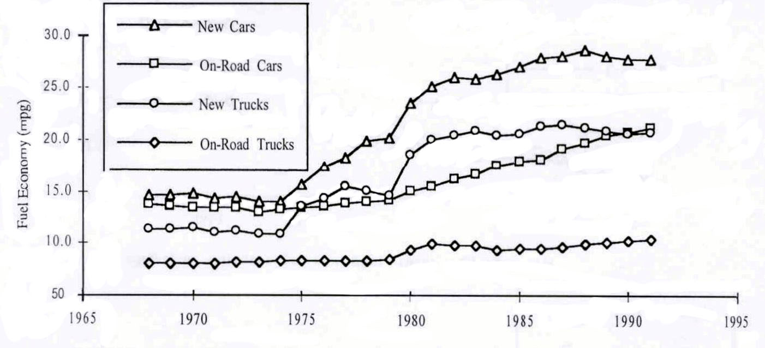

Figure 1.3 Car and light truck fuel economies for years 1968-1991USA mpg
Pitstick and Danilo (1992).

1.6 Best fuel consumption cars
This section is to show that the target of the 3 litre car is in the mind of the cars manufacturers and to show nowadays the market is getting near it.

1.6.1 Commercial vehicles
From the Vehicle Certification Agency (http://www.vcacarfueldata.org.uk/ ), the commercial vehicle with better fuel consumption (UK mpg) are the ones in these tables.
Please note that the last column is not given in the VCA and was calculated with the formula given in section 1.3.

Ranking | Model | Engine | Engine Capacity cc | Transmission | CO2 (g/km) | Fuel consumption (mpg) | Fuel consumption (l/100km)
1 | Honda | Insight | 995 | M5 | 80 | 83.1 | 3.4
2 | MCC | Smart | 599 | SM6 | 115 | 58.8 | 4.8
3 | Daihatsu | Cuore | 989 | M5 | 127 | 53.3 | 5.3
4 | Perodua | Nippa | 847 | M5 | 129 | 51.9 | 5.4
5 | Suzuki | Swift | 993 | 5MT | 130 | 51.4 | 5.5
6 | Daihatsu | Sirion | 989 | M5 | 132 | 51.4 | 5.5
7 | Seat | Arosa | 999 | M5 | 134 | 50.4 | 5.6
8 | Toyota | Yaris | 998 | M5 | 134 | 50.4 | 5.6
9 | Suzuki | Alto | 993 | 5MT | 134 | 49.6 | 5.7
10 | Fiat | New Punto | 1242 | M5 | 136 | 49.6 | 5.7

Table 1.2 Ten best fuel consumption gasoline cars
http://www.vcacarfueldata.org.uk/

Ranking | Model | Engine | Engine Capacity cc | Transmission | CO2 (g/km) | Fuel consumption (mpg) | Fuel consumption (l/100km)
1 | MCC | Smart | 799 | SM6 | 90 | 83.1 | 3.4
2 | Seat | Arosa | 1716 | M5 | 119 | 64.2 | 4.4
3 | Volkswagen | Lupo | 1716 | M5 | 119 | 64.2 | 4.4
4 | Volkswagen | New Polo | 1422 | M5 | 120 | 62.8 | 4.5
5 | Skoda | Fabia | 1896 | M5 | 130 | 58.9 | 4.8
6 | Fiat | New Punto | 1910 | M5 | 130 | 57.6 | 4.9
7 | Mercedes | A170 | 1689 | M5 | 131 | 57.7 | 4.9
8 | Seat | Ibiza | 1896 | M5 | 135 | 56.5 | 5.0
9 | Peugeot | 206 | 1997 | M5 | 136 | 56.5 | 5.0
10 | Audi | A3 | 1781 | M5 | 138 | 55.4 | 5.1

Table 1.3 Ten best fuel consumption diesel cars
http://www.vcacarfueldata.org.uk/

1.6.2 Near 3 litre cars
Most car manufacturers are trying to develop a 3 litre car. They are taking different approaches to achieve it: hybrid cars, GDI, direct injection diesel with variable geometry turbocharger and small engines. Some of these cars are:

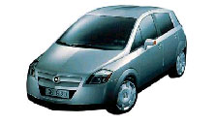
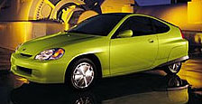

Figure 1.4 Opel GD 90 and Honda Insight
http://www.motorshow.or.jp/show99/English/CONCEPT/opl01.html
http://www.hybridcars.com/honda.htm

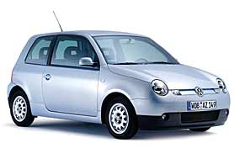
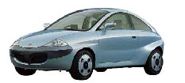

Figure 1.5 Volkswagen Polo and Nissan Cypact
http://www.volkswagen.vw-audi.es/lupo3L/index_m.htm,
http://www.motorshow.or.jp/show99/English/CONCEPT/opl01.html

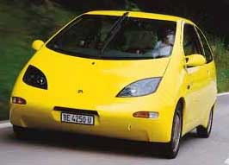

Figure 1.6 Renault / Greenpeace Smile
http://www.greenpeace.org/~climate/smile/index.html

Ford also has done some studies about the feasibility of the 3 litre car. An example can be seen in Deacon et al, where they try to achieve the 3 litre car by modifying a diesel Ford Ka. Finally, they achieved a consumption of the 3.1 litre / 100 km by using EGR, special tyres, lower inertia, low friction engine oil and optimising the gear ratios.

The data available from these concept cars is the following:

 | Smile | Insight | G90 | N cypact | Lupo
Cd | 0.25 | 0.25 | 0.22
Af | 1.9
Weight | 650 | 835 | 750 |  | 874
Length | 3480 mm | 3945 |  | 3740 | 3530
Width | 1423 mm | 1695 |  | 1630 | 1620
High | 1423 | 1355 |  | 1420 | 1460
Cylinder | 2 cylinder | 3 cylinder | 3 cylinder | 4 cylinder | 3 cylinder
Sweep volume | 358 cc | 995cc | 973cc |  | 1196cc
Special feature | supercharger 2.6 bar | hybrid |  |  | VGT and intercooler
Power | 55 hp | 50Kw-56Kw with assistance (68-76kw Honda internal data) |  | 55 kw | 61 hp
fuel type | super unleaded | petrol | petrol | Diesel di | Diesel DI
Consumption | 3.3 l | EUDC 3.4 l | 3.88 l | 3.4 l | 4.1 l
Compression ratio | 9:01 | 10.8:1

Table 1.4 Concept car data

All the data presented and the pictures was obtained from:
http://www.greenpeace.org/~climate/smile/index.html, http://www.honda.co.uk/news/technicalinfo.html, http://www.hybridcars.com/honda.htm, http://www.volkswagen.vw-audi.es/lupo3L/index_m.htm, http://www.motorshow.or.jp/show99/English/CONCEPT/opl01.html

1.7 Effect of fuel economy improvement technology on other vehicle attributes.

An improvement in fuel economy will have impact in other important attributes of a car, such as: styling, ride handling, performance, NVH, driveability, durability, safety features, accessories, passenger accommodation and cargo carrying capacity.
As suggested in Austin et al emissions, driveability and NVH will be the elements most influenced by the changes due to the 3 litre car target. As it is impossible for the author of this thesis to estimate any of these impacts, the following tables, from Austin et al, are included in order to give an idea of these impacts and possible solutions.

Description of Measure | Attribute Impact
Packaging Improvements | Safety concern not quantified
High-Strength Steel Body | Same as Above and -1 NVH
Lightweight Interior | Safety concern not quantified
Lightweight Chassis | Same as Above
Aluminum Body Closures | Same as Above
Aluminum Body | Same as Above
Aluminum Cylinder Heads | Same as Above
Aluminum Engine Block | Same as Above
Minimum Practical Aero Drag w/ Existing Bodies | No Significant Impacts
Minimum Practical Aero Drag w/ New Bodies | No Significant Impacts
5% Lower Rolling Resistance | No Significant Impacts
10% Lower Rolling Resistance | No Significant Impacts
Zero Brake Drag | No Significant Impacts
Neutral Idle Plus Aggressive Shift Logic | -1 Driveability
T1 + Early Lockup | -2 Driveability
5-Speed Automatic w/ ASL and Early Lockup | -2 Driveability, -1 Gradeability
CVT | -1 NVH, +2 Gradeability
Higher Compression Ratio | No Significant Impacts
4-valve Cylinder Heads | No Significant Impacts
Mild Turbocharging | -1 NVH, -1 Driveability, -1 Towing
4-valve VVL&T | -1 Driveability
B4 w/ Cylinder Deactivation | -2 NVH, -2 Driveability
Miscellaneous Friction Reduction | No Significant Impacts
Lean Burn | -1 Driveability, NOx Emissions ?
Oil/Water/Fuel Pump Improvements | No Significant Impacts
Cylinder Deactivation | -2 NVH; -2 Driveability
Electric Power Steering | No Significant Impacts
Miscellaneous Parasitic Loss Reductions | No Significant Impacts
Turbocharged D.I. Diesel | -2 NVH, -3 NOx/PM Emissions

Table 1.5. Effect of fuel economy improvements on other vehicle attributes
Austin et al

Measure | Mitigation Technique (Added Weight)
High-Strength Steel Bodies | Reinforcements, extra support for suspension cradle, etc. (20 lbs.)
All Other Weight Reductions | None Identified
All Drag Reductions | None Required
Neutral Idle Plus Aggressive Shift Logic | Electronic Throttle Control (ETC) and Improved Controls
Above + Early Lockup | ETC, Viscous Clutch, Improved Mounts
Above + 5-Speed Automatic | ETC, Viscous Clutch, Improved Mounts
CVT | ETC, Noise Suppression Package #1 (44 lbs.)
Higher Compression Ratio | (Knock Sensors Included)
4-valve Cylinder Heads | None Required
Mild Turbocharging | ETC, Noise Suppression Package #1, Improved Cooling (44 lbs.)
4-valve VVL&T | ETC
VVL&T + Cylinder Deactivation | ETC, Improved Mounts/Suspension, Noise Suppression Package #2 (62 lbs.)
Lean Burn | ETC
Cylinder Deactivation | ETC, Improved Mounts/Suspension, Noise Suppression Package #2 (62 lbs.)
Friction Reduction | None Required
Parasitic Loss Reductions | None Required
Turbocharged D.I. Diesel | Noise Suppression Package #2 (62 lbs.)

Table 1.6. Possible mitigation techniques for the effects of fuel economy improvements on other vehicle attributes. Austin et al

1.8 Introduction to the thesis work
The purpose of this thesis it to use a structured approach to explore the feasibility of the 3 litre per 100 km fuel consumption small family petrol car with regular port fuel injection. For this purpose the engine simulation program AVL Boost was used to predict the levels of performance from engine configurations thought to be appropriate to the problem.
This thesis discusses a structured approach to the problem, starting with the reasons which promote the target of the 3 litre car. Then it describes a general study of possible improvements to achieve the 3 litre car.
The next natural step is to make some engine simulations and with the aid of a program which simulate the European Test cycle, to calculate the viability of the 3 litre car. But as there was not available other thesis or works with the engine simulator AVL Boost, this thesis is going to cover also some theoretical aspects involved in the engine design and engine simulation, which were used in the engine simulations discussed at the end of the thesis. The discussion of engine design and engine simulation are not only important for the work of this thesis, they also will be important for future works based in engine simulation and specially based in AVL Boost.
Later. are performed some sensitivity analysis of parameters which affect engine performance. These sensitivity analysis allowed to obtain a final model.
Finally at the end of the thesis, a program made by the author which calculates the fuel consumption of an engine simulated in AVL Boost or in other engine simulator, is explained. This program with the data obtained from AVL Boost allowed to make important conclusions as result of the whole work performed for this thesis.
The last thing to mention in this introduction to the thesis work is that this project is supported by AVL List GmbH, Austria.

