APPENDIX 5

INSTRUMENTS SPECIFICATIONS

The single axis rate gyroscope
Characteristic | Value
Angular velocity Range | 0.2 to 100deg/s or 0.1 to 50 deg/s
Angle range | +/- 45º max.
Roll, Pitch | +/- 45º max.
Yaw | +/- 180º max.
Accuracy | +/- 1 % FS
Bias drift | +/-2 deg/ Hr.
Resolution | 0.1 deg.
Operating Temperature | -20 to +70 ^{O}C
Bandwidth | 10 Hz
Dimansions | 75.6 x 42.5 x 65 mm

The three axis accelerometer
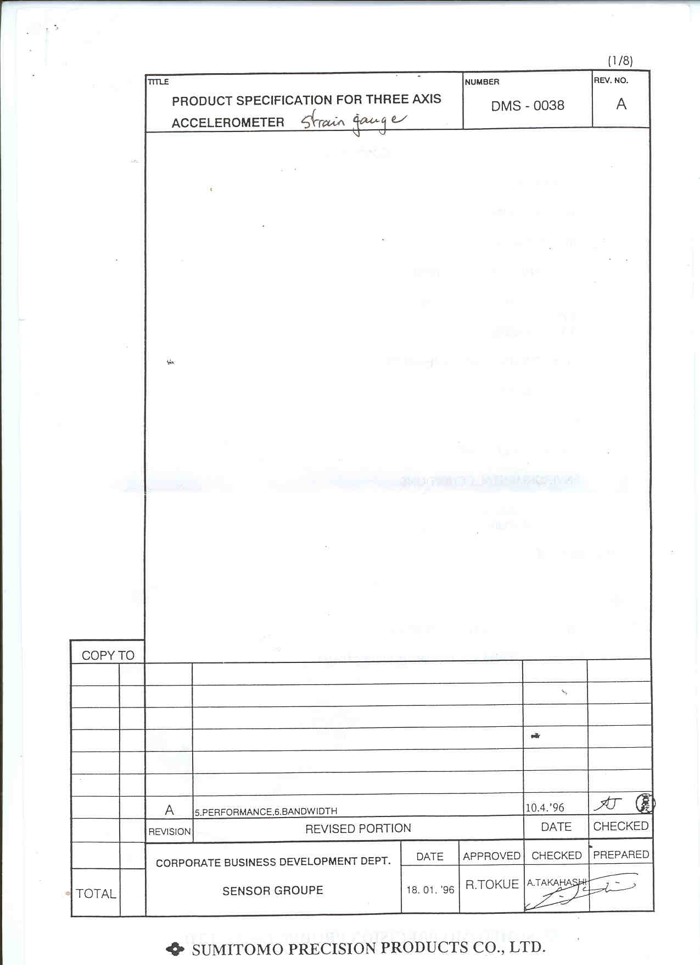

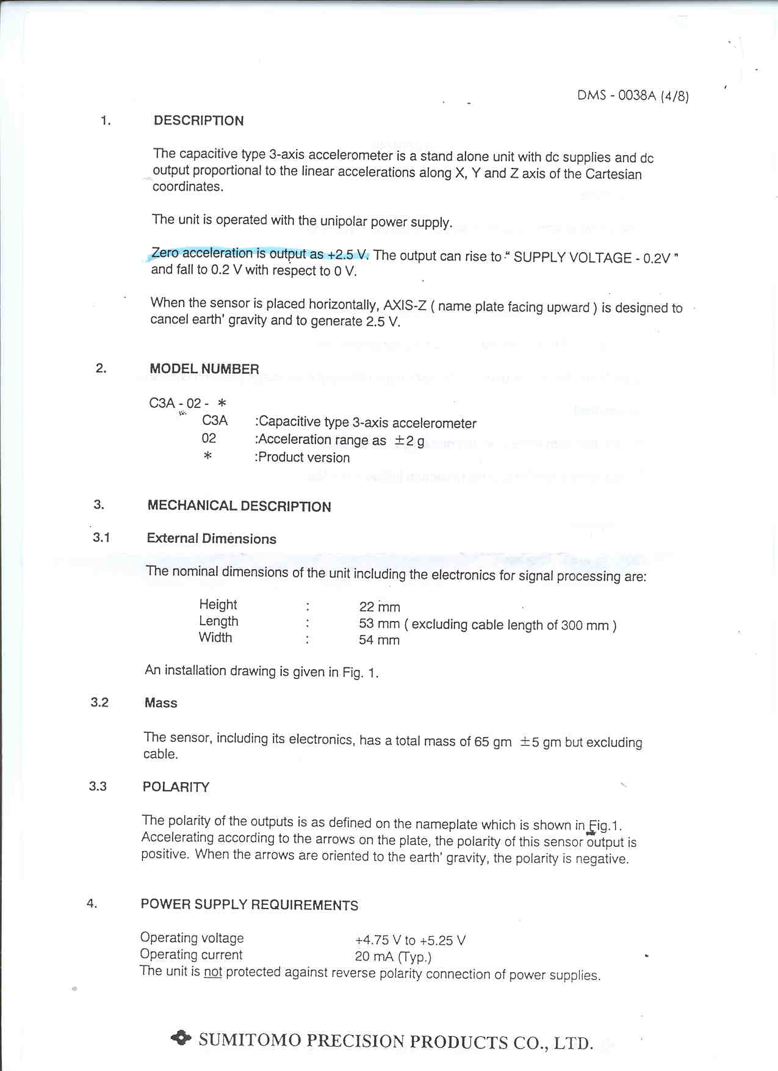

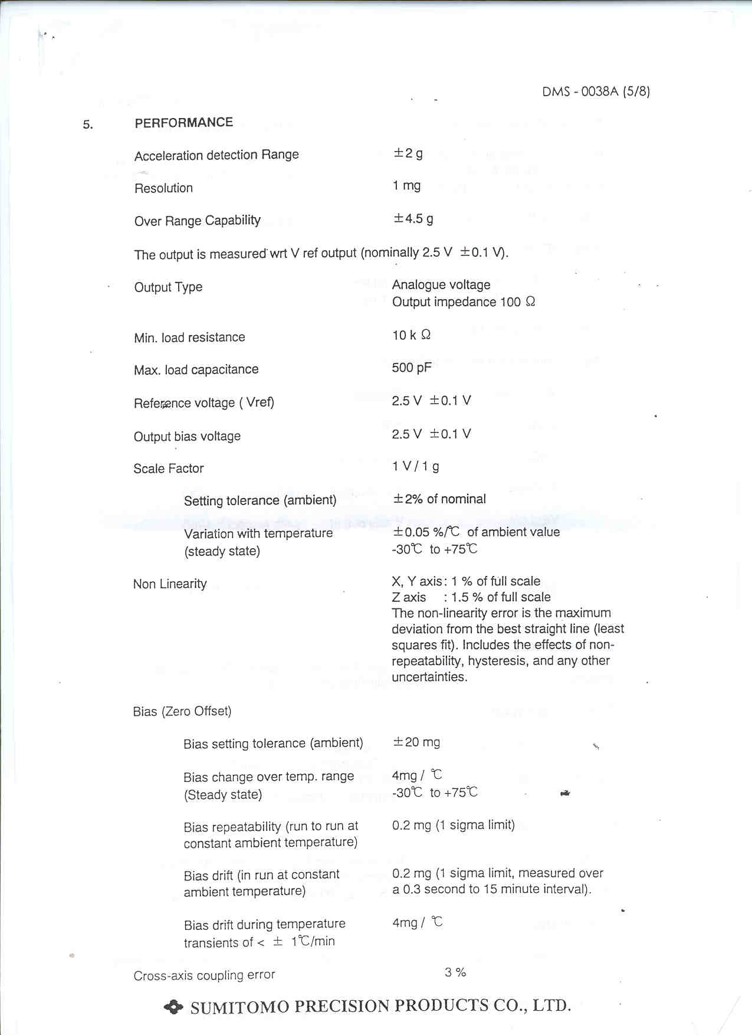

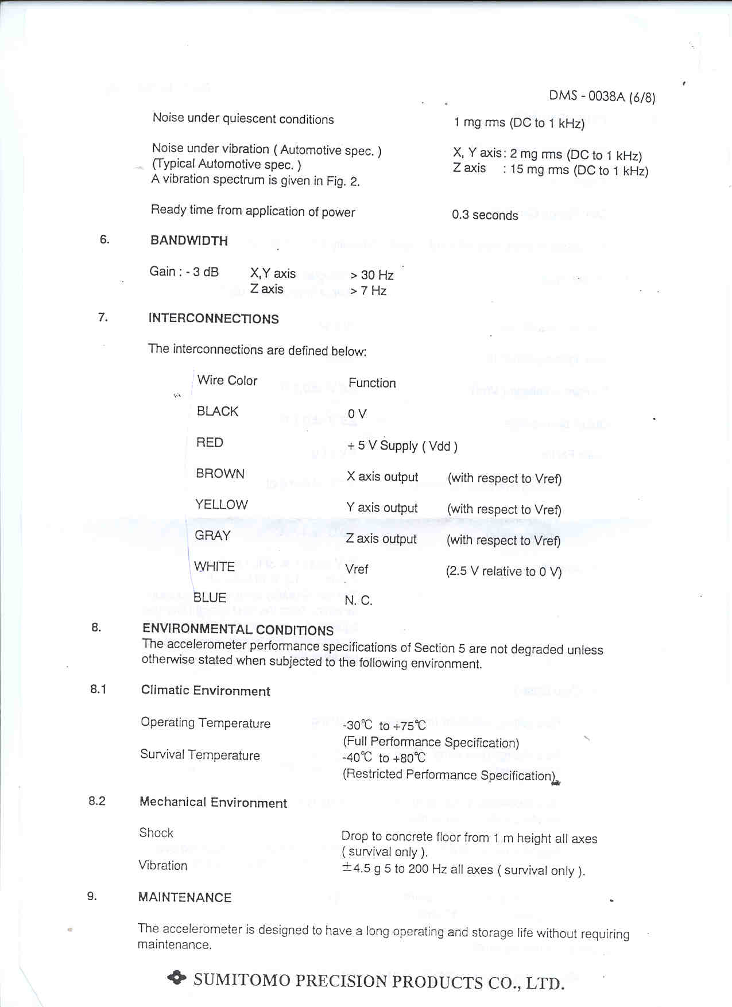

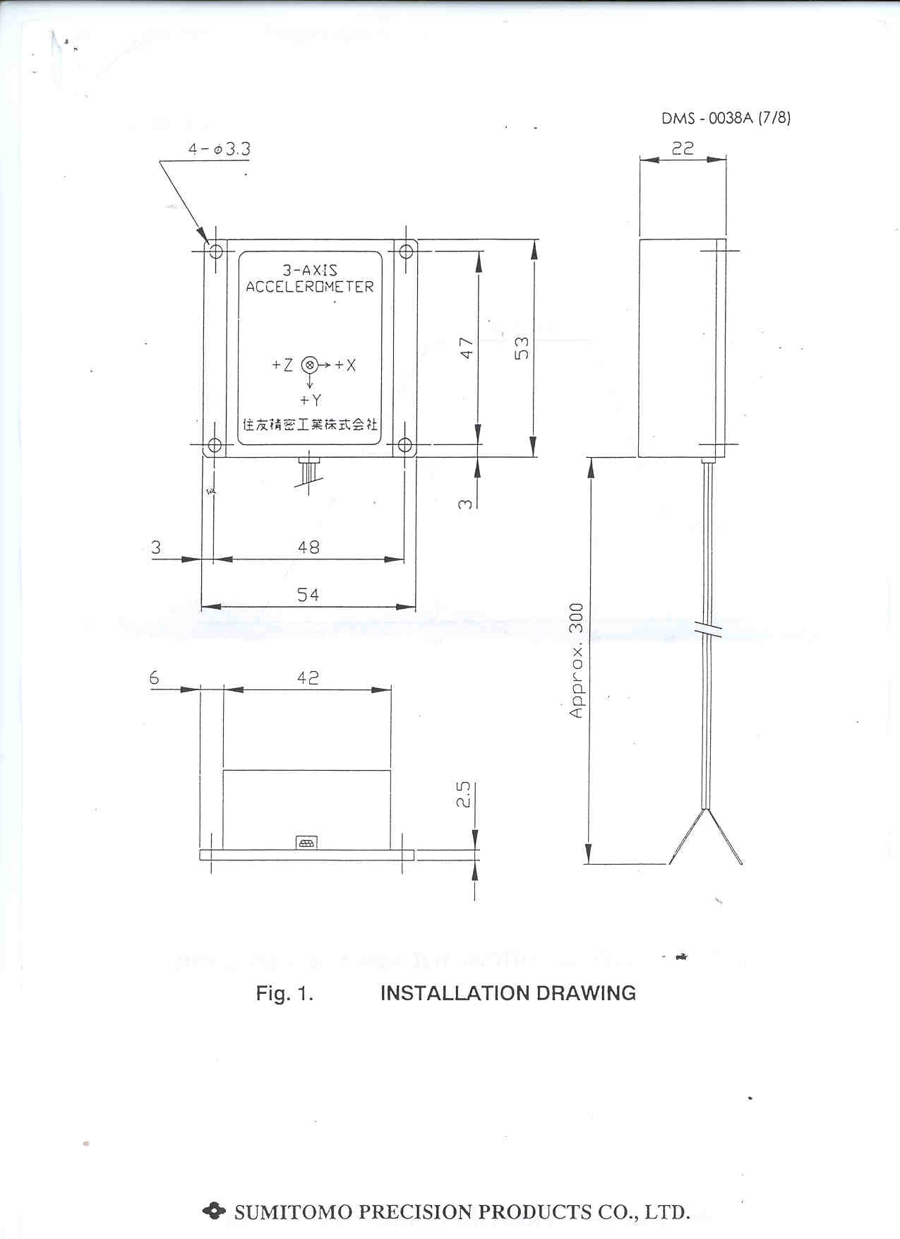

The hand steering wheel potentiometer

RS Spectral 534 Series 200Ω ref 173-366
22 mm 3W 10 turn wirewound
- resistance tolerance ± 5 %
- Linearity (independent) ± 0.25 %
- Mechanical rotation 3600 +10° -0°
- Starting torque 36 gcm
- Operating temperature -55°C to 125°C
- ∅22.22 L 19.1
- Shaft ∅6.35 L 20.6
- Mounting bush ∅9.5 L 35

Power supply converters:

- RS 5 w Regulated Dual output NMX SO Series. Model: NMXD 1205. SO 12. Voltage output is ±5V and the maximum current output is 500 mA.
- RS Vehicle power adaptor (12V DC to 230V AC). Model SM 1791.Provides 230V rms quasi-sine wave output suitable for use with equipment fitted with a mains transformer. It is a 120 w Battery to Mains Converters, with a input voltage between 11 and 32V DC and a 230V AC output voltage.

