Appendix 4.2. Fmep
In this appendix are going to be explained the procedures to estimate the fmep and fmep models that are more complex than the Heywood’s, explained in chapter 4.
The main reason for this appendix is that the fmep is one of the key points for improving fuel economy in passenger cars, as showed in sections 4.3.1 and in 2.9. and therefore further explanation from the given in chapter 4 was needed. Also it was included because it will be useful for future engine simulation works.

A4.2.1 Measurement methods of the fmep
To obtain any of the following fmep expressions, the authors of the following models had completed many engine tests and with the data obtained by applying different mathematical approaches, they have obtained different fmep equations.
Muñoz and Payri (1989) and Ferguson explain four methods to measure the fmep, which are briefly explained below.
- Measurement of fmep from imep. The fmep is the difference between break mean effective pressure (bmep) and indicated mean effective pressure (imep). To obtain the imep is needed accurate pressure data versus crank angle, which is not easy. Just this method gives the exact value for the fmep.
- Direct motoring test. It is calculated by measuring the power needed to motor the engine. Even though it gives an underestimation of the fmep as discussed later, it is wide spread used because is the only method that allow to measure the losses of each element by removing elements.
- Willans line. It is obtained from a fuel consumption plot versus brake output obtained from engine tests and extrapolating to zero fuel consumption.
- Morse test. The fmep is obtained by measuring the reduction in brake torque when one of the cylinders is cut out from firing.
Another point to take into account is if the data obtained to generate correlations comes from a motored engine or from a firing engine. The motored engine gives less fmep, mainly due to:
- It has lower pressures and therefore lower gas loading and lower rubbing friction.
- Temperatures in motored operation are lower, producing grater viscosity of the lubricant and therefore increasing viscous friction. In the other hand, the clearances are bigger due to the lower temperature, which tends to make friction lower.
A comparison between motored an fired engines is provided by Heywood (1988) and by Ferguson (1986).
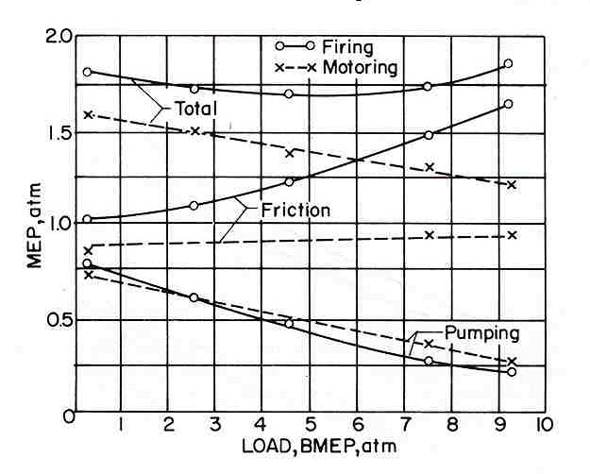
Figure A4.2.1 fmep comparison between gasoline engine motored and fired
Ferguson (1986)

Ferguson (1986) states the fmep motored is equal to the fmep of a fired engine in diesel engines and in gasolines with low load. As can be seen in the figure, there is significant difference between motored and fired gasoline engines at high loads.

A4.2.2 Estimation of fmep
There are several empirical equations for estimating the fmep, each one uses different parameters and needs different degrees of definition of the engine. They are going to be introduced in order of complexity, and therefore the order of use in an engine design process.

a) Heywood equation (1988)
It is described in chapter 4. It is mentioned in order to clearly show the order of complexity of each model
$$\text{tfmep}(\text{bar})=\text{ 0}\text{.}\text{97}+0\text{.}\text{15}⋅\left(\frac{N}{\text{1000}}\right)+0\text{.}\text{05}⋅{\left(\frac{N}{\text{1000}}\right)}^{2}$$

b) Arsie et al (1999)
This paper discuss first of all two complex models to estimate the mechanical efficiency, that is equivalent to estimate the fmep as shown in equation 4.7. These models are Rezeka-Henein and Patton-Nitschke-Heywood.
The first model takes into account the losses due to piston rings viscous lubrication, losses due to mixed lubrication of piston rings near top dead centre, loses due to piston skirt friction, valve train friction, auxiliaries and bearing friction.
The second model takes into account friction losses in crankshaft bearings, reciprocating components, valve train, auxiliary and pumping losses.
They also give a simpler equation to calculate the mechanical efficiency, based in non linear regression of several engine conditions. This formula is not an accurate description of the physical phenomena of friction losses because it does not take into account lubrication regimes, oil film thickness and gas pressure. But as they prove, it gives very good results.
$$\begin{aligned}η_{m}=\text{10}\text{.}\text{82402}+0\text{.}\text{0173}⋅\left(\frac{N⋅T}{{\text{10}}^{3}}\right)−0\text{.}\text{3859}⋅{\left(\frac{T}{{\text{10}}^{2}}\right)}^{2}−0\text{.}\text{5217}⋅{\left[{\left(\frac{N}{{\text{10}}^{3}}\right)}^{2}{\left(\frac{P_{\text{man}}}{{\text{10}}^{4}}\right)}^{2}\right]}^{0\text{.}\text{2365}}− \\ 0\text{.}\text{5410}⋅\left(\frac{{\text{10}}^{3}}{N}\right)−\text{10}\text{.}\text{8629}⋅{\left[\left(\frac{N}{{\text{10}}^{3}}\right)⋅{\left(\frac{T}{{\text{10}}^{2}}\right)}^{2}\right]}^{−6\text{.}\text{89}\text{.}{\text{10}}^{−3}}+0\text{.}\text{001439}⋅\left(T_{\text{man}}\right)+0\text{.}\text{06819}⋅\left(P_{\text{man}}\right)+ \\ 0\text{.}\text{00231}⋅\left({\overset{\text{.}}{m}}_{\text{air}}\right)\end{aligned}$$
With P_{man} intake manifold pressure in Pa, T_{man} intake air pressure in ºC, N engine speed in rpm, T brake torque in Nm and m_{air} intake air flow in kg/h.
Note that this formula is useless for the first approach to the simulation because it requires knowledge og the torque, mass of air and intake manifold conditions, while these are not known before the simulation. But it is also important that the data needed to use this formula can be obtained from the output of any engine simulator program and it will be useful for future analysis.

c) Yagi et al equations (1990)
Yagi et al has shown by testing motorcycle engines that the fmep is nearly proportional to $\sqrt{\frac{S⋅D_{\text{cm}}}{B}}$ with B bore, S stroke and D_{cm} the equivalent crank diameter. The equivalent crank diameter depends on number of cylinders, diameter of crank journal and diameter of crank pin.
They also show that the pumping loss is proportional to ${\left(V_{s}⋅\frac{N_{e}}{Z}\right)}^{2}$ where Vs is the stroke volume, Z the effective valve opening area and Ne the engine speed.
They suggest an empirical equation to estimate the fmep:
$\text{fmep}=\left\{\text{60}⋅{\text{10}}^{−9}⋅{\left(V_{s}⋅\frac{\text{Ne}}{Z}\right)}^{2}+1\text{.}1⋅{\text{10}}^{−9}⋅N_{e}^{2}+0\text{.}\text{0011}⋅ν+0\text{.}\text{14}\right\}⋅\sqrt{\frac{S⋅D_{\text{cm}}}{B}}$
Where ν is the kinematic viscosity.
Limitations:
- Oil temperature 80±2º C
- λ= 2 l /S >3.7 (l conrod length)
- 0.6 < $\sqrt{\frac{S⋅D_{\text{cm}}}{B}}$ < 0.8
- Engine speed ≤ 10000 rpm
This formula incorporates new parameters compared with Heywood’s and Arsie’s, as the viscosity of the lubricant and some geometric parameters as bore, stroke and equivalent crank diameter. This formula needs to know estimate the oil viscosity and the equivalent crank diameter, that will imply to have mostly designed the engine, with most of the geometric dimensions defined.
Some values obtained by them could be seen to give an order of magnitude for the fmep are in the following graph:

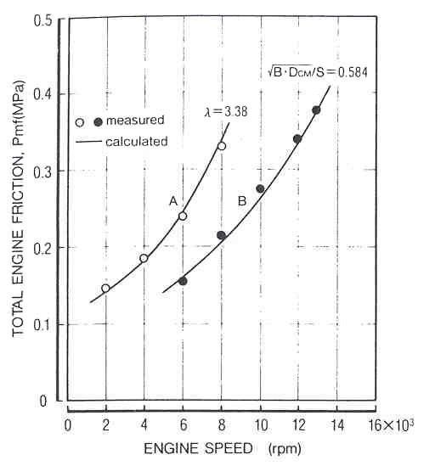
Figure A4.2.2 Comparison of measured and calculated fmep, when λ or √ (S D_{cmc}/B)
are out of the specified limitations. Yagi et al (1990)
.

Even when the formula is out of its limitations, still being a good correlation between measured and calculated data. All the others out of specified limitations can be seen in similar graphs in the paper.

d) Ferguson and Kirkpatrick (2001)
They give very useful formulae for each of the elements which contributes to the fmep. Although all this data is not useful for this thesis will be very useful for future works. Moreover, they have a program that calculates the fmep just by introducing some design parameters such as the bore, stroke, compression ratio, intakes characteristics and bearings diameters. This program is available in
http://www.wiley.com/college/mechs/ferguson356174/apps/friction/friction.html
It is also interesting the break down they perform the fmep of a diesel engine.

e) Bishop. Further models.
The more complex the model and the more parameters it has, hopefully the better descriptor of the fmep phenomena is. For this thesis these models are useless because they require a great amount of data from the engine, that will be obtained in later steps of the engine design. But it is important to highlight its importance at early stages of the engine design, in order to improve the engine performance and fuel economy.
In addition to the simple models explained, more complex models with equations for each of the elements of the fmep break done are available in Heywood (1988), Bishop (1964) or in Lee et al (1999).
For example Bishop (1964) divides the fmep in five components: crankcase mechanical friction, compression-expansion pumping loop losses, exhaust and inlet system throttling losses, combustion chamber and valve pumping loop losses and piston mechanical friction. He also divide some of them and study them separately, giving a expression for each of the elements he study.

