Appendix 4.1. Cam design
The motion of the valve is determined by the cam profile and is needed as an input to AVL Boost. Before moving into possible approaches to define it, it is necessary to mention some conditions that the cams have to comply with and which will limit the cam shape.
In order to fit the valve tightly, it is necessary to have some clearances in the valve mechanism to absorb expansions and wear. This clearance should be absorbed at the beginning of the ramp, in a zone of constant velocity and with a velocity which produces low values of impact forces, produced when the follower finds the ramp. Then the valve should suffer a quick lift, producing high acceleration, zone A. Finally the valve is decelerated to a zero velocity in the maximum lift point. Important limitations to the system are the impact forces and the dynamic forces produced by the accelerations.
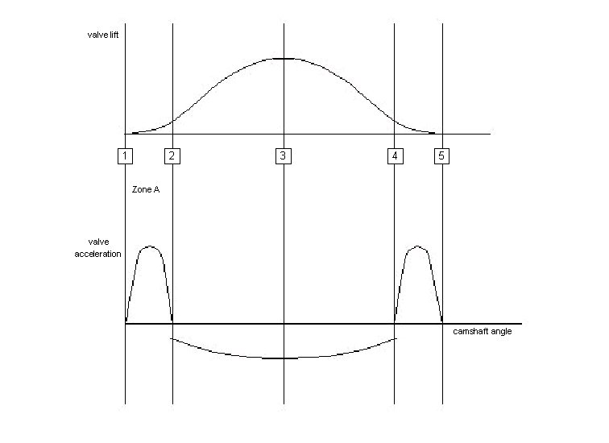
Figure A4.1.1. Cam profile and cam acceleration

There are also some important specific points. Points 1,3 and 5 are determined by valve timing and valve lift and points 2 and 4 are limited by the chosen limits on valve gear load and spring load.
It is necessary to have a mathematical descriptor for the valve lift profile in order to obtain the desired valve lift for later use it in an engine simulator program or to manufacture the valve. But also it will be need to be aware that the actual valve motion differs from the designed motion due to valve-gear elasticity, Taylor (1985, p543, vol 2).

A4.1.1 Cam description
There are several mathematical approaches to describing the cam profile as discussed in Heisler (1995). The following methods are discussed: three arc cam, constant velocity cam, constant acceleration cam (parabolic), simple harmonic, cycloidal cam, multisine wave cam and cam with quietening ramps.
A few years ago, the most common approach to describe the valve motion and cam shape were to use polynomials. But nowadays, as discussed in Mosier (2000), they have been replaced by spline descriptors because they are much powerful mathematical descriptors. With this mathematical approach, the lift can be defined by lift points (e.g. at low speeds) or can obtained as integrals of the acceleration, e.g. at high speeds where the dynamics are very important. The most commonly used spline bases are the B-splines and knots, Mossier (2000).
Further description of the design process of the cam follower motion and cam profile can be found also in Mosier (2000).
It is necessary to describe the lift profiles of the valves to introduce them as an input to AVL Boost. To describe the lift profile, for this thesis, the polynomial approach has been chosen because is easier to use than the splines and because it is not needed a degree of profile refinement that will make the splines description necessary. The polynomial description used was found in Muñoz and Payri (1989) and is defined as follows.

$$L=L_{\text{max}}+C_{2}⋅α^{2}+C_{a}⋅α^{a}+C_{e}⋅α^{e}+C_{i}⋅α^{i}+C_{u}⋅α^{u}$$
Where L is the valve lift, α is the crank angle.
a, e, i, u are variables and C_{i} are coefficients that are defined as:
$C_{2}=\frac{−a⋅e⋅i⋅u⋅L}{\left(a−2\right)⋅\left(e−2\right)⋅\left(i−2\right)⋅\left(u−2\right)⋅L^{2}}$ $C_{a}=\frac{2⋅e⋅i⋅u⋅L}{\left(a−2\right)⋅\left(e−a\right)⋅\left(i−a\right)⋅\left(u−a\right)⋅L^{a}}$
$C_{e}=\frac{−2⋅a⋅i⋅u⋅L}{\left(e−2\right)⋅\left(e−a\right)⋅\left(i−e\right)⋅\left(u−e\right)⋅L^{e}}$ $C_{i}=\frac{−2⋅a⋅e⋅u⋅L}{\left(i−2\right)⋅\left(i−a\right)⋅\left(i−e\right)⋅\left(u−i\right)⋅L^{i}}$
$$C_{u}=\frac{−2⋅a⋅e⋅i⋅L}{\left(u−2\right)⋅\left(u−a\right)⋅\left(u−e\right)⋅\left(u−i\right)⋅L^{i}}$$
The main problem of this equations to define the lift is that it is not clear the influence of each parameter and as well it gives the maximum opening point at 0 crank angle and it does not allow to define the valve opening time. Therefore a program was made in Visual Basic in order to solve this facts and to provide a complete interface to calculate the valve lift.

A4.1.2 Valve lift programs
The valve lift program is made in Visual Basic, in order to control an Microsoft Excel interface. It consist of 4 main subprograms: calculations and drawing, change sheet, plot sheet and real lift. All of them are associated to buttons to make the interface easier.
These programs made possible the study done in point 5.5.1.

a) “Calculation and drawing” program
This program cleans completely the Excel sheet, including the graphs. Then it ask for the number of points to develop an initial table. From this initial table table, it extracts and draw automatically only the useful data: positive lift values of the previous calculated table. Further explanation is given in the following picture.
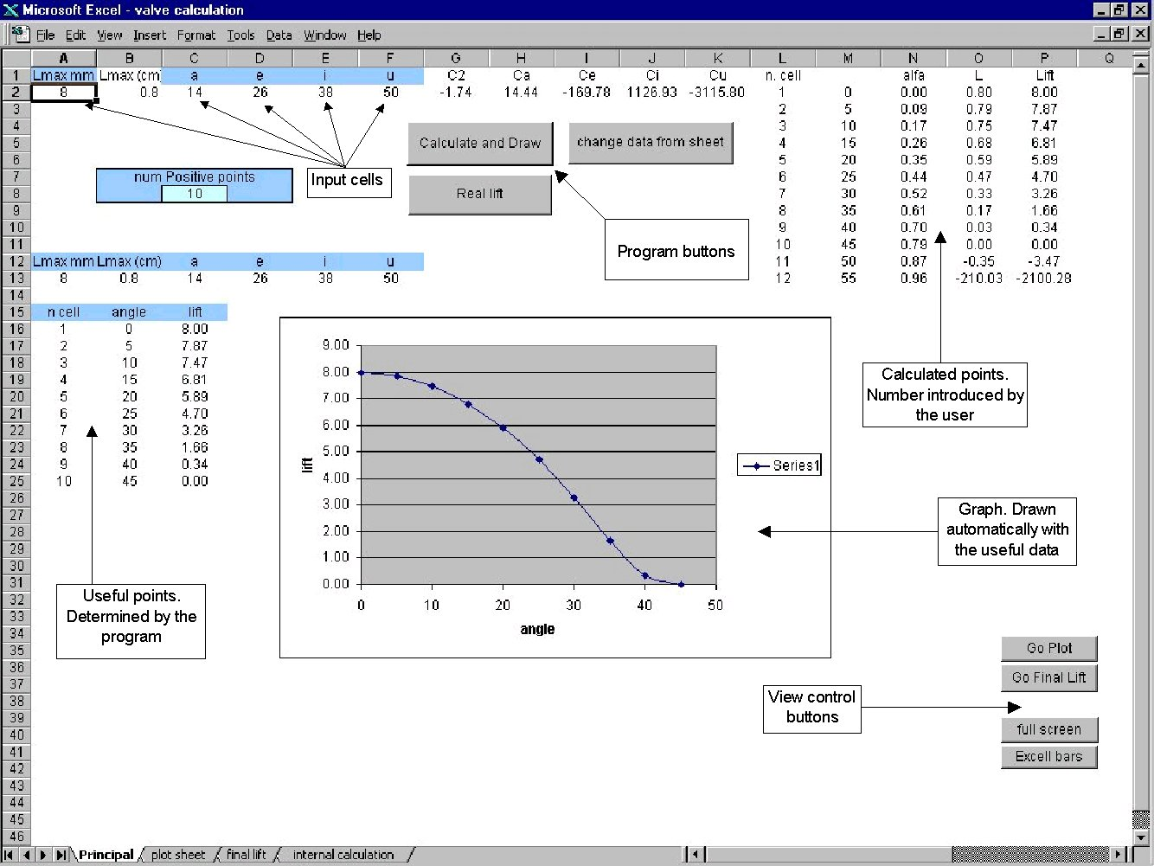

Figure A4.1.2. Principal Excel sheet of the created program.

b) “Change sheet” and “plot sheet” programs
“Change sheet” and the “plot sheet” programs where made to allow to see the influence of the different parameters of the valve lift formula.
“Change sheet” program changes the table obtained by the “calculation and drawing program” and moves it into another Excel sheet called plot sheet. This operation can be made as many times as the user wants. All the moved tables will be stored in order in the plot sheet.
When the user considers he/she has enough tables to compare, by using the plot sheet button, it will plot all the different tables of the plot sheet.
Note that despite the tables stored in the plot sheet have different sizes, all of them will be plot in a unique graph, allowing an easy comparison between them. Further information can be seen in the following picture.
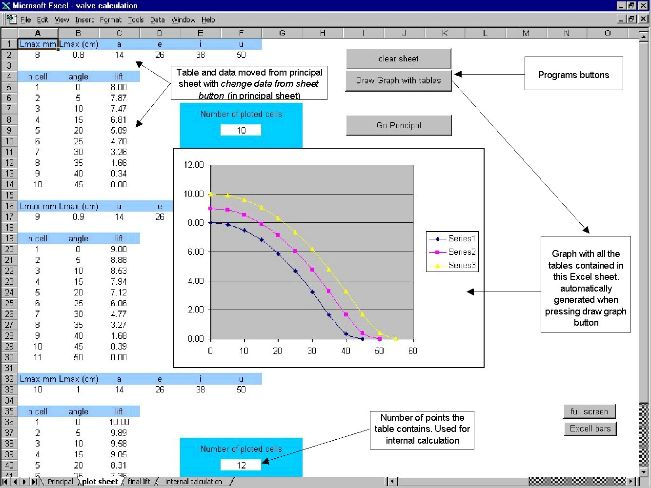
Figure A4.1.3 .Plot Excel sheet of the created program

c) “Real lift program”
The “calculation and drawing program” will produce a table that describes just a half of the cam shape with the lift the user would have specify. This values are useless because the user did not specify the opening time and the maximum opening point. This specifications are introduce by the “real lift program”. This program will ask for a x scaling factor (to adjust the opening time), for a y scaling factors (to allow to correct possible shape distortions due to the x scaling factor) and for the degrees at which the maximum opening point will occur. Then a new table, a new graph and the user inputs will be presented in new Excel sheet.
This last table obtained can be directly introduced to Boost program. Further explanations are given in the following picture.
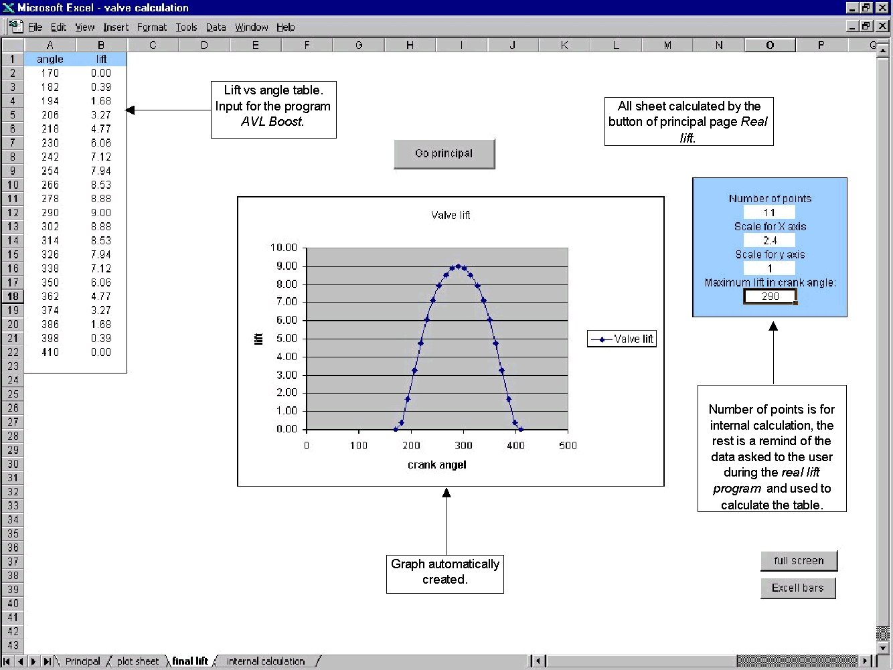

Figure A41.1.4. final lift Excel sheet of the created program

