Appendix A. Engine parameters and checks.

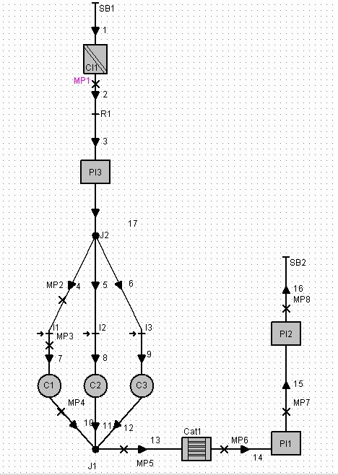
Figure A.1 Final model diagram

A.1 Engine parameter values

Cylinder
Bore | 62 mm
Stroke | 65 mm
Swept volume | 0.6 litres
Connecting rod | 113 mm
AFR | 14.5
Compression ratio | 10.5
Combustion model | Vibe function
Cylinder heat transfer | Woschi 1978
Ports heat transfer | Zapf
Scavenge model | Perfect mixing
Effective blow by gap | 0.0008 mm
Start combustion | 715 crank angle
Combustion duration | 50 crank angles
Shape Parameter | 1.6
Parameter a | 6.9

Piston surface area | 3300 mm²
Cylinder head area | 3500 mm²
Liner piston | 204 mm
Wall temperatures | 550 K

Valves
Intake valves |  | Exhaust valves
Valve diameter | 23 mm | Valve diameter | 19 mm
Opening time | 350ºCrank | Opening time | 170ªCrank
Duration | 220ºCrank | Duration | 220ºCrank
Lift | 10 mm | Lift | 10 mm
Scaling factor | 1.68 | Scaling factor | 1.7

Tables A.1 Engine parameters values

Please note that 720 degrees of crank angle is TDC.
Please note that the valve size is little smaller than in the sensitivity analysis because in the sensitivity analysis the engine has a swept volume of 0.7 litres while in the final model this is 0.6 litres.
The valves profiles and valves tables can be observed in the following pictures created with the valve lift program made by the author of this thesis.

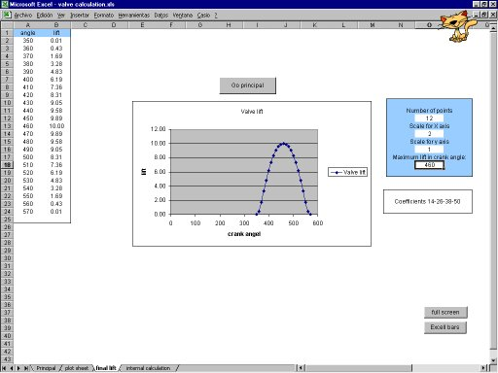

Figure A.2. Inlet valve lift curve generated by valve lift program

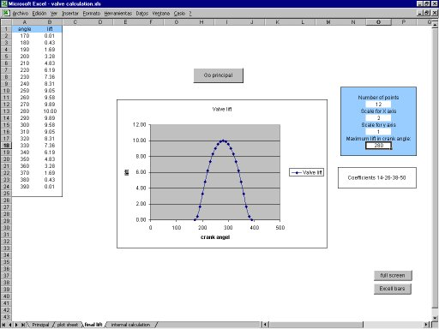

Figure A.3. Exhaust valve lift curve generated by valve lift program
Pipes
 | Length (mm) | Diametre (mm)
1 | 850 | 50
2 | 130 | 50
3 | 70 | 50
4 | 300 | 25
5 | 300 | 25
6 | 300 | 25
7 | 60 | 25
8 | 60 | 25
9 | 60 | 25
10 | 100 | 21.5
11 | 100 | 21.5
12 | 100 | 21.5
13 | 20 | 45
14 | 1500 | 45
15 | 1000 | 45
16 | 70 | 45
17 | 100 | 50
Friction coefficient = 0.019

Others | Volume (l) | Flow coefficient
Pl1 | 6 | 0.6
Pl2 | 3 | 0.9
Pl3 | 3 | 0.6
Cl1 | 5 | 1
Cat1 | 5 | 1
Junction | Flow coefficient
J1 | 0.49
J2 | 0.9

Tables A.2 Pipes, plenums, junctions, air cleaner and catalyst characteristics

Further information about the engine configuration, output values and computing information can be found in appendix D.

A.2 Checks
The following graph with the different efficiencies was used to check that the engine had standard values and standard behaviour. Their shapes and values could be compared with any engine book such as Heywood (1988) or Taylor (1985)
Figure A.4. Efficiencies of the engine.

At 3000 rpm where obtained the following results:
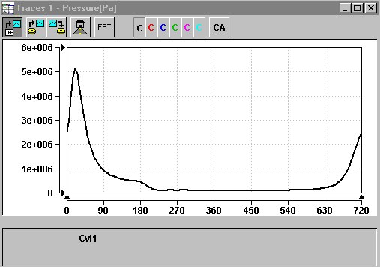
Figure A.5. Pressure against crank angle

As can be seen the peak pressure is around 50 bar, normal value for an engine, Muñoz et al (1989)
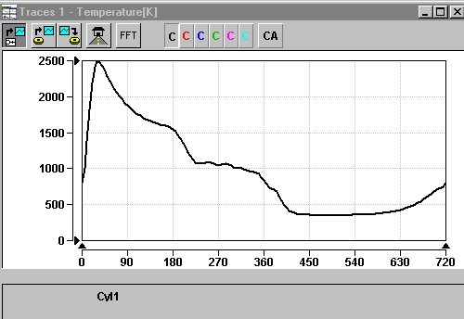

Figure A.6. Temperature against crank angle

The maximum temperature achieved is 2500 K, value close to the flame temperature of 2585 obtained by Moss.
Please note that the fluctuation in temperature during the exhaust (around 270º) is due an oscillation in the exhaust mass, as can be seen in the following graph.
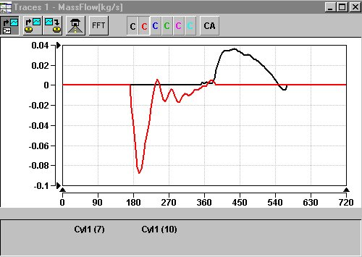

Figure A.7. Mass flow to the cylinder against crank angle at 3000 rpm.

From this graph can be seen that the valves opening times and lift are not optimised for this engine speed. Please note that they are optimised for example at 5000 rpm as can be seen in the following graph.
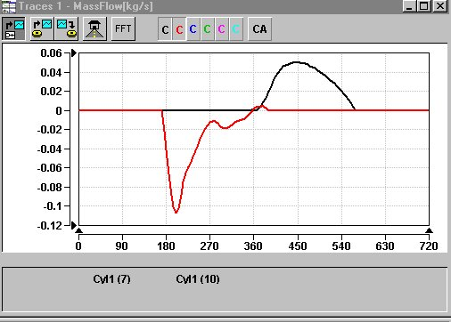

Figure A.8 Mass flow to the cylinder against crank angle at 5000 rpm.

Please note that the mass flow shape of the exhaust process of this graph is similar to that shown in Ferguson (1986)

