8- Final comparisons
As can be seen in the graphs in the group D section, the driver was able to excite the car between 0.5 Hz and 2.5 Hz in the unladen case and between 1Hz near 2.5 Hz in the laden case. Therefore we would expect coherence near zero out of these ranges, as can be seen in the coherence plots.
In the coherence graphs (also in group D section) we can appreciate coherence of one in the mentioned ranges for the yaw rate and the roll rate. Also is important to remark that even though we found spikes in one direction of the lateral acceleration, the coherence obtained is very good between 0.5 Hz and 1.8 Hz for the unladen case and between 1 Hz and 1.9 Hz in the laden case.
The test results are only reliable in those places where the coherence is near to one. Hence the comparison between the test and the models should be only done in the above ranges. Comparisons between linear model, non-linear model and Carsimed can be done in all the frequency rage because they are not affected by the noise in the sensors. Just care should be taken with Carsimed because its input is the steering angle measured in the test, but we consider that the steering input will not suffer great noise contamination, therefore we will consider this model out of noise. Also in Carsimed we should rely only in the frequencies where we have excited the steering wheel (as comment above).
In the following pages are presented the final graphs.

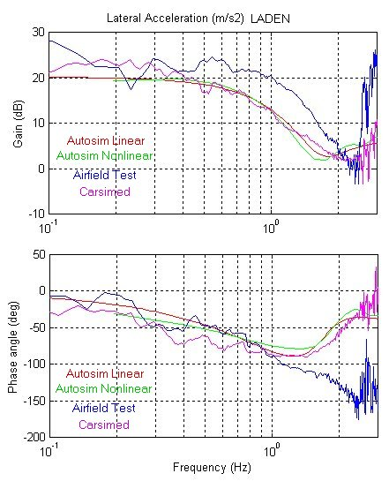

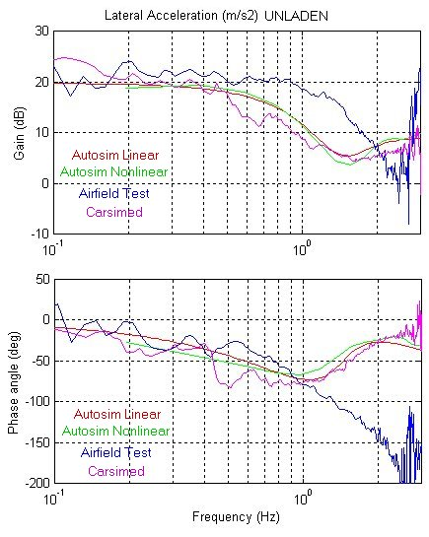

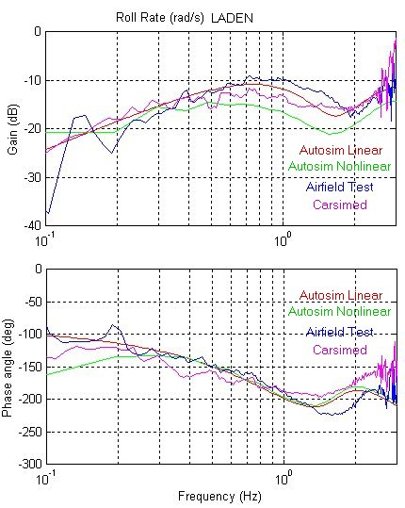

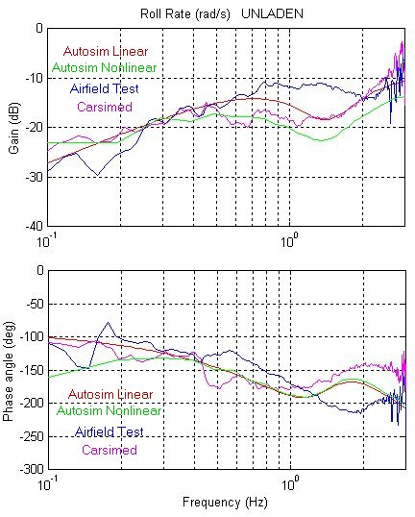

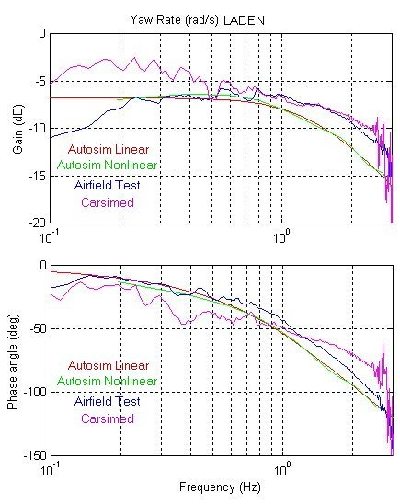

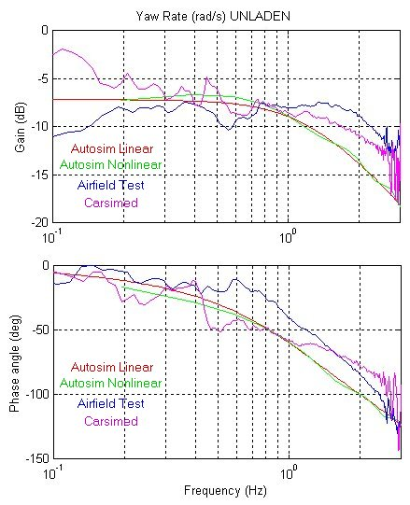

8.1 Summary of the features of all cases
In this section we are going to give a summary of the reasons for the behaviour of the vehicle through the frequency range. Further analysis is done in groups A and D reports.
- Reason for the dip occurring in the lateral acceleration and in the roll rate gains, reducing response at a specific frequency, is the cancellation effect of front and rear tyres. The cancellation occurs due to the front and rear tyre lateral forces being in anti phase which reduces the net lateral forces generated by tyres and hence the decrease of the lateral acceleration response to steering input.
- The reason for the phase peak of the lateral acceleration phase and the roll phase is the same as the previous.
- As the frequency increases, the yaw rate and the lateral acceleration gains diminish. This is produced by the called inertia effect. This phenomenon consists in that the system stops responding at high frequency produced by the attenuation of the mass. This is produced because at higher frequencies there are terms that depend in w those grow in importance.
- All the phases are negative. This means that the responses are following the input (steering wheel angle) with a lag, in other words they are retarded from the input. Zero degree lag is obtained in the theoretical models for zero frequency for yaw rate and lateral acceleration, as we would expect, because in the instant we start steering, starts building a response.
- Roll rate has a peak at about 2.5 Hz that corresponds with resonance at rolling natural frequency.
- At higher frequencies the front wheels are the ones that mostly works. When steering at high frequencies they are changing a lot the slip angle and therefore the force produced. On the other hand rear tyres are not changing slip angle, because they do not notice the changes due to the mass attenuation.

8.2 Comparisons between models and airfield test
All the models and the test produce similar shapes of lateral acceleration, yaw rate and roll rate gains and phases. Also the values of gains and phases are the same.
All the graphs match as expected because we are in linear range. This means that all the groups have done a good job: good theoretical model, good parameter measurement, good calibration and good data processing. Just we have to make some comments:
- Lateral acceleration above 1.5 Hz has much noise as we can see as well in the time history data, and in the fact that we have low coherence value.
- The test data do not seem to match exactly the other graphs, having small peaks and deeps. This is due to the way Matlab prints the data, if we would apply a smooth function that, the shapes would perfectly match.
- In the yaw rate at small frequencies there is a deviation between the airfield test and the models. In this part the models give the correct shape. We can not rely in the test data at low frequencies because it has poor coherence up to 0.5 HZ.
- Places were the test graphs diverge are at frequencies were the coherence is small, therefore in those places we should rely in the theoretical models, that can be seen that they give the same response. This could be mostly seen in the lateral acceleration phase at frequencies above 1.5 Hz .

8.3 Comparison between laden and unladen cases.
First of all we would like to point that bigger difference would be appreciate if there is more difference of weighs between the cases.
The unladen case has always bigger gain and less phase lag of lateral acceleration. Therefore the car is more responsive. The car is more responsive, because as it has less mass, it can react quicker.
Is possible to see that the yaw rate gain in the laden case is bigger. The frequency increasing increases this effect. This is explained due to the fact that the yaw rate increases as the centre of gravity goes downwards, as can be seen in the sensitivity analysis done by group A.
Yaw rate gain is slightly smaller in the unladen case, making the car better for handling when is not laden.
Phases of yaw rate and roll rate in both cases are equal.
Finally we would like to recommend the lecturers to take care about two things in the data processing:
- If a 180 degrees lag is found between test and models, this is because there is a sign mismatch produced because the axis in the model do not coincide with the axis of the accelerometers.
- In roll rate and yaw rate gains do not matter in which angle units are we working: degrees or radians, but in the lateral acceleration this would produce different gains.
We want to thank the last effort done by our data processing group to overcome the above problems.

