7. Airfield test

The objective of the test is to find out the frequency response of the Ford Mondeo, in order to characterise its dynamic behaviour.
There are several methods to test the frequency response of a vehicle. Some of them are explained by the International Standard Organisation (ISO) in the ISO 7401:1995(E):’Road vehicles – Lateral transient response test methods’.
- Step input
- Random input
- Pulse input
- Continuous sinusoidal input.
In this assignment we have used near sinusoidal sweep steering angle input with near constant amplitude and near constant vehicle speed, trying to follow to some extend the indications of the ISO 7401.
We have performed two loading conditions:
- Unladen case. For this loading condition, just the driver and a co-pilot in charge of the data acquisition system are required. This loading condition has been established to be similar to the ISO.
- Laden case. For this condition, the driver and 4 more people are inside the vehicle. It would be recommended to include some concrete blocks in the boot and inside the passenger compartment, in order to see more difference between laden-unladen. But this option was rejected because the concrete blocks would hit the instrumentation and would brake it.
The test speed was set at 80 Km/h in stead of 50Km/h as in previous years. The reason for that is because at higher speeds we will be able to see dynamic effects much better. The main problem from using a set speed of 80 Km/h is the difficulty to excite frequencies below 1 Hz, but as at frequencies below 1 Hz dynamics affects are small, we did not consider it an issue.

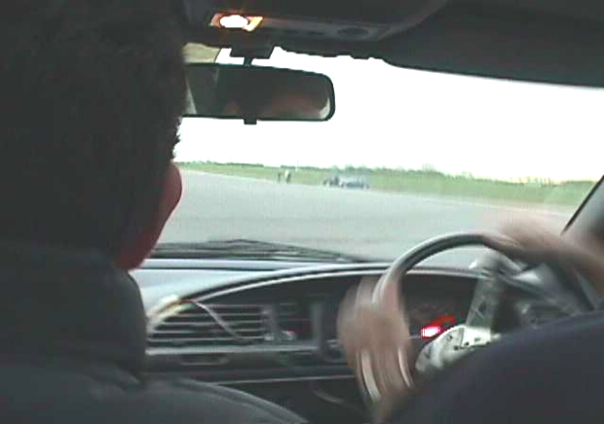

Picture 7.1. Driver performing manoeuvres during the test

7.1- Considerations
The lateral acceleration should be less than 0.3g-0.4g in order to have linear behaviour of the vehicle. At lateral accelerations above these values, non-linear start to have a strong influence on the dynamic of the vehicle. This will make the comparison between model and test impossible due to two reasons:

- The model is constructed with linear assumptions.
- Frequency domain studies assume linear response.
The test should have both quiescent start and end, in order to process in order to have all the signals with zero phase lag at the beginning and at the end and also allowing processing it without using any windowing to taper the extremities.
Mechanical limitations of the steering wheel angle were not used because we considered them unsafe and because they can produce a harmonic content in the input.
We recorded several runs in order to determine which were the best. The criteria being used to determine a valid run was:
- Near constant speed
- Near constant steering angle amplitude excitation.
- Values of lateral acceleration below 0.35g
- Wide frequency range excited.
- It has quiescent start and end.
We were not able to excite above frequencies above 3Hz because the Ford Mondeo has quite a big steering wheel and it takes too much time to go from near 60 degrees to –60 degrees.
Frequency tests are usually carried out to frequencies of 5 Hz, but we suppose that these tests are performed with a smaller steering wheel and by more skilled people.

7.1.1- Conditions of the test
- Flat and level road to perform the test
- Smooth dry pavement of high friction asphalt
- 1.6Km track length
- Ambient wind speed less than 7 m/s
- Ambient temperature 7°C

7.2 -The pre-test
As scheduled, we have carried out one pre-test before holidays to check that all sensors where giving signal, we were able to record and to process the data. After the exams and before the final test, we decided to make another pre-test in order to save the less time in the airfield, finding the problems and short them out before the final test. Note that this is an important fact because we have short time for the test: just 3 days between 5 and 8 in the morning.
The main problems found during the pre-test can be summarise as follows:
- The car ran out of petrol, so we had to fill in the tank in order to perform the test
- Some sensor connections unplugged due to the movement of the car, so we had to use tank tape to anchor them.
- We found problems with the computer connection. It unplugged during the pre-test. As a result we recommend the data acquisition person to hold with care the computer and the connection.

7.3 -The Test
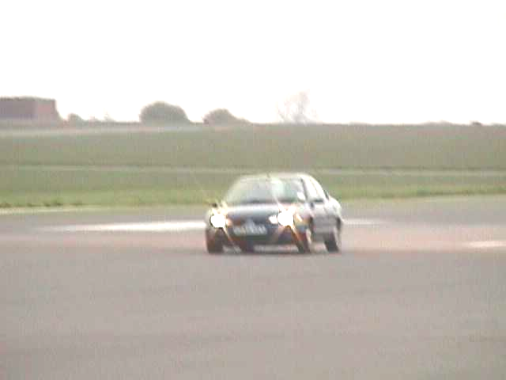
Figure 7.2. Ford Mondeo during the test

Thanks to the pre-test, we reduce the potential failures in the system. The team just spent two days in the airfield, in order to finish all the measures required.
DAY 1
- We realise that to excite the steering wheel with just one hand was unsafe
- We found some noise in the Lateral acceleration signal due to the battery hitting near the location of the lateral accelerometer.
- We decided the driver as the person who was able to keep near constant speed, near constant steering amplitude angle input and was able to excite wider frequency range. This was Sathya Rajendra Babu.

DAY 2
We were able to record data from two different drivers: Sathya and Peter. But despite the pre-tests and the previous day in the airfield, we had some problems with the data obtained. The lateral acceleration signal had some spikes just in one direction that the other days did not appear. We did not repeat the test again, just we would take into account this fact and we would use coherence function to see which data is useful.
Data obtained from Peter had too much nowise, therefore we did not consider it for the final comparison.
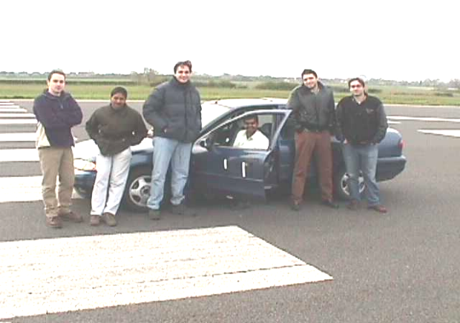

Testing group, first day. Photographer: Gabriel

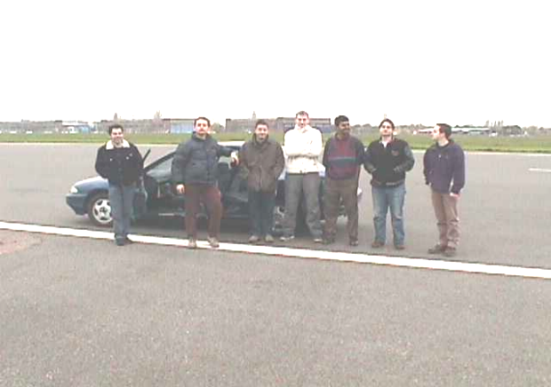

Testing group, second day. Photographer Luis.

