D.8-Dynamics 2001 Graphic User Interface

D.8.1-Introduction

To support the work of the Signal Processing Team, a graphical user interface (GUI) has been developed to enable quick and easy comparison and plotting of the theoretical and test results.

The purpose of this software is to enable the results from each data source to be plotted on a common axis, or individually as required. It is also possible to select different colours for each set of data to enable the different plots to be clearly distinguished from one another.

The GUI proves to be a useful work tool, as it allows direct comparisons to be made between the various results of interest, and has been of great value in identifying faults in the measurement and signal processing chain.

The following report presents the GUI, its main functions and a brief summary of the program files used by the system to plot the required information.
D.8.1-GUI Description

The Dynamics 2001 user interface has been created to enable the accurate presentation and comparison of the vehicle dynamics 2001 final results. All the principal information for analysis, including frequency responses, time history, power spectral density and coherence, can be easily accessed and plotted using the interface.

To access the GUI, it is necessary to go into the 2001 files directory and type Dyna2001 at the MATLAB prompt, the default figure for Dynamics 2001 will appear as shown:

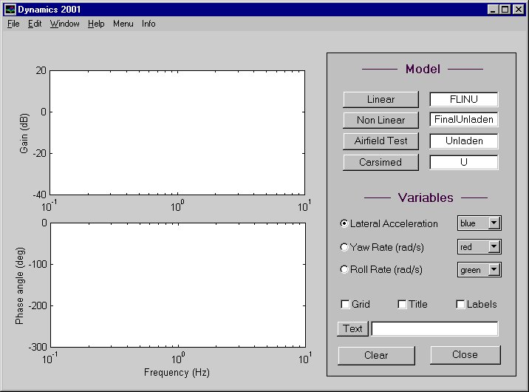
11
12

4
1
6
9

10

3

2
8

5

7

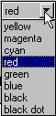The main functions included on the GUI are labelled in the above figure, and are all described briefly below:

- Radio buttons to select which variables to plot.

- Popup menus to select the colour with which the corresponding variable will be plotted. There are 8 options as shown.

- Edit text boxes to enable the user to input the name of; the linear model, the output files for non-linear and carsimed and the data recorded from airfield test. The final names can be displayed by pressing info (12). For the airfield test data and carsimed there are 6 files associated to each name (e.g. Unladen1.mat….to… Unladen6.mat), and for the non-linear model and the carsimed output there must be both a .bin and a .erd file.

- Push buttons to plot the selected variable for the different models. Only one variable can be plotted each time, but the plots will be held until the screen is cleared. This permits a rapid comparison of an variety of results; same variable for different models, all variables of the same model, comparison between laden and unladen, comparison between frequency responses for different number of averaged files (cases airfield test and carsimed), comparasion between responses using different number of points in the fast Fourier transform, etc…

- Checkboxes to add to the plot:
- Grid
- Title equal to the selected variable
- Labels equals to the pushbuttons model names.

- This push button will add text to the plot, as written in the corresponding edit text box.

- Push button to clear the plot areas.

- Push button to close Dynamics 2001.

- Plot area for the Gain.

- Plot area for the Phase.

- The Menu permits for either change to be made in some of the configurations or access to other important information.

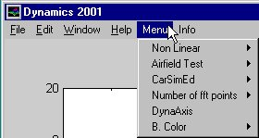
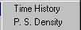
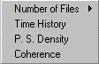
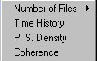
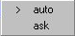
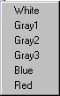
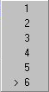
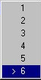
(e)
(f)
(g)
Menu Hierarchy
(a)
(b)
(c)
(d)
(e)
(f)
(g)
(d)
(e)
(f)

The following points summarise the sub categories of the Menu Function (11), as illustrated in the previous figure:

- 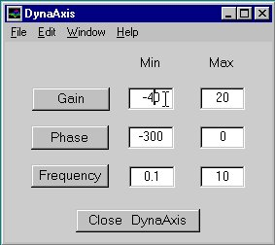Number of FFT points - permit the selection between: Auto – the number of fft points is calculated to be the power of two nearest to the number of sample. Ask – shows the number of samples and the number of fft points are keyed in by the user in the MATLAB command window.

- DynaAxis – launch a program (at right) to manipulate the frequency response plots axis.

- B. Color – change the Dynamics 2001 window background color, this function is useful to capture the plots as a bitmap.

- Number of Files – Permits the selection independently for airfield test and carsimed, of the number of files to average when calculating the frequency responses.

- Time history – Display the input files for lateral acceleration, yaw rate, roll rate and steering wheel angle vs number of samples for the file names currently in the edit boxes. The pushbuttons at top right in time history figure allow the navigation through the used files, the number of files displayed is equal to the number of files to average.
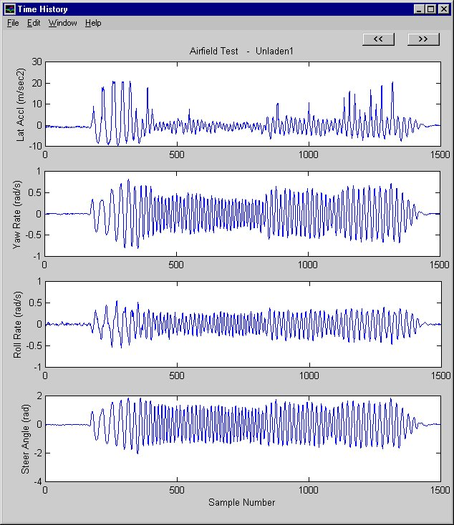

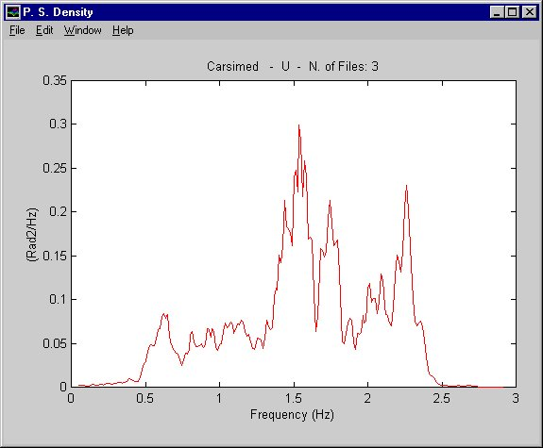

- P. S. Density – this option display the power spectral density for the current input files. An infinite number of P. S. Density windows can be open, allowing comparison between the different inputs. Eg power spectral density for the average of 3 carsimed unladen outputs.

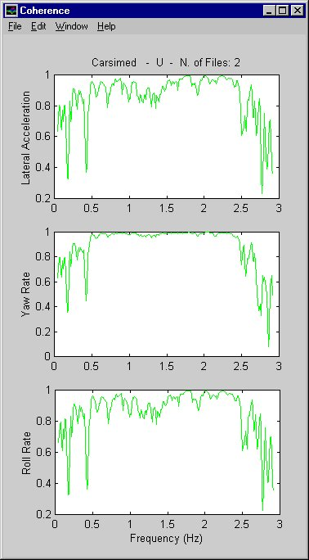

- Coherence – shows the coherence plots for the lateral acceleration, yaw rate and roll angle. Eg at right for carsimed output unladen case and an average of two files.

- Dynamics 2001 information displays the following window, containing the basic information of input files available and the list of files used by the GUI.
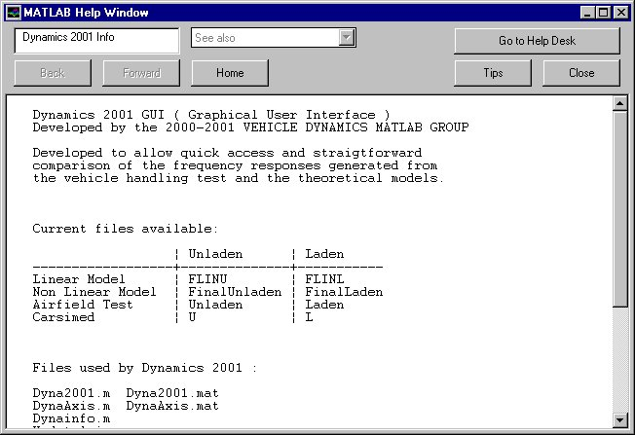

The following is a brief summary of the files used by the Dyna2001 GUI:

Dyna2001.m Dyna2001.mat
Figure containing the Dynamics 2001 layout. If edit with the MATLAB text editor this file is practically impossible to understand. The best way to understand the Dynamics 2001 figure and have access to all information, properties and call back functions the GUI design environment tools should be used. See GUIDE, ALIGN, CBEDIT, CTLPANEL, MENUEDIT and PROPEDIT.

DynaAxis.m DynaAxis.mat
Figure containing the layout of DynaAxis application, will only work with Dynamics 2001.

UpdateAxis.m
This file reads the gain and phase axis current limits and updates the values in DynaAxis edit text boxes.

Dynainfo.m
This file is called when the info button is pressed. Contains the text strings to be displayed in the MATLAB help window.

Coherence.m
This file is used by Dynamics 2001 GUI to plot the coherence for non-linear model, airfield test data and carsimed data.

CoherencePlot.m CoherencePlot.mat
Figure containing the layout for the coherence plots.

PSDensity.m
File used by Dynamics 2001 GUI to plot the power spectral density for non-linear model, airfield test data and carsimed data.

PSDPlot.m PSDPlot.mat
Figure containing the layout for the coherence plot.

Thistory.m
File used by Dynamics 2001 GUI to plot the lateral acceleration, yaw rate, roll rate and steering wheel angle vs number of samples for the non-linear model, airfield test data and carsimed output data.

THPlots.m THPlots.mat
Figure containing the layout for the time history plots.

Results.m
File used to run the linear model and output the gain and phase frequency responses.

Nonlin_gui.m
Identical to nonlin.m, changed to be used by GUI. Used for reading the non-linear model data and calculating the required spectral functions and frequency responses.

Test_Gui.m
Identical to test.m, changed to be used by the GUI. Used for reading the airfield test data and calculating the required spectral functions and frequency responses.

TestData_Gui.m
First part of test.m used by GUI to read the airfield test data.

Acarsimed_gui.m
File used to read the carsimed output files and calculating the required spectral functions and frequency responses.

Carsimed_gui.m
File used to read one specific carsimed output file and output the time history variables.

