4. GROUP C

INSTRUMENTATION AND
MOUNTING IN CAR
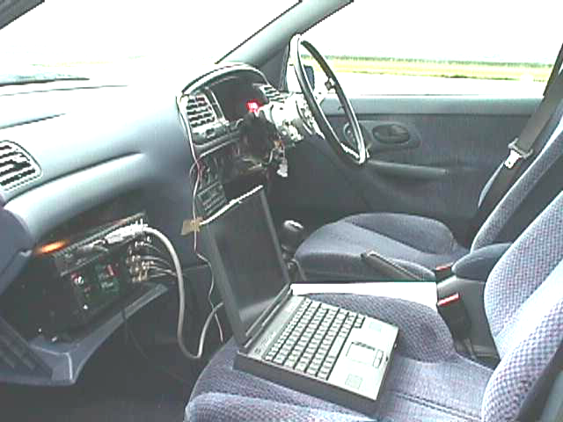
Ford Mondeo with the instrumentation required during the Airfield test. Io-Tech, BNC cables, laptop...

C.1-INTRODUCTION
The “instrumentation and mounting in car” team C has performed the tasks of choosing, calibrating, powering and mounting in the car the instrumentation to be used to obtain the dynamic response of the car, as well as powering and setting up the data recording equipment.
After finding out which devices were available in the lab and/or under Mateo’s disposal, we gathered information about the function principles and utilisation of these devices and other devices to be used during the project.
With this information we chose those instruments to be used regarding several aspects:
- Suitability for measuring the parameters agreed with other teams. The election of these parameters was discussed regarding last year’s recommendations about reliability and significance of the data obtained and also the usefulness of the data obtained in order to compare this with the theoretical model.
- Simplicity (e.g. one three axis accelerometer with only one powering lead rather than three accelerometers)
- Availability. Although a budget for the project was available, it wouldn’t have probably been enough to cover this quite expensive instruments purchasing.
- The power consumption was not an issue at this stage since this could be adapted to the instruments requirements afterwards.
The calibration of the instruments was carried out using voltmeters and oscilloscope as well as the data recording equipment: Io-Tech Daqbook. It allowed doing a double-checking. This calibration provides information about the instruments output voltage as a function of the physical magnitudes measured.
The powering installation provides electrical energy to the instruments and recording equipment at the voltages, type of current (e.g. AC or DC) required at stable values.

The data recording equipment includes and Io-Tech expansion chassis where to place the data acquisition cards, the Io-Tech analogue to digital converter and a laptop which will control that hardware by means of the DaqView 7.5 software and also records the data in the hard disk.
All the equipment was fitted in the car conveniently to be controlled by the passenger, and leaving enough space in the rear seat to accommodate 3 people for the laden case. This was preferred rather than placing concrete blocks in the boot, which would have needed difficult fixing to the car body to avoid them to move around.
Two pre-trials have been carried by members of this team to assess the normal function of all the equipment. The first day test was used to fix minor issues and chose the driver and finally the second day the actual test took place.
This team wants to thank to Mateo Betella the invaluable help and guidance offered and without which it could not have been possible for this team to perform all the tasks on time.

C.2-YAW AND ROLL RATE GYROSCOPES
When the car steering system is excited the response of the car will include among others a yawing and a rolling behaviour. Those are measured by means of two different rate gyroscopes, which will provide the rate of change of an angle (e.g. yaw angle and roll angle)

C.2.1-Background about gyroscopes
To help for the better understanding of the measurements and be able to cope with some problems that may arise, it has been gathered some general information about gyros
Recent developments in solid state technology have made possible very small cost effective devices to sense (angular) rotation.
An example of such a device is shown in fig. X below. It is usually fabricated on a silicon substrate using surface micro-machining techniques. In this case three layers of polysilicon are used, with the first and third layers being fixed and the second layer free to vibrate about its centre. The centre is held in position by four spring arms attached to four mounting posts.
This device can sense rotation about X and Y axes and sense acceleration in the direction of Z-axis. The centre layer of polysilicon, driven by electrostatic forces, vibrates about the Z-axis. Voltages applied between the fixed comb fingers and the comb fingers of the second polysilicon produce these forces.
Capacitor plates (as shown) are formed between the first and third polysilicon on the X and Y axes and the second layer of polysilicon. Differential capacitive sensing techniques can then be used to sense any displacement of the vibrating disc caused by angular rotation.
For instance, if angular rotation takes place about X-axis, Coriolis forces produce a deflection of the disc about Y-axis. This detection can be detected by the capacitor plates on the X-axis. The sensing of the three functions is achieved by using a common sensing circuit that alternatively senses the X rotation, Y rotation and acceleration.
[ Ref: Automotive Electronic Handbook, Ronald Jurgen, Mc Graw&Hill, 1995, p.7.24].
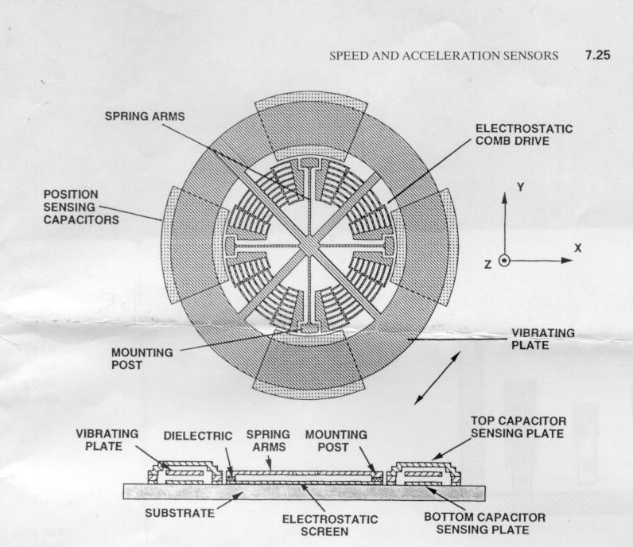

Picture C.1: Gyroscope internal layout

C.2.2- Procedure for calibrating the gyros
The main purpose of calibrating the gyros through the proceeding description, was to provide a measurable yaw or roll rate input to the gyroscopes, observe any phase lags between them as well as the voltage output of the 2 gyros used.

C.2.2.1- Construction of the pendulum
The pendulum was constructed by fixing the following two parts together, with 2 screws: The pendulum arm, and the pendulum plate, on which the two gyros were adjusted.

C.2.2.2- Fitting the gyros on the pendulum.
Next, the two gyros were placed in the centre of the pendulum plate, so that the one was placed on the one side of the pendulum plate and the other on the other side, hence “opposing” each other. In this way, the expected signal from such a configuration would imply a 180o phase lag between the two gyros, indicating that they work properly. A noteworthy point here was that the length of the screws was not sufficient so the pendulum arm was sawed in order to reduce the width of the pendulum arm and adjust the two gyros in the pre-described way. (Picture D.2) shows the already described construction. A more detailed illustration has been also made in IDEAS.

protractor

pointer hole Pointer showing
(axis of Degrees of rotation
rotation)
Pendulum arm

Pendulum
plate Position of the gyros

screws
adjusting
the gyros
Position
of the screws

sawed part of pendulum arm
Front view 90^{O} rotated view

Picture C.2: Calibration layout.
A noteworthy point is that the team considered using a Rotary Variable Differential Transducer (RVDT) for obtaining the angular displacements (degrees) of the pendulum. However, this approach was not considered satisfying, because:
a) The RVDT is a continuous rotary device, but for linear operation, the range is usually only about 40^{O}, and the error of this device (even to the 40º range) would be more or less the same as this of simply using a protractor and a pointer. For calibrating the RVDT, we should have used also the protractor and we should have had same measurement errors as for our own calibration without using the RVDT.
- The use of the RVDT would also imply the use of a demodulator (AC to DC converter), which was not available at that time.
Thus, the simple configuration of using the pointer and protractor, as shown in the figure above, was used to measure the angles of rotation of the pendulum during calibration.
The input voltage to the gyros was about 9V and they were connected directly to the IOTECH, which gave the voltage output to the computer:

Voltage input unit
Pendulum with gyros
IOTECH
Computer

(Two arrows are for the two gyroscopes and two channels used in the IOTECH)
A noteworthy point here is that the gain used in the Datbook for both gyros during calibration was 1 (x1).
The pictures C.3, C.4 and C.5 show the pendulum built in order to calibrate the two gyroscopes:

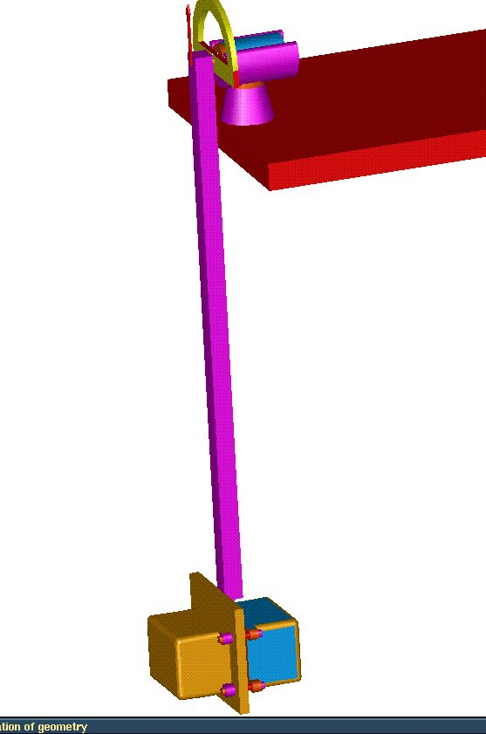

Picture C.3: Pendulum.
As you can see on the picture above, gyroscopes are fitted in the same position to balance properly the pendulum and to compare easily their results that must be out of phase. (One reaches its maximum positive velocity and the second reaches its maximum negative velocity.)
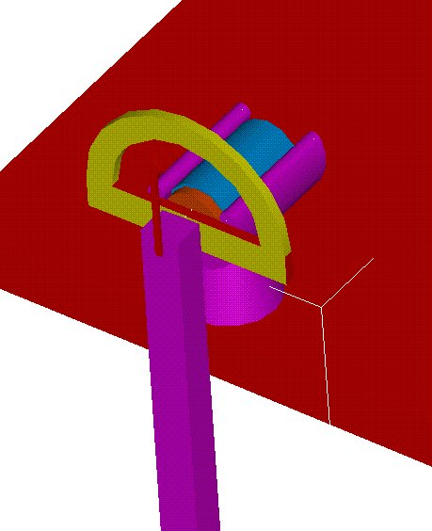

Picture C.4: Initial angle measurement.
The picture above shows the way to measure the angle at which we launch the pendulum.
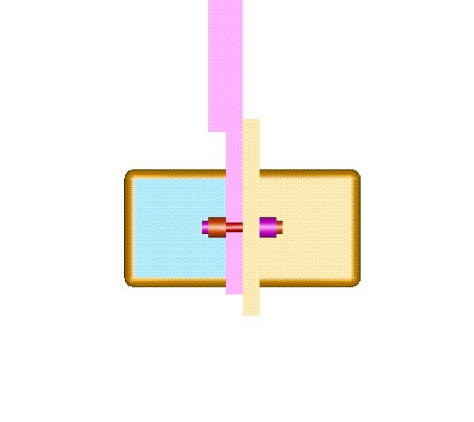

Picture C.5: Gyros fitting detail.
A critical point was that the two gyros had to be perfectly symmetric and perfectly parallel.

C.2.2.3- Mathematical approach for calibrating the gyroscopes.
The problem we had was the accuracy of the measurements because we weren’t able to know the angle of the pendulum in function of time. The only thing, which was easily controllable and measurable, was the angle at which we launch the pendulum. Then we used an energy method in order to have the velocity of the pendulum for a given start angle.
$\frac{1}{2}{\text{mV}}_{\text{final}}^{2}−\frac{1}{2}{\text{mV}}_{\text{initial}}^{2}=\text{mgh}$

As we are not able to know every time what is the angle value, we focus on the maximum velocity given by the pendulum when the angle is 0 which can easily be read on the IOTECH.
Then we start with an initial speed, which is not. And we launch the pendulum at a certain angle from the vertical and we record its maximum velocity.
Our final equation linking the starting angle and the maximum velocity is:

$∂ϑ∂t=\frac{V_{\text{final}}}{L}=\sqrt{\frac{2g\left(1−\text{cos}(ϑ)\right)}{L}}$

θ
With g= 9.81 m/sec²
And L=0.845 m
Picture C.6: Pendulum geometry.

Starting angle from initial position to vertical

Thus with different starting angles we are able to know the maximum velocity of the pendulum when it reaches the vertical position.
We obtain the following results:
starting angle (degree) | gyroscope 1 serial number : 60428 (volts) | gyroscope 2 serial number: 60141 (volts) | speed at teta equals 0 (rad/sec) | speed in deg/sec
5 | 1,5 | 1,5 | 0,297246 | 17,0309
10 | 3,09 | 3,03 | 0,593926 | 34,0294
12 | 3,8 | 3,75 | 0,712313 | 40,8125
15 | 4,36 | 4,3 | 0,889475 | 50,9632
Table C.1: Calibration data

Chart C.1: Theoretical value
Chart C.2: Calibration data
Chart C.3: Calibration data

Chart C.4: Calibration data
Chart C.5: Calibration data

Chart C.6: Phase between gyroscopes
As we can see on chart C.6, the two gyroscopes are perfectly out phase that presumes good results and accuracy.
We had to be careful to not overshoot the gyroscopes because our pendulum was quite heavy and had a good acceleration then we weren’t able to do some measurements above 15 degrees because of the maximum velocity range of the gyroscopes which is 50 deg/sec.
Moreover we estimate that our calibration is accurate because we only use the protractor one time to fix the starting position of the pendulum and use only results given by the IOTECH for the maximum speed which is reached when θ equals zero and when the sign of the shape changes.

C.3-LATERAL AND LONGITUDINAL ACCELERATIONS
Those are measured using a single three axis accelerometer using only two axis: X for longitudinal and Y for lateral acceleration.

C.3.1-Expectation and choice of the accelerometer
We must use a specific accelerometer due to the fact that the range of value we are likely to measure in the car is: -0.5g ≤ Ac ≤ 0.5g. Furthermore in our installation our accelerometer is powered with dc.
Moreover due to the possibilities of human body the driver will be able to go a maximum input of 5Hz The use of a piezo-electric accelerometer will not be appropriate at this input frequency because of it’s of low impedance, except with a very expensive model.
Hence we will use a capacitive 3-axis accelerometer (Sumitomo), which is a stand-alone unit with dc supplies, and dc output proportional to the linear accelerations along X, Y and Z-axis of the Cartesian coordinates
The unit is operated with the unipolar power supply

C.3.1.1- Our main accelerometer performances are:
- An acceleration detection range of ± 2g
- A resolution of 0.001 g.
- A non-linearity factor of 1% of full scale it’s including the effects of non-repeatability, hysteresis and any other uncertainties.

C.3.2- Calibration of the linear accelerometer
In order to calibrate our accelerometer we will use the simplest know acceleration, which is gravity (9,81 ms^-2). It is adequate for our calibration regards to the range of value we will obtain in our experiment.
This calibration is achieved by mounting the accelerometer on a graduate bubble inclinometer, which gives us a perfect measure of the angle and the position of our accelerometer.
This experiment was also performed after balancing the support on which the accelerometer and the inclinometer are mounted in order to avoid any initial error in our measurements. We had some previous experience about this mechanical balancing operation.
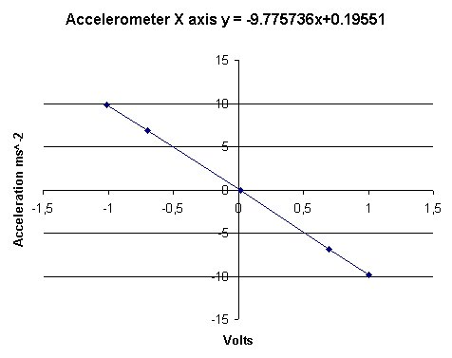
Chart C.7: Calibration curve for the longitudinal X axis

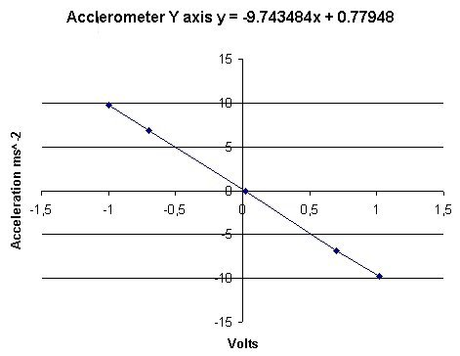

Chart C.8: Calibration curve for the lateral Y axis
We also need to detect any lag in a dynamic measurement between the accelerometer and the movement of the car. This was achieved by using a shaker with the accelerometer mounted on its vibrating shaft. Then we measured the input signal in the shaker and the output of the accelerometer.
This calibration was carried out in a range of 70 to 400Hz because the shaker provided in the lab wasn’t able to work at lowest frequencies than 70 Hz. So we have decided to make a manual experiment giving a low input frequency (see below).
We can observe signals trough the oscilloscope and using the 9 squares method (explained below) this method allow us to notice any lag between the two signals.

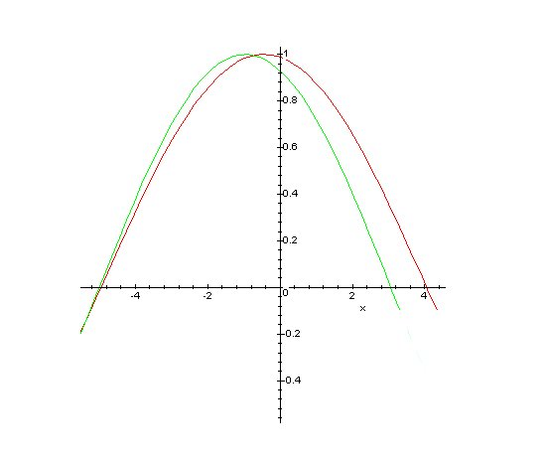

Lag between the two signals around 20°

Chart C.9.A: Nine square method for accelerometer dynamic response.

With this method one square represent 20° so if we extend our reference signal to nine squares on the oscilloscope we will have 180°.
As far as the trigger is used for both signal we have to work out on the second signal to cross each other at the same departure point and see when both signal cross again the X-axis
If they cross the X-axis at the same point it means that there is no lag between the two.

Chart C.9.B: Nine square method for accelerometer dynamic high frequency response.

Signals observed with our shaker and our accelerometer.
We can conclude that there is no phase delay at all on the X and Y-axis at this range of frequencies.
Signals observed with the manual input (i.e. low frequencies) correspond to those graphs in which XY are coupling (X represent the input and Y represent the output). If there is a phase delay between the X and Y we will observe an ellipsis otherwise if we observe a straight line it means that there is no phase delay.

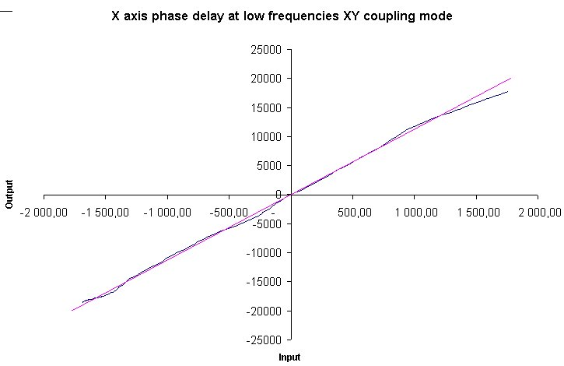

Chart C.10.X: Nine square method for accelerometer dynamic low frequency response

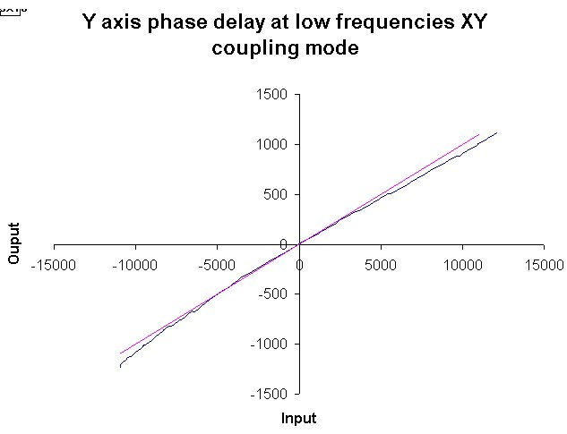

Chart C.10.Y: Nine square method for accelerometer dynamic low frequency response

On both axes, at low frequency, we observe that we have almost a straight line but definitely not an ellipsis thus we can conclude that there is no phase delay.

C.3.2.1-Power supply and acquisition chain:
Power supply
Accelerometer
X &Y axis IO-Tech

C.3.3- Mounting of the accelerometer
Due to the fact that the accelerometer is mounted on the chassis via a single piece in steel, which is not perfect, we encounter some trouble to achieve a correct zero position. Thus we use the graduate bubble inclinometer to mount it in the best position.

C.4-STEERING ANGLE MEASUREMENT
As the test is performed at constant speed, the only input is the steering wheel angle. We need to measure it, in order to feed the simulation with the same steering input and compare the theoretical and experimental results.

C.4.1-Requirements
The lateral acceleration of the car should be no more than 0.3 g-0.4 g, to maintain a linear behaviour. This group have performed some calculation to give an idea of the range of steering wheel angle allowed by this rule can be obtained from theory for a constant radius r and constant speed v = 80 Km/h = 22 m/s cornering situation. Lateral acceleration is given by:
Latacc = $\frac{v^{2}}{r}$ so for less than 0.3 g = 3 ms⁻²: r > $\frac{v^{2}}{\text{latacc}}$=$\frac{{\text{22}}^{2}}{3}$= 165 m
Then for an Ackermann steering system, the wheels angle is α = arctan$\frac{\text{Wb}}{r}$.
The steering gear ratio is G = 14.724 (Results from the Parameters Measurement Group (B)). So, the theoretical maximum steering angle is :
G*α = 14.724 * arctan$\frac{2\text{.}7}{\text{165}}$ = 13.8°.

Ackermann Model
v
r
Latacc < 0.3 g
r
r
Wb
α
α
constant radius and
constant speed cornering
Picture C.7-model for max steering angle calculation

Note that the value is much smaller than the excited during the test (near 60 degrees) and the used for the same test in the SAE 930828 that was around 45 degrees.
This value gives the order of the steering angle range. But much greater angles are allowed keeping the lateral acceleration below .3 g, and needed to get some response. The first reason is the compliance in the steering system.
The second reason is that the car response also depends upon the oversteer/understeer features of the car, and the tyre slip angles, unlike the road wheel angle exclusively as in the Ackermann model.
A gear system for steering angle measurement is already fitted in the car.
The gearing ratio is 60/20 and the steering wheel moves 3 revs from lock to lock.

C.4.2-Potentiometer choice and specifications
Two sensors are available to measure this angle:
- Rotary Variable Differential Transformer (RVDT). It has no end-stops and no brush (so infinite life). But it requires a signal conditioning unit, its linear range is only ±60°, and it does not fit in the gear system.
- Potentiometer. It has end-stops but a range of 3600°, which allows the driver to go to full lock. It has brushes but will last enough anyway. It fits in the gear system.

Chosen potentiometer:
RS Spectral 534 Series 200Ω ref 173-366
22 mm 3W 10 turn wirewound
Main features
– Precise
– Compact
– Supplied with metal lockwasher and nuts

C.4.3-Potentiometer mounting
Potentiometer fixed with washer and nut
To steering rack
To steering wheel
60 teeth gear
20 teeth gear
Mounting board attached to dashboard
Picture C.8-Mounting diagram
Power supply
+5 V
–5 V
Dacqbooq
10 V signal
Ground
Picture C.9-potentiometer wiring diagram
red
black
green
white

C.4.4-Potentiometer calibration
A first approximation of the steering angle for a given output voltage is 120°/V:
But the mechanical range of the potentiometer is not 10 revs exactly, but about 3610°. And the maximum resistance is not 200Ω but about 197Ω, and the minimum is about 0.3Ω instead of 0. So we calibrate the potentiometer in order to know exactly the angle corresponding to a given output voltage.
The potentiometer is fitted with an arrow and a fixed reference point, so that the revs are accurately measured. The input and output voltage are measured as well with the Dacqbook. Input is set to 9.5 V in order to be able to measure it (the range of the Dacqbook is 0-10V so any value over 10V would give a 10V output).
The input mean value was 9.52 V.
1V
output
=
full range = 1 rev
potentiometer shaft
gear ratio
1/3 rev = 120°
steering wheel
Picture C.10-approximate ratio
Next page’s calibration curve takes into account the gear ratio and is almost linear, so well approximated by the interpolation line. Its slope is 109.23 °/V, which is close to the estimated value of 120°/V. The error is less than 1% (a big error value is obtained for 0° but it is not a problem for our test since 0° means full lock).
The potentiometer is fitted with its shaft in middle position, and the road wheels straight, so that 5 V corresponds exactly to 0° steering angle.

Table C.2-Potentiometer calibration table

Chart C.11-Potentiometer calibration plotting

C.5-POWER SUPPLY
The power supply has been planned taking into account last year’s warnings. Though, due to problems with the initial configuration and after trying to solve them a second configuration has been adopted. Both are explained below.

C.5.1-First approach.
In this configuration we decided to use two lines of powering since the beginning.

C.5.1.1 High voltage supply
To get rid of battery problems on both the laptop and Io-Tech, we decided to provide directly a 230V AC supply by using a DC/AC converter unit to transform the voltage from the car battery at theoretically 12V DC to 230V AC. This adapter has been connected to a multiple plug socket, placed in the boot, which is fed straight from the battery. After the adapter a multiple plug connector was used to feed laptop and Io-Tech.

C.5.1.2 Low voltage supply
To power the instruments we were going to use a DC to DC converter which also acted as a stabiliser in order to provide a instrumentation voltage input value as constant as possible. The choice of this converter was done regarding the input voltage of the instruments and also the maximum current that it had to supply to power all the instruments. This can be seen in the table below.

Instruments | Voltage input (V DC) | Voltage output (V DC) | Current (A)
Rate gyroscope ( yaw ) | 8,5 to 18 | variable | ≤ 0,13
Rate gyroscope ( roll ) | 8,5 to 18 | variable | ≤ 0,13
3 axis accelerometer ( longitudinal and lateral ) | 4,75 to 5,25 | variable | 0,02
Potentiometer ( steering ) | 10 | Variable | 0,3
Table, C.3- Instruments powering characteristics.
In the above table can be seen that we need output voltage of 5 and 10 V and a total current supply of 0,58 A .
The RS (supplier) product which best met this specifications was the 5w Regulated Dual output converter NMXD 1205 SO, which can provide a dual voltage of ±5 V and current output of 0,5 A . The latest value is less than the required but nevertheless we decided to purchase this product for the following reason.
The potentiometer contributes with a maximum value of 0.3 A when it is fully turned to one end (e.g. lower resistance) but we don’t expect to be in this situation during the test because it implies full lock of the wheels. Therefore the actual current consumption of the potentiometer should be less than 0,3 A and the excess of only 0.08 A shouldn’t be a problem.
When the converter was received we tried to check that applying 12V as input we got the ±5 V as specification, but we didn’t get any voltage. This test was performed in the laboratory with a power supply unit normally used for electronic applications so we figure that the reason because it didn’t work was because it was not able to provide enough current. We continued working in the installation to be able to feed the converter with 12 V from the battery, which is supposed to provide enough current.
One of the problems we had to face was the high voltage output from the battery to be used to feed the DC to DC converter.
This device has an input voltage value of 12V with a maximum margin of a ±10%, which means a maximum input voltage of 13,2 V. We checked the battery voltage at several conditions: high and low engine speed and lights and other electrically powered devices on and off, but the voltage didn’t drop down 13,2 V and didn’t vary too much around 14,4 V, so we needed to drop it in other way. Using an old potentiometer we could drop the battery voltage to a value within the converter allowable range. The potentiometer would act as a voltage divider.

R₂
14,4 V
0 V
0 V
12 V
R₁
U₁
U₂

Picture C.11: Voltage divider.

R₁= 166 Ω
R₂= 833 Ω
U₁= 14,4 V
U₂= 12,0 V
$$U_{2}=\frac{R_{2}}{R_{1}+R_{2}}U_{1}=\frac{\text{833}}{\text{166}+\text{833}}\text{14}\text{.}4=\text{12}V$$
The total resistance of the potenciometer was 1000 Ω which corresponds to 10 turns end to end, having hence 3,6°/Ω. Turning then ∼600° gave us the desired voltage, and then the shaft was clamped. The voltage output was checked with a voltmeter confirming the theoretical value.

The power supply of all the instruments would have been like the next figure:
0 V
12 V
-5 V
+5 V
0 V
14,4 V
0 V
Yaw gyro
Roll gyro
Poten-tiometer
Accele-rometer

Picture C.12: Low voltage powering diagram.

When we had the potentiometer and the DC to DC converter connected we checked the converter output and it was nill.
We concluded that it was broken when it was supplied to us. At that time we were close to the pre-trial and were not able to claim a substitute converter under the manufacturer’s guarantee due to the delay it would carry, so we decide to try the second approach.
C.5.2 -Second approach.

Here we start with the 230V AC provided by the adapter. So we are in the same conditions as in the laboratory, where the sensors have been calibrated.
The actual wiring diagram is given in next page.
As the DC/AC converter unit works properly, a multiple plug connector was used to feed the laptop and the Io-Tech through their own converters. The power supply unit used in the laboratory to calibrate the sensors was also used in the test to power them. It uses 230V as input voltage and the output was set at 10V (e.g. –5V , 0V , +5V).

The battery voltage stability had previously been checked when it was tried to be used to feed the DC to DC converter, and this was fairly stable. Now the battery will feed the DC to AC converter and once we have 230V AC, those to feed the power supply unit. These two units also stabilise and condition their voltage outputs, so that the instruments were fed at constant voltages.
This power source supplies –5V/+5V to the two gyros and the potentiometer, and -5V/0V to the accelerometer.
BNC connections are used as a standard in low voltage circuits. These connections are reliable, easy and quick to plug and unplug, and not sensible to vibrations.

Car Battery
Multi plug connector
DC/AC converter
Power
supply unit
Potentiometer
Yaw gyro
Roll gyro
2-Axes accelerometer

Dacqbook Data Acquisition System
230V AC
+12 V DC
0
+5V DC
0
0 +12Vd.c
Dacqbook
transformer
Laptop
transformer
Laptop
+12 V DC
+12 V DC
+12 V DC
0 +12Vd.c
-5V DC
Steer angle
Lateral acceleration
Roll rate
Yaw rate
Longitudinal acceleration

Picture C.13: Wiring Diagram

C.6- THE DATA ACQUISITION SYSTEM

C.6.1- Introduction
The data acquisition system consists of a laptop, the daqbook, the expansion module and the sampling cards.
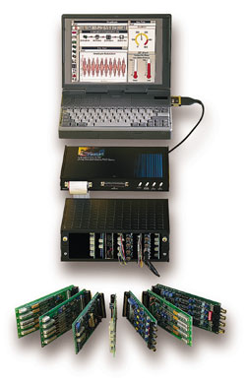

Picture C.14: Data acquisition system.
Such a data acquisition system monitors a process by collecting readings of various measurements. All the readings can be stored in an appropriate format for after test processing. The data can be saved in either ascii “.txt” or binary “.bin” format and they can be loaded, displayed and analyzed with Matlab, MS Excel, etc.
For example if we have an accelerometer connected to the power supply, we can obtain a signal for an excitation of the accelerometer. That signal is converted into a standardised voltage output and filtered, so that it is suitable for the analogue to digital converter.
If it is needed, that voltage can be amplified in the card previously to digital conversion by modifying the gain in the card, or after by modifying the gain in the software. Finally the digital information is stored in the laptop.

C.6.2- Steps of data acquisition
There are typically four stages to any data acquisition system:
- A sensor reacts to a physical quantity (acceleration, sound, light, etc.) and transducers that quantity into an electrical signal. The signal produced can vary with the measured value directly or inversely and in a linear or non-linear way. These signals, in order to be useful, must be conditioned and for that purpose the signal conditioning function is used.
- The signal conditioning is considered as a black box. The signal conditioner changes the raw transducer signal into a standardized voltage output to be sent to the analogue to digital converter (ADC). Depending on the signal quality, several steps and processes may be involved. (e.g. linearisation, isolation of high voltages, amplification of weak signals, filtering of noise and irrelevant frequencies, differential voltage measurement, etc.). For that application the DBK18 card modules were used, to operate as low pass filters and amplifiers.
- The analogue-to-digital converter changes a conditioned analogue signal into a corresponding digital number. For example a 12-bit converter uses 212 = 4096 numbers or a 16-bit converter uses a 216 = 65536 numbers. In our case the ADC function is performed by the Daqbook 200, which has a resolution of 16-bit.
- Finally the computer (PC) can apply further processing to the digital data and then display or store the results. For our assignment the DaqView 7.5 software is used.

C.6.2.1 DBK18 – Signal Conditioning
The cards used are the DBK18. These modules are used to operate as low pass filters and amplifiers. A sample of a DBK18 is shown below.

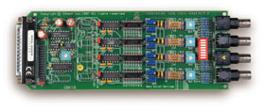

Picture C.15: DBK18 card
This card is consisted of four channels, filtering (Three pole Butterworth LPF) and amplifying (Gains :x1,x10, x100, x200, x500) each channel independently.
The primary function of the DBK18 is to remove any unwanted high frequency components from the signal and avoid aliasing problems. The DBK18’s output is normalized to correspond to a user-selected range for the measured quantity. The output range is 0 to 10 volts in uni-polar and ±5 volts in bipolar mode. Gains can be set to optimize the signal amplitude for these ranges.
The total number of channels available is 20, as the DBK41 expansion enclosure allows a maximum of five DBK18 cards. A block diagram of a DBK18 card is shown below:

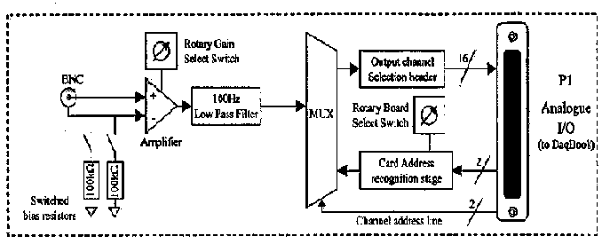 Picture C.16: DBK18 Block diagram

For our assignment we needed only two cards and five channels. The labelling of each channel is shown below.

1-0-3
1-0-2
1-0-1
1-0-0
1-1-0
1-1-1
1-1-2
1-1-3

Picture C.17: Channel label in DaqView

Later in picture C.19 you will see that channel1-0-0 is used for the steer angle, 1-0-1 for the lateral acceleration, 1-0-2 for the longitudinal acceleration, 1-1-0 for the yaw rate, 1-1-1 for the roll rate.

C.6.2.2 DaqBook
The DaqBook performs the analogue to digital conversion with a resolution of 16-bits and the maximum sampling frequency can be 100kHz. It has a range of voltages of 0-10 volts in unipolar mode or –5 to +5 volts in bipolar mode. It can give amplification of 2, 4 or 8. Furthermore there are different ways of triggering it. (auto, manual, timed) A DaqBook block diagram can be seen below.

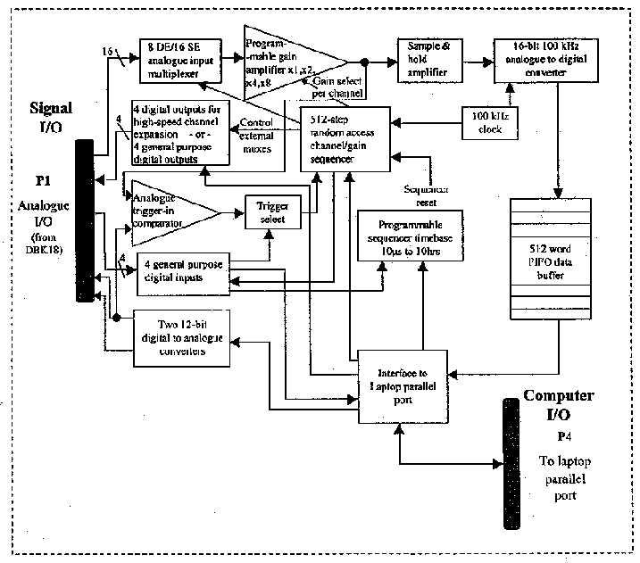
Picture C.18: DaqBook block diagram

C.6.2.3 DaqView - Software
The software used is the DaqView 7.5. 12, which is a new edition installed for this year’s assignment. First of all this software was configured to work for two DBK18 cards. In order to work with two cards we need to set rotor 1 and 2 on and with that configuration we get 8 channels [1-0-(0…3) and 1-1-(0…3)] at P1. The channel’s set-up is shown in picture 18. It can be seen which channels are active, the gain set at each channel, the label of the channel and the units used. The polarity is chosen individually in each channel.
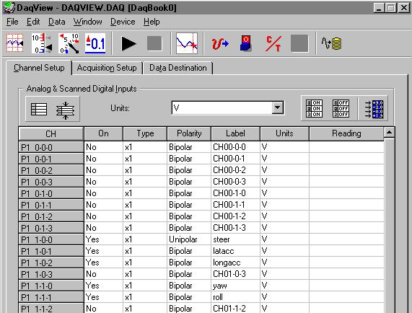
Picture C.19: Channel’s set-up
The sampling rate is selected to avoid any aliasing (explained later) problems.
The sampling rate is set to 300 Hz. Lately the signal will be decimated by the data processing group.
The scan count is set to 15000 for a total run time of 50 seconds. The first and last 10 second are allowed for steady speed straight line running , whereas the actual car response signal corresponds to the central 30 seconds. The passenger is in charge to manually trigger the data acquisition by pressing a key in the software, although there are other automatics ways to trigger. With that settings the system would then record for 50 seconds and stop. The data that would be obtained in that 50 seconds will be passed to the data processing group for analysis.
Finally in the next page there are shown two pictures about the acquisition set-up and the channels’ display.

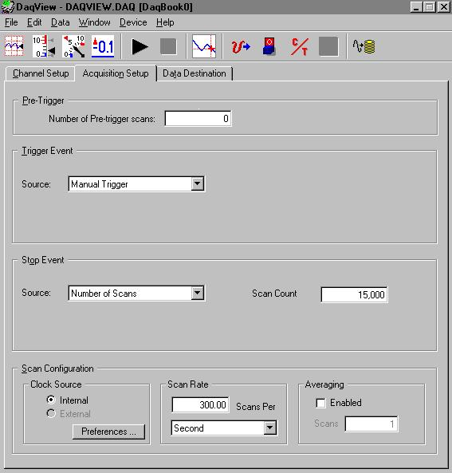
Picture C.20: Data acquisition set-up

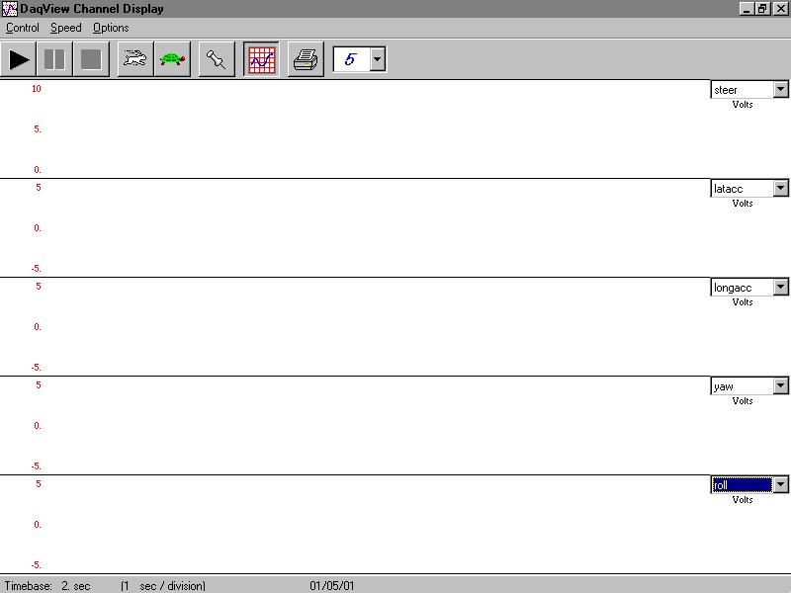
Picture C.21: Channels’ displays

C.6.3- Aliasing
A lot of attention must be given to the selection of the sampling frequency because of the aliasing problem. This is a problem that occurs when the sampling theorem is not obeyed.
The sampling theorem states that: “ If a continuous function only contains frequencies within a bandwidth, B hertz, then it is completely determined by its value at a series of points less than 1/2B seconds apart”. The sampling frequency must be at least twice the bandwidth.
Aliasing will occur when there are components of the signal at frequencies greater than the maximum allowed by the sampling theorem. That is shown in picture 22 .

liasing.
Picture C.22: Aliasing

